OSAS
Banking
ACH Payment to Vendors

The following items need to be set up before using Banking for ACH payments to vendors.
AP or PO/File Maintenance/Vendors/Select Vendor Codes.
Enter the Account Number and Routing Code.

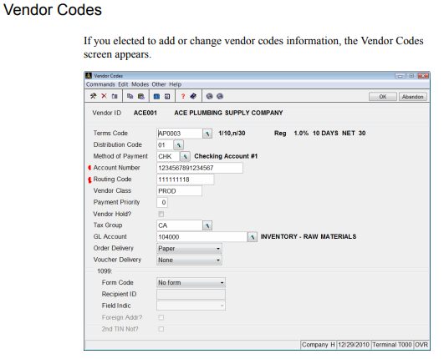

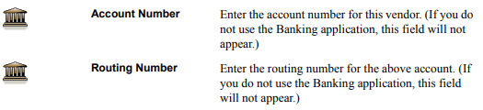

AP or PO/Codes Maintenance/Methods of Payment.
Set up ACH as a method of payment, use Payment Type 5-electronic payment.

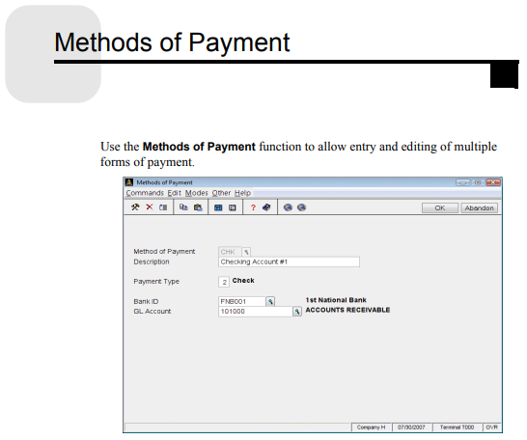

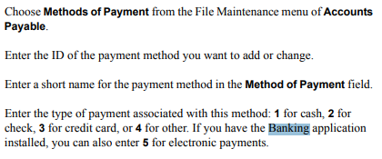

AP or PO/File Maintenance/E-Mail Defaults.

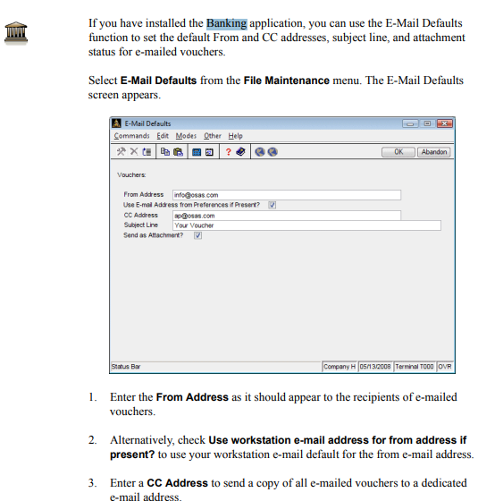

AP or PO/Pay Invoices/Print Vouchers.
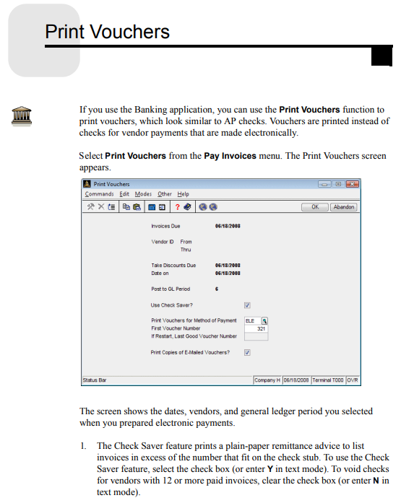
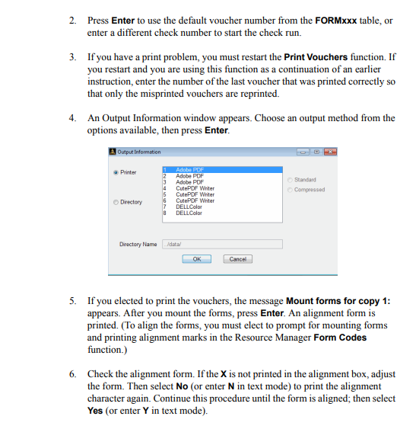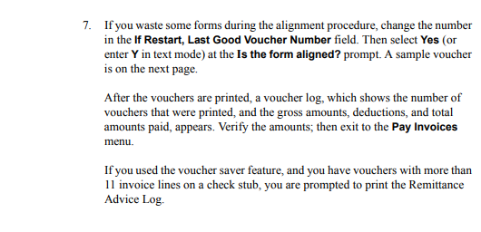

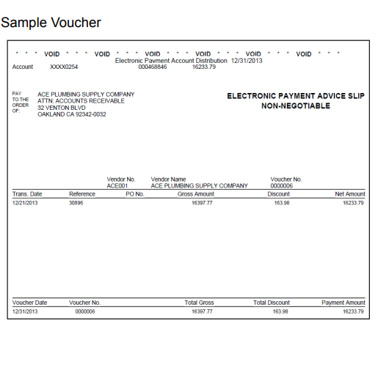

AP or PO/Pay Invoices/Create ACH File.
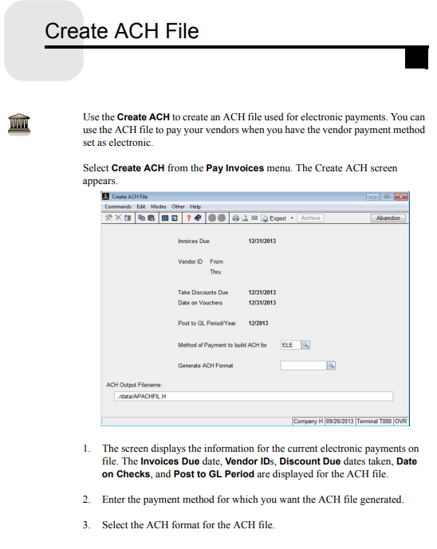
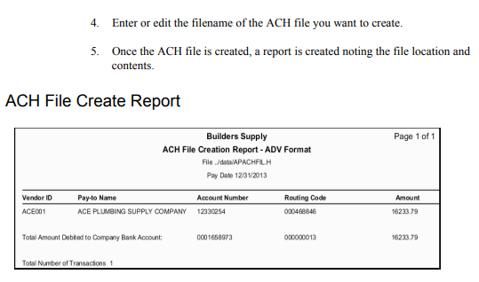

AP or PO/Pay Invoices/Payment Register.
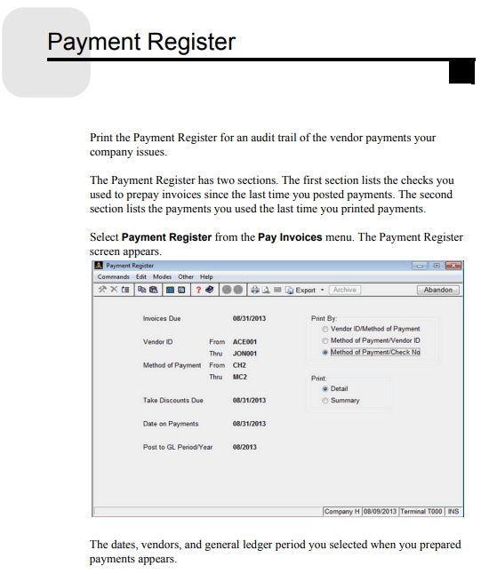
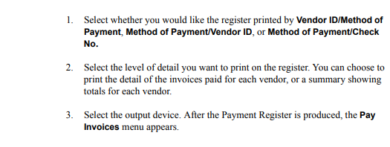
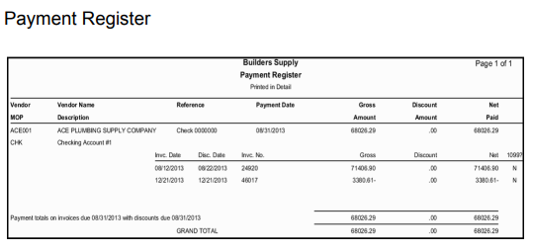

AP or PO/Pay Invoices/Post Payments – Make sure you have created the ACH file before posting.
