OSAS

AP

Expense Reporting

**Setup and Procedures**

Expense Reporting is a way for an employee to enter into OSAS personal purchases that are business expenses which will be reimbursed by the company such as employee meals, hotels, car rental, or other authorized expenditures.

**Users with permission to enter expenses and receive reimbursement must have a vendor ID** if reimbursing for out of pocket expenses.

*AP/PO, File Maintenance, Vendors. Each vendor ID must have a Terms Code assigned.*

**A default tax class must be entered in the EXRPTx table** (AP/File Maintenance/Tables). It must be company specific. Copy from EXRPT to set up your company specific table. The default tax class can be edited during AP or PO transactions.

*Note: If table EXRPTx does not appear in tables, enter as shown below.*

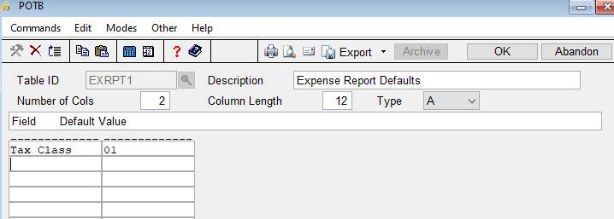

**Set up Expense User Groups** which establish users who can create and edit expenses and users who can approve expenses. Members of any group can only create/edit or approve expense reports for users within their own group.

***AP/PO, Codes Maintenance, Expense User Groups***

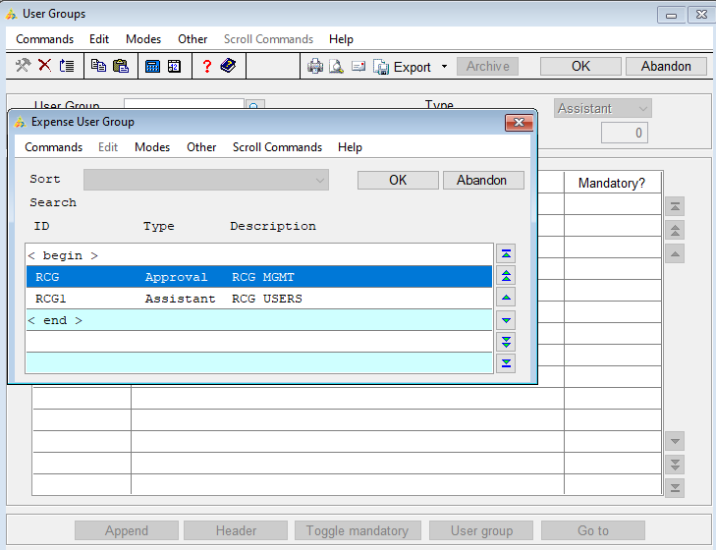

Approval groups can approve expenses for expense reimbursement users associated with their group but cannot edit them (unless the expenses are their own). You have the option to indicate mandatory users who must always approve expenses.

***Type:*** *Select Approval or Assistant from the drop-down box for the appropriate user group.*

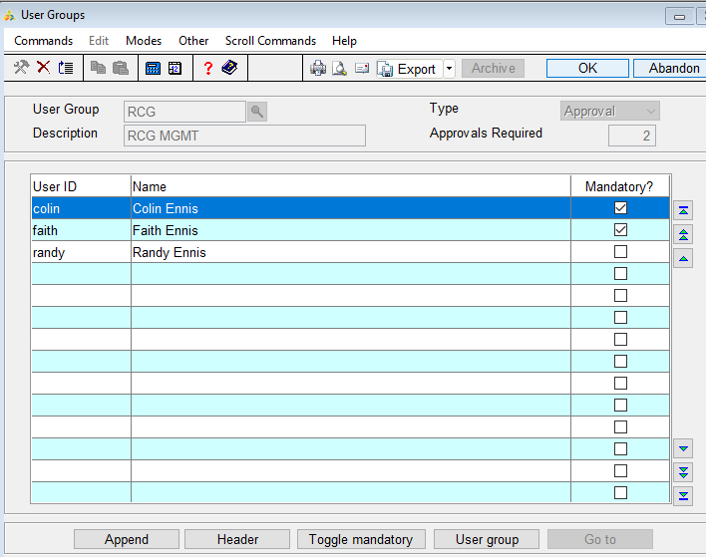

Assistant group users are allowed to create and edit expenses and expense reports for expense reimbursement users associated with their group but are not allowed to approve them.

***Type:*** *Select Approval or Assistant from the drop-down box for the appropriate user group.*

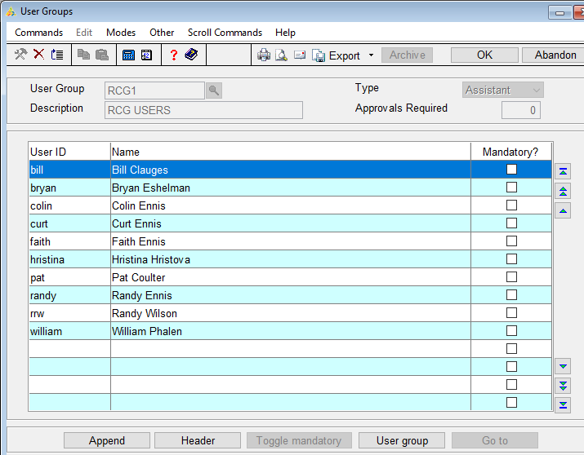

**Set up Expense Reimbursement Users** for users who will be reimbursed on an expense report. Users who submit expenses that will be reimbursed to them must be listed as expense reimbursement users.

If an expense reimbursement user is not associated with an approval group, when the user submits an expense report, the report will automatically be approved.

If the user is associated with an assistant group and not an approval group, expense reports are also automatically approved.

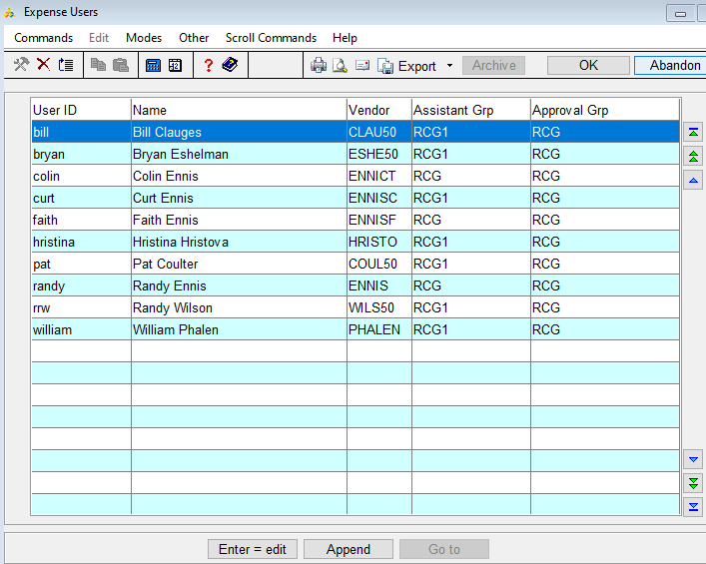

**Set up Expense Categories** to establish codes to which expenses can be assigned. Assign a default GL account for expenses that fall into the selected category, which can be overridden if necessary when the expenses are entered in the Expense Entry screen.

***Type****: is for reference only and is optional.*

***TIP:*** *use the category Type as a grouping option. An example would be breakfast, lunch, and dinner all have a category type of MEALS.*

***Job Required****?: If AP is interfaced with JC or CJC and you require expenses in the category to be tied to a job cost code, check the Job Required? You can enter an optional Job Cost Code as needed.*

***Percent Reimbursed:*** *Enter the percentage of the expense that will be reimbursed. A blank field indicates 100%.*

***Rate Per Quantity:*** *If your company reimburses expenses as a rate per quantity, enter the Rate Per Quantity. This allows you to set a specific amount to be*

*reimbursed for every unit of the expense. For instance, you may specify a*

*rate of $150 for every unit (night) for a hotel stay. The expense user would*

*receive $150 for each night, no matter the actual amount they paid.*

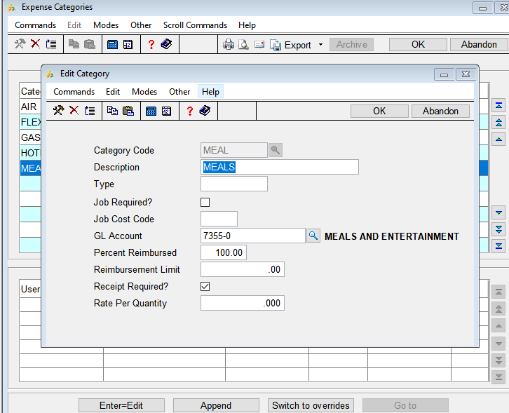

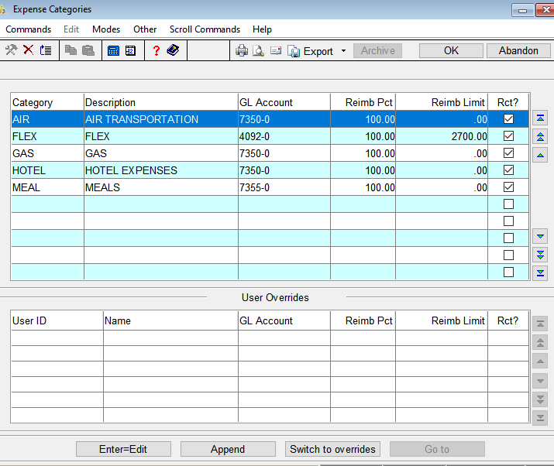

If you have one or more expense reimbursement users whose expenses in the

category should be applied to a different GL account and/or job code, or a

user has different percentage or limits for reimbursement, you can create an

individual override for the user(s). If applicable, press **S** to switch to the

**User Overrides** section of the screen. The Append User Overrides screen

opens. Enter the appropriate GL account number.

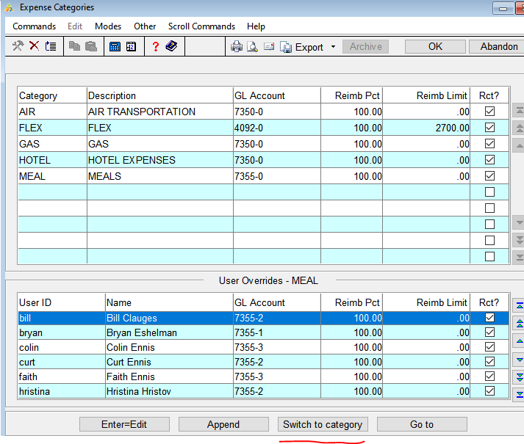

**Expense Entry**

Use Expense Entry to enter business-related expenses to receive reimbursement. Expenses entered will be processed back at the office by accounting in order to reimburse the employee.

Because expense reimbursement is a common activity for users with Job Cost or Contractor’s Job Cost, expenses can be attributed to any job, phase, and cost code active in the appropriate job module.

Select Expense Entry from the AP or PO Expense Reporting menu.

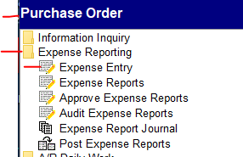

By default, the logged-in user will be displayed in the User ID field. If you are a member of an assistant group, you can select the User ID of a reimbursement user associated with your group from the drop-down list.

Select a View Status from the drop-down list. This will determine the expenses that display.

.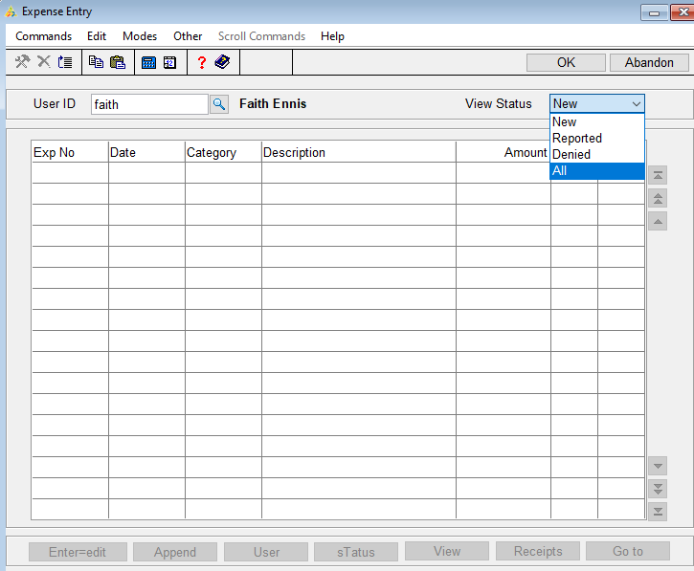

Page down/Ok to continue.

**Click Append to add a new expense.**

**Expense Date**: The workstation date defaults in the Expense Date field. Accept of edit the date which will apply the expense.

**Category:** Select an expense Category from the drop-down list.

**Description**: Enter a description of the expense. If AP/PO/LC option to use additional descriptions is set to YES, an additional description window will appear,

**Quantity**: If the expense category has a rate per quantity greater than zero, enter the quantity of the expense. Example: if the expense is for two nights at a hotel, enter 2. If the expense category rate per quantity = 0, this field is skipped.

**Rate**: This is a read only field. If a change is needed, see **Set up Expense Categories** in Set Up.

**Expense Amt**: By default, the expense amount is quantity times the rate. This field is enabled only if the expense category does not use a rate per quantity in the category definition. Enter the expense amount.

**Reimbursed Pct**: This is a read only field. If a change is needed, see **Set up Expense Categories** in Set Up.

**Reimbursed Amt**: This is the reimbursed percentage of the expense amount. Accept or edit the amount if available.

**Page down/OK**

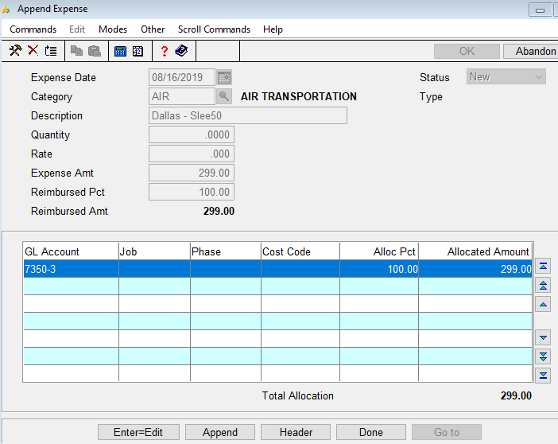

The GL account allocation section becomes active after Page down/OK. By default, the first line of the allocation entry allocates 100 percent of the reimbursed amount, utilizing the default GL account for the expense category. If this is correct, press D(one).

If you need to allocate expenses to multiple job/phase/cost codes (JC or CJC only), you must first reduce the default allocation amount/percentage. Press enter to edit the default allocation then Press A (Append) to add a new allocation. Enter the GL Account, Job ID, Phase ID, Cost Code, Allocation Percentage, and Allocated Amount as needed.

Page down/OK.

To add receipts for an expense, Press R(eceipts).

If you have electronic copies of the receipts saved to your workstation, press U(pload) to open the Upload Document screen and upload the file from your workstation to the server. Multiple expense transactions may reference the same document once it is uploaded.

Use the **Browse** button of the **Upload File** field to navigate to the document’s location on your workstation. Select the document and choose **Open**. The **Document** field shows the destination of the file once it is uploaded to the server. The Document field defaults a path to the Document

folder and filename.

***Tip:*** *Ensure the DocumentShare path is defined in Resource Manager so the file can be opened from the software.*

Edit the destination path and/or file name, if necessary. Enter a Description

for the electronic receipt document.

**Page down/OK**.

Once the file is uploaded and saved, it will appear in the Document

Information HLE. The file path is replaced with: (DOC) filename. If you

place the file in a subdirectory, such as **../OSAS80/Documents/Receipts/**

**filename**, only the path through the Documents folder is replaced: (DOC)/

Receipts/filename.

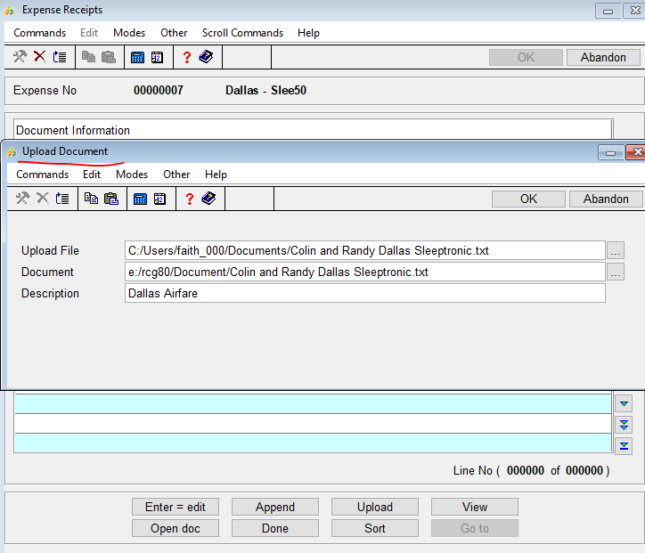

If you have electronic copies of the receipts already saved in the Document

folder on the server, press A to open the Append Document screen and add

those receipts to the expense transaction.

The Document field defaults a path to the Document folder and filename.

***Tip:*** *Ensure the DocumentShare path is defined in the Resource Manager so*

*the file can be opened from the software.*

Use the Browsebutton of the Document field to navigate to the document’s

location on the server. Select the document and choose Open. Enter a

Descriptionfor the electronic receipt document.

**Page down/OK** to continue.

Once the file is appended, it will appear in the Document Information HLE.

The file path is replaced with: (DOC) filename. If you place the file in a

subdirectory, such as **../OSAS80/Documents/Receipts/filename**, only the path

through the Documents folder is replaced: (DOC)/Receipts/filename.

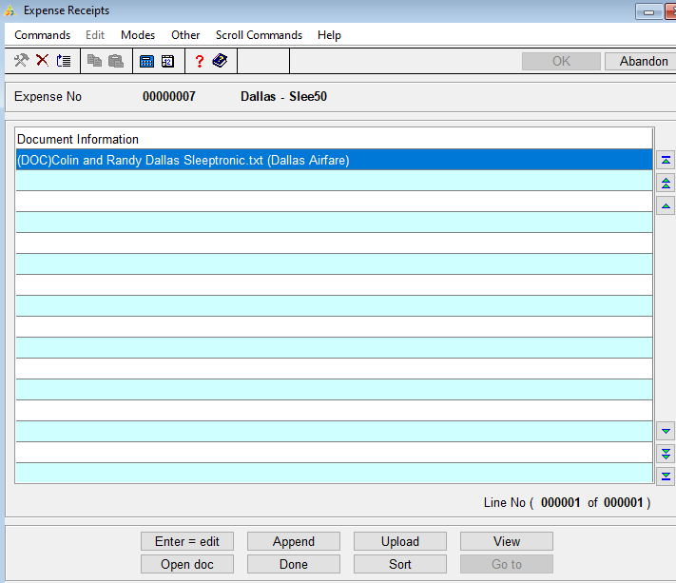

Once you have added a receipt for an expense, the Rcptcheck box will be

marked.

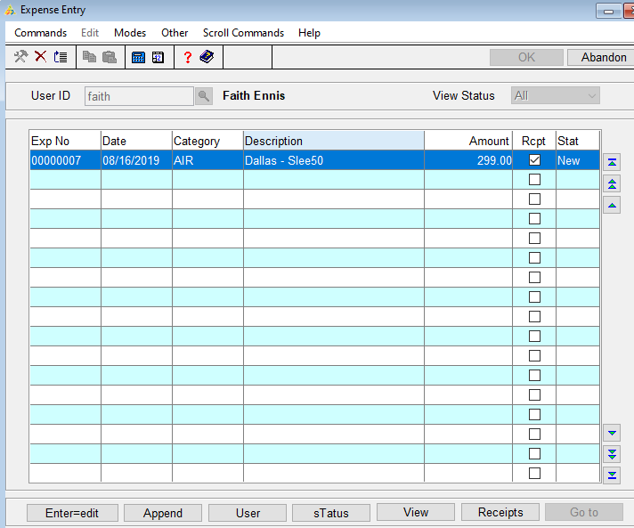

**Expense Reports**

Expense Report is a collection of related expenses (airfare, hotels, and meals during a single business trip). You can select from the expenses entered to create the expense report.

Select Expense Reports from the AP or PO Expense Reporting menu.

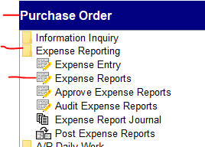

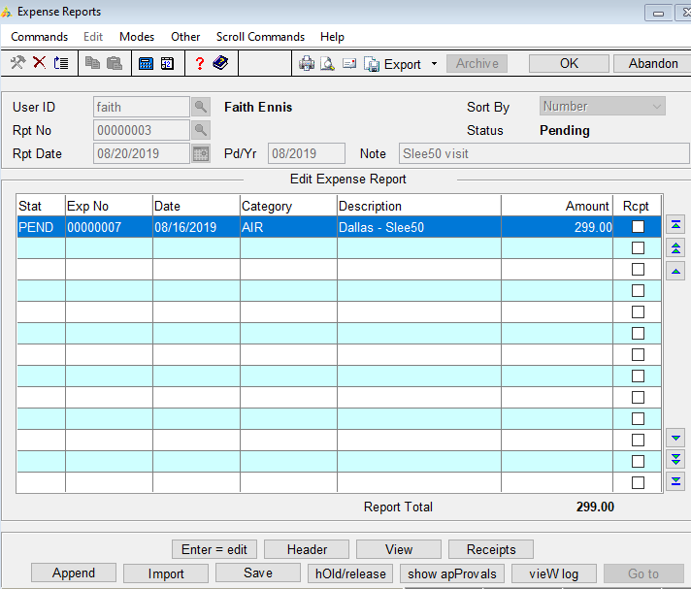

***NOTE:*** *The screen display is different depending on the status of the expense*

*report you choose. If the expense report you open has a status of ‘Approved’ or*

*‘Pending’ (submitted), the screen will appear as in the previous screenshot. If the*

*expense report status is ‘New’ (not yet submitted), the screen will appear as*

*shown below:*

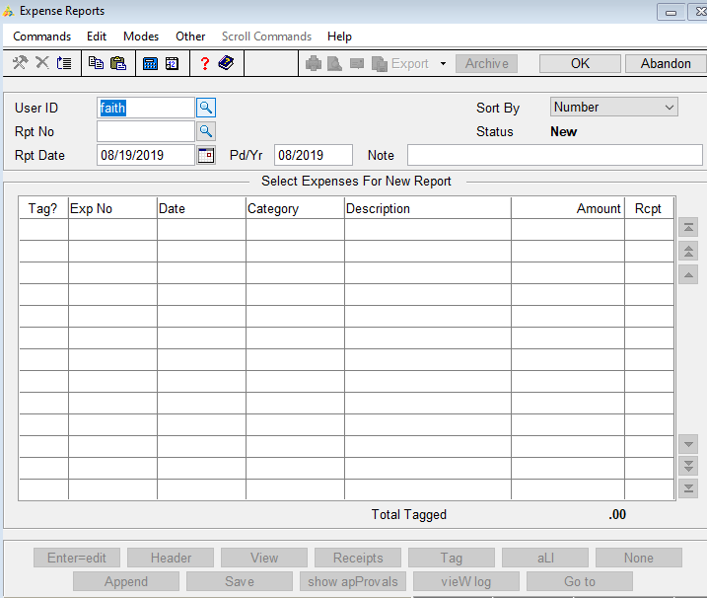

By default, the currently logged-in user is selected in the User IDfield. If

you are a member of an assistant group, you can select a User ID of a

reimbursement user associated with your group for whom you want to create

or edit an expense report. A popup window will notify you if you are not

allowed to enter or edit an expense report for a selected user.

**Rpt No**: Enter through the Rpt Nofield to create a new expense report. Use the **F2**

(**Inquiry**) command to select an existing expense report to edit.

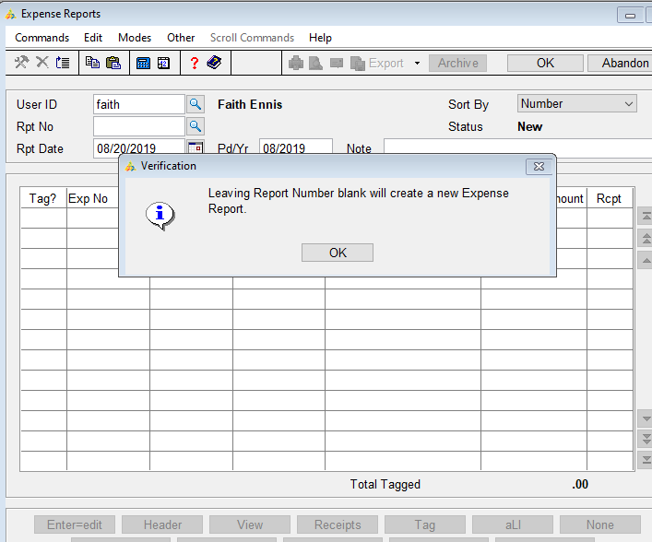

**Rpt Date**: Accept or enter the date for the report.

**Pd/Yr**: Accept or enter the period and year to associate with the report.

**Note**: Enter a note to describe the expense report.

Once you edit the Notefield, you must **Save** and submit the report (the option to submit

appears when you use the **Save** button) to write the changes.

**Page down/OK**: to continue. Expenses that have not yet been submitted will be listed with a status of ‘New’ and on a screen with the option to tag the expenses on the report.

Expense reports that have been submitted or approved will be listed on a screen with no option to tag the expenses on the report.

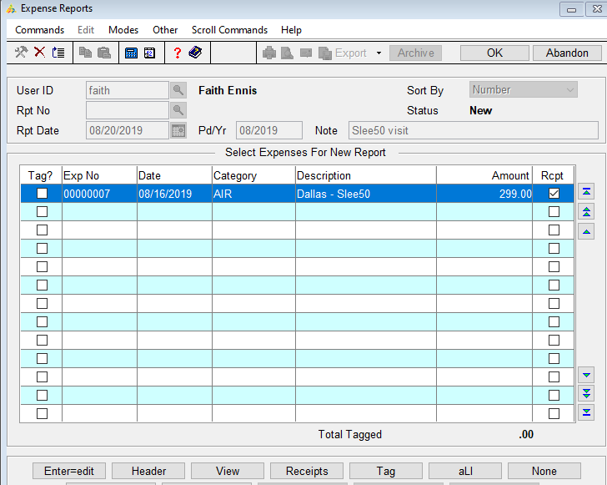

Select an expense.

**Edit**

**Header** to select a different report date, pd/yr,

**View**

**Receipts** to open the reimbursement receipts screen. If you add receipts to an approved expense report, the report must go through the approval process again.

**Tag** to approve an expense. This will tie the expense transaction to the expense report.

**aLl** to tag all listed expenses.

**None** to clear all tagged expenses.

**Append** to add additional expense transactions.

*Note:* *If you are adding expenses to an expense report with a status of Pending’, you may have an option to import expenses. If you have entered a number of expenses via the Expense Entry function that are not included on any expense report, you can import those expenses to the current report. The import process only ties the expense to the expense report, as opposed to appending an expense, which creates a new expense transaction as well as tying the expense to*

*an expense report.*

**Save** the report/write changes. A notification window offering you the option to submit the expense report for approval or reimbursement (YES/NO).

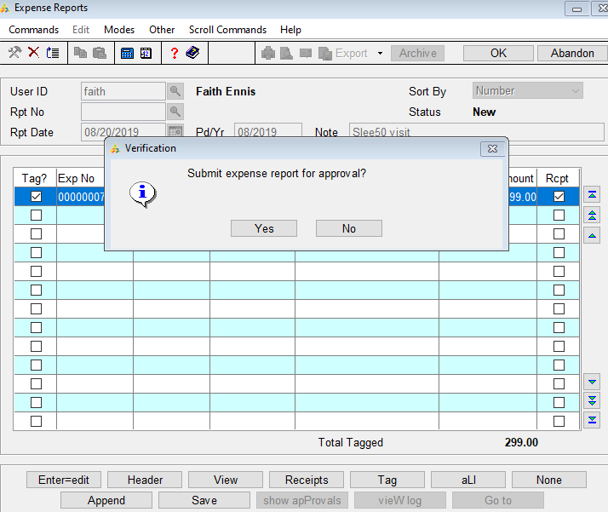

If YES, a notification window will appear listing the expense report number and the reimbursement amount on the report.

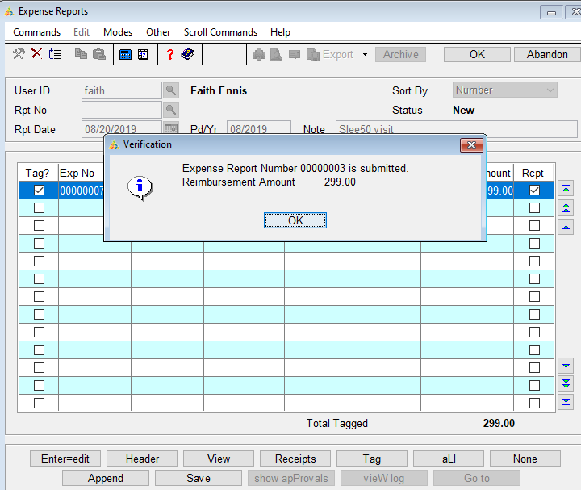

**Import Expense Sequence field** (if available). Select an expense to import that page down/ok to continue.

**hOld** (if available) to put the expense on hold. Only the user placing the hold can release it.

**Show aPprovals** (if available) to show approvers available to approve the expense report.

**Approve Expense Reports**

Edit, approve and audit expense reports for reimbursement. Expense reimbursement users who are not assigned to an approval group do not need to use this function. The expense reports submitted by those users are automatically approved. They **do** need to utilize the Audit Expense Reports function.

Select **Approve Expense Reports**

Select a report to approve and hit the Enter key

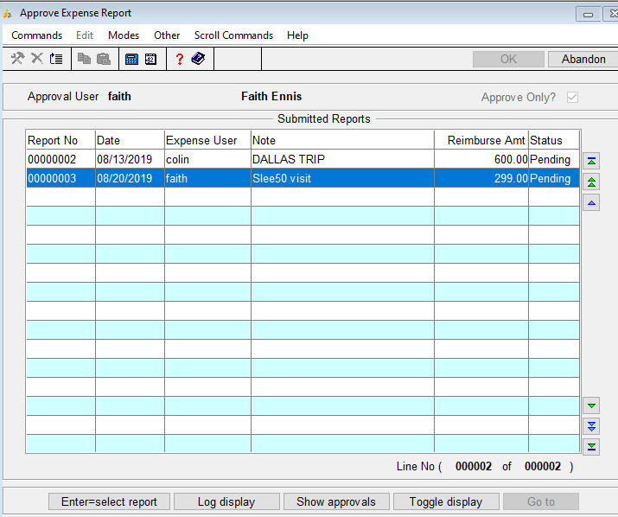

Press **A** to approve the expense report. Click the Approve button again to unapproved.

Press **D** to deny the expense report. Click the Deny button again to undeny.

Other options are to view details of the expense, view receipts, show approvals available for the report, go to the next report, view the approval log, toggle the Hold/Release status.

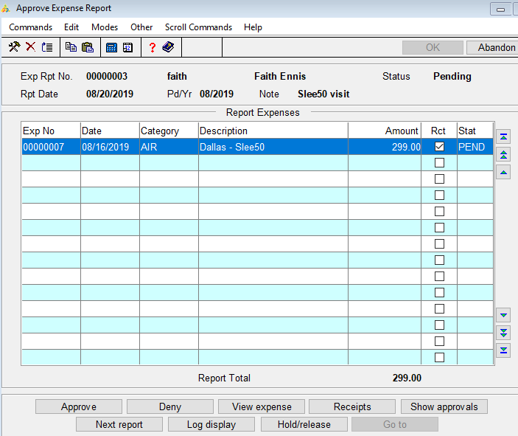

Whether approved or denied, a comment box appears after selection. This is optional.

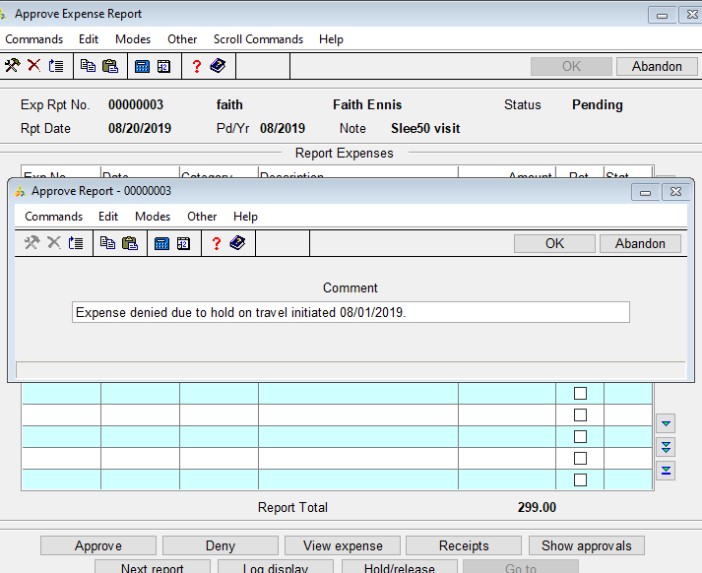

You can also view the expense record, view the expense receipts, and show the approvers available.

**Log display**

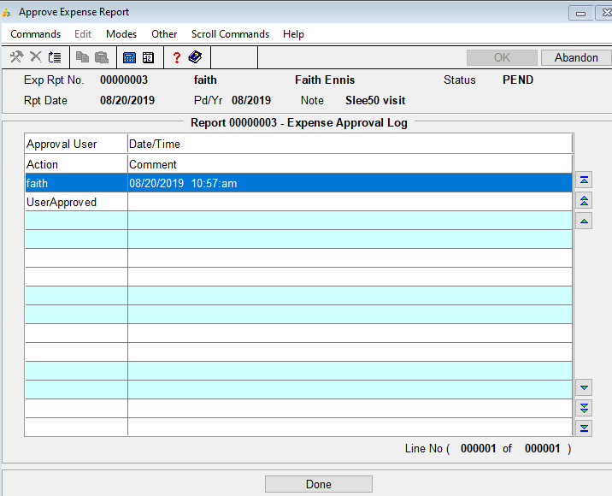



**Audit Expense Reports**

Review expense reports and print issues with any expense entry submitted.

Select **Audit Expense Reports, page down/OK.**

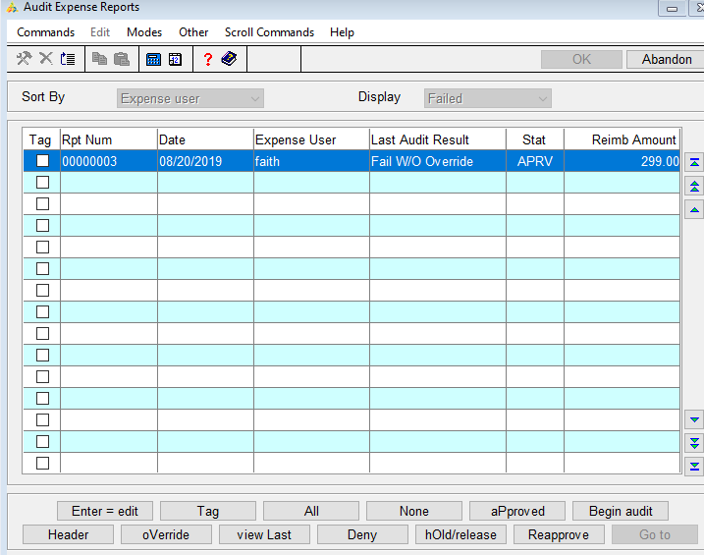

Select an expense. Options to edit, tag (reports will be audited), tag all, clear all, or tag all report with approved status.

Select Begin audit to audit tagged reports.

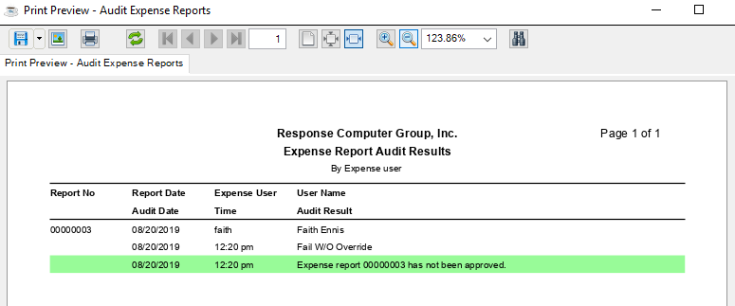

Select override to override audit failures for the report or to clear prior override.

**Expense Report Journal**

Use the Expense Report Journal to check expenses before posting the expense reports.

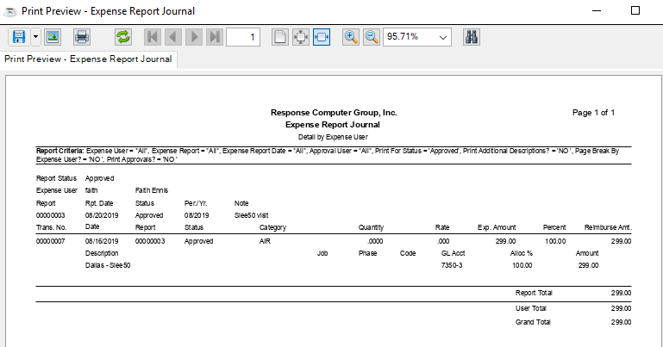

**Post Expense Reports**

Post reimbursement expenses. Posting will NOT create GL entries but will post to either AP or PO transactions.

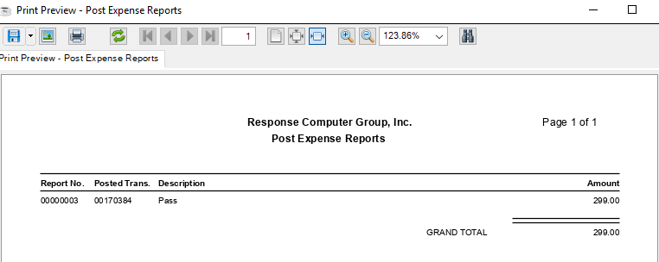

Transaction shows in AP or PO as a transaction ready to be posted.

