OSAS

Account Payable

Fix Open Invoices

This is a modification available for purchase.

Fix Open Invoices is just that, a fix to AP/PO ONLY. It does not correct GL, Inventory, Bank Reconciliation, etc. If you delete an invoice through Fix Open Invoices, there is no audit trail.

Fix Open Invoices is best used for correcting dates and check numbers. We suggest using caution when correcting amounts or deleting invoices through Fix Open Invoices as the corrections/deletions cannot be traced.

Fix Open Invoices can only be used in Text version, not GUI.

Go to AP/PO

Go to Management Reports

Go to Fix Open Invoices

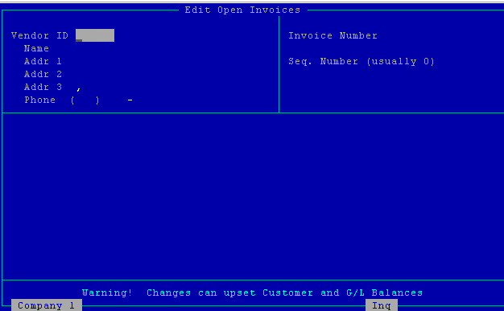

Vendor ID – Enter vendor ID

Invoice Number –hit F2 and select from the list. Looking at the date makes finding the invoice number easier if you use the same invoice number. Invoices that are paid will have a STAT as Z.

Seq. Number (usually 0)-Normally the sequence number is 000000. If you have used the same invoice number more than once, the sequence number will be 00000x (x = the x time the invoice number was used).

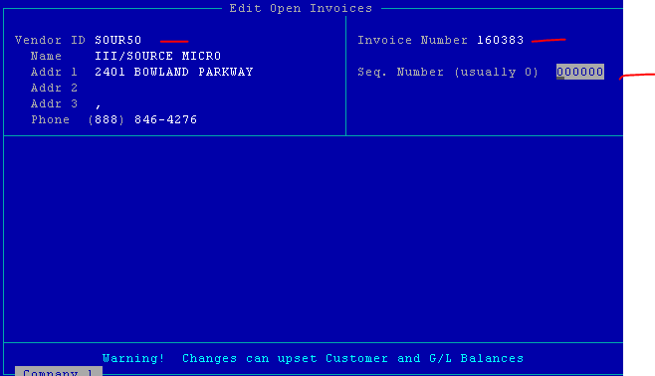

Once you hit enter, the invoice information will appear at the bottom of the screen.

Hit F3 to Delete (this will not update GL)

Or

Hit enter to the date field(s) and change as needed then page down.

Make sure the GL year is also correct.

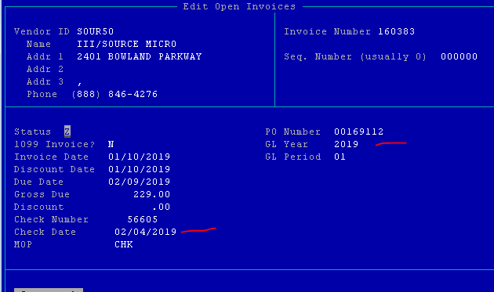

Or

Hit enter to the check number field, change as needed then page down.

Or

Hit enter to an amount field, change as needed then page down (this will not update GL).

Or

Up arrow to the Vendor ID, change as needed then page down. This is useful if you enter an invoice to the wrong vendor and need to change it before printing the check. AP history is not updated.