AP/PO

OSAS V8.0

1099’s

The accumulation of 1099 payment information begins at the time you set the vendor up as a 1099 payment vendor.

To set up a vendor for a 1099:

Go to AP/PO

Go to File Maintenance

Go to Vendors

Select Vendor Codes

1099:

Form Code is either **I**ndividual, **B**usiness, **N**o form

Recipient ID: Individual – enter Social Security #

Business – enter Federal ID #

Field Indic: Options are 1-3, 5-9, A-E. By entering each option the description of that option will appear. (ie: 1-Rents, 7-Nonemployee)

Foreign Addr? If the vendor has a foreign address enter Y or check the box, otherwise N.

2nd TIN Not? If you have been notified by the IRS twice in the last three years that the Recipient tax ID is incorrect, enter Y, otherwise N.

FATCA Requirement? If this vendor is used for satisfying your FATCA filing requirements, enter Y, otherwise N.

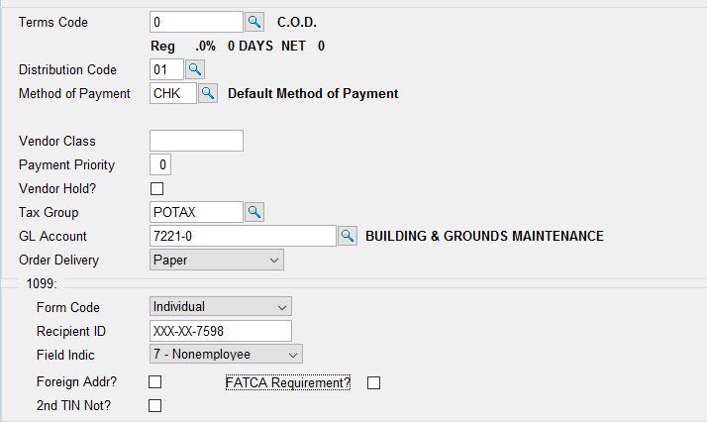

For editing the actual 1099 payments for the vendor you will first need to determine whether you have closed out your year and “moved 1099 payments to last year” or whether the 1099 payments are still in the current year (Year to Date).

At 12/31 you will need to move your 1099 payments to last year whether or not this is your fiscal year end. Moving the payments to last year will clear out the current year 1099 payments to allow you to start accumulating for the next year.

If you forgot to move 1099 payments to last year you can run that now and adjust both your current year and last year amounts for the 1099 vendors for both years.

Adjust 1099 Amounts:

Go to AP/PO

Go to Periodic Processing

Go to Edit 1099 Amounts

Show: All 1099 Vendors or only Vendors with Variances

Year: Current year or Last year

All 1099 vendors or vendors with 1099 variances will display, showing their current or last year 1099 amount, 1099 invoice total and non credit card invoice total, at the top.

Highlight a vendor and the invoices associated with that vendors 1099 amount will display at the bottom.

(V)endor amounts or (A)ll amounts will allow editing of the 1099 amounts easily.

If you make any changes to the 1099 amounts, once you exit the screen the 1099 amounts in Vendors/File Maintenance/History Information will be updated.

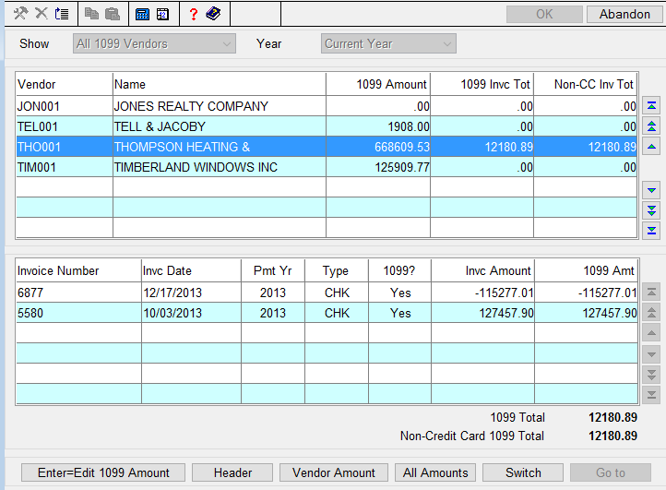

Or you can edit 1099 amounts in File Maintenance.

Go to AP/PO

Go to File Maintenance

Go to Vendors

Select History Information

Enter to 1099 Payments and edit Year to Date (current year 1099 amounts) or Last Year 1099 amounts.

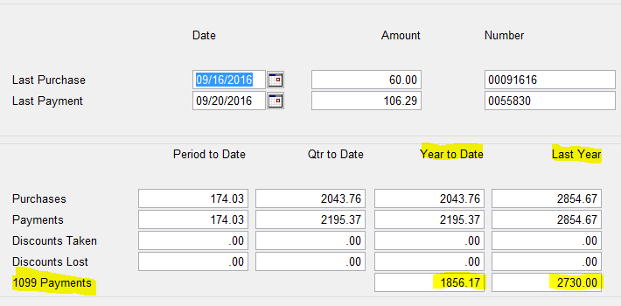

Once 1099 amounts are correct run the 1099 worksheet.

Go to AP/PO

Go to Periodic Processing

Go to 1099 Forms

Print for either 1099-MISC or 1099-NEC or Magnetic Media.

