OSAS

AP/PO

Open Order Report

An Open Order Report shows PO’s that have been entered and printed, received and not received, not invoiced, returned, and cancelled orders by selection.

**AP/PO**

**Transactions Reports**

**Open Order Report**

Leave all fields blank to see all orders by all vendors for all items and jobs by all requested dates.

If you only want to see specific fields, enter data as needed.

**Status**: to see all open PO’s, no matter the status, select All, otherwise select a status.

**Print By**: select an option to print the report.

**Select**: click to included each option as needed. (We suggest selecting all and uncheck as needed).

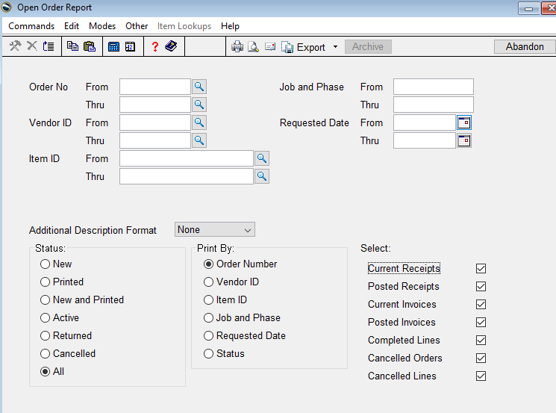

The report shows each order and line item, how much was ordered and what has been received and or invoiced.

