Open Systems

Accounts Payable

Posting to Invoice File and History File are Different

If the amount posted to the vendor file and history file on a posting sheet are different (example shows the same amount), the following can be done to correct AP/PO.

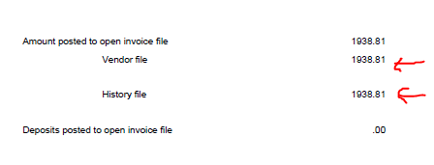

Figure out the amount not posted to the vendor file and find that amount on the purchases or return journals.

Verify the amount is not showing in Hold/Release Invoices. Go to AP/PO, Pay Invoices, Hold/Release Invoices, enter vendor ID and verify the invoice showing on the journal is not displayed.

Enter the invoice in question again, run journal, post.

The invoice has now posted to the invoice file, history file (again), and GL (again).

Since it posted to GL twice, one of the GL posts needs to be deleted.

To correct GL:

Go to GL, Journal Transactions, Edit Transactions.

Hit the END key to go to the end of the file.

The last entries should be what was just posted.

Hit enter at one of the entries. The following message will appear.

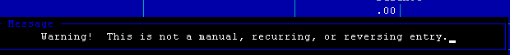

Hit enter to proceed.

Change the amount in the debit and credit columns to zero (0).

The GL balance at the bottom of the screen should be zero after all entries associated with the post have been changed to zero (0).

