AP/PO

OSAS

Processing Prepaids through OSAS

After prepaying AP invoices with a manual check number, ACH, or CC, do the following to process the payment through OSAS:

Pay Invoices/Prepare Payments

Invoices Due – enter the date of 01/01/1901.

A warning message that the date may be invalid will display, hit enter to proceed.

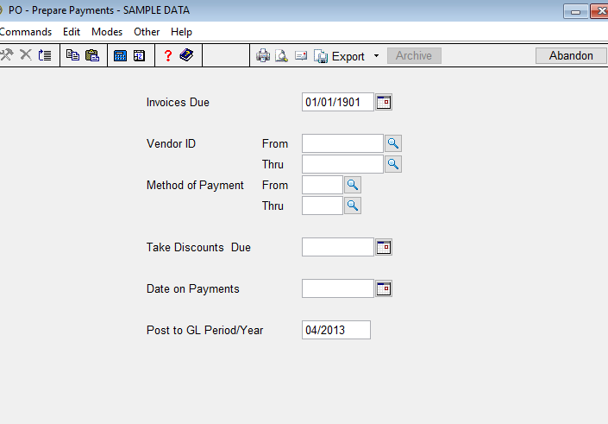

Take Discounts Due – Enter the date of 01/01/1901.

A warning message that the date may be invalid will display, hit enter to proceed.

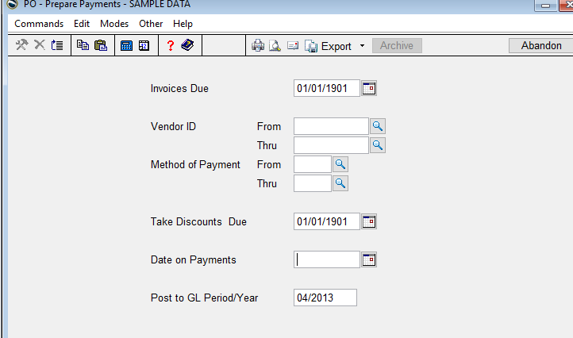

Date on Payments – Enter today’s date. The date of each prepaid will actually post.

The only column with an amount should be the Prepaid Checks and/or Deposits (if used).

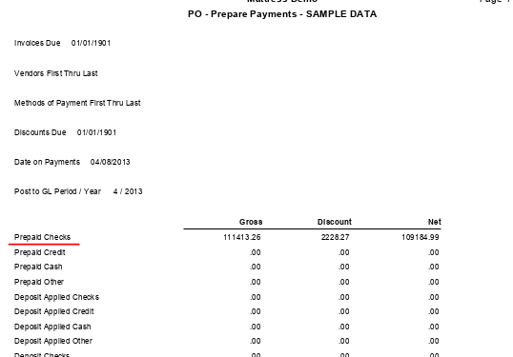

Print the Payment Register. You don’t have to print the edit register because checks don’t need to be printed.

All payments should show under Prepaid Payments. Nothing will show under Checks to Print.

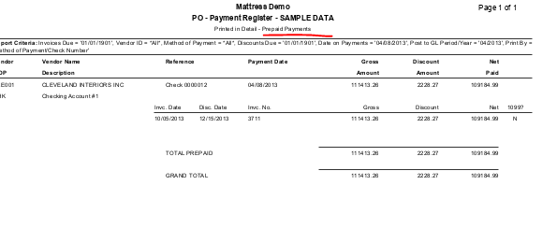

Final step is to Post Payments.

