OSAS
Accounts Payable/Purchase Order

Printing Checks-Start to Finish

After all A/P invoices have been entered and posted, checks for invoices can be printed.
First you will need a report that lists the invoices that are open or due as of a certain date.

- Go to Accounts Payable/Purchase Order.
- Go to Management Reports.
- Go to Open Invoice Report
- Pick Vendor ID-Hit enter through the From and Thru fields to pick all the vendors or enter a range or one specific vendor.
- Pick Invoices Due-Enter the due date that you wish to pay invoices through. Example: If today is 01/0718 and you would like to pay all invoices due through 01/14/18, enter 01/14/18 in this field. If you would like a list of all invoices unpaid enter a date way in advance such as 12/31/2018 or 12/31/9999. If using 9999 you will get a message that the date may be invalid, just hit enter.
- Take Discounts Due-Enter the same date that was entered in the Pick Invoices Due field or a date that will allow the discount to be taken.
- Print-Select #4 – All unpaid invoices.
The report will print. If you have posted invoices as Released look through the report and make sure those are the invoices you want to pay or mark which invoices you would like to pay. If you have posted invoices as Held look through the report and mark which invoices you would like to pay.

If you posted the invoices as HELD during Post Transactions then the invoices that you would like to pay need to be released. If you do not post as held during Post Transactions skip this section.
- Go to Pay Invoices
- Go to Hold/Release Invoices.
- Enter the vendor ID of the payable you will be paying. Arrow to the invoice that is to be paid and hit the letter H to change the status from H to R. You can hit the letter H again to change to T for Temporary Hold, R for Released, or H for Hold.
- Repeat this procedure for all invoices that are to be paid.
- For invoices that are posted as NOT HELD, you can hit H to change the status from Released to Held, or change the due date to a future date to pay at a later time.

*New in version 8*
Whether an invoice in Hold/Release Invoices is on Hold or Released you can print an on-demand check.
When in Hold/Release, a vendor’s unpaid invoice screen will look similar to below.
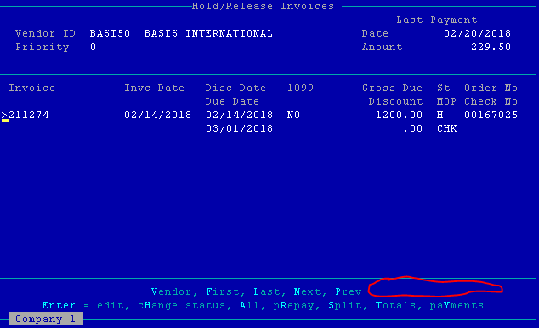
To print an on demand check from Hold/Release Invoices, hit R for Prepay and enter the MOP, check number, and payment date.
For more than one invoice, hit P for Prepay and enter the same MOP, check number, and payment date for all invoices to print on a check.

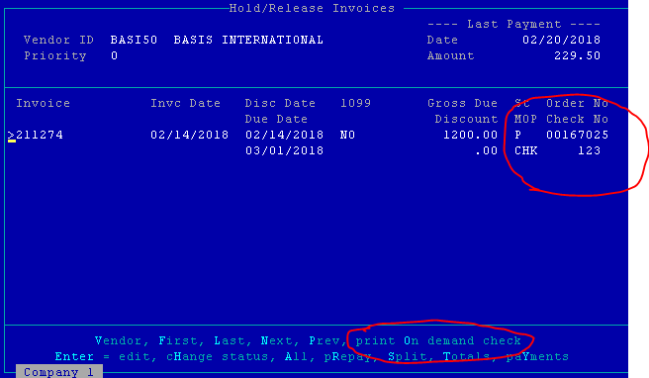
A new option at the bottom of the screen will appear “Print On Demand Check”.
Select O for print on demand check to print a check.
Once O is selected, you are prompted to select an output (printer) and printer number.
This invoice now becomes prepaid. When running your normal check run, this invoice will not print a check but will show on the Edit Register as Prepaid.

The invoices that need to be paid now need to be prepared.
- Go to Pay Invoices.
- Go to Prepare Payments.
- Pick Invoices Due-Enter the due date that you wish to pay invoices through. Example: If today is 01/07/18 and you would like to pay all invoices due through 01/14/18, enter 01/14/18 in this field. See #5 in Pick Invoices Due for other explanations.
- Vendor ID From/Thru-Hit enter through both fields to include all vendors.
- Method of Payment From/Thru-Hit enter through both fields to include all MOP.
- Take Discounts Due-Enter the same date that was entered in the Pick Invoices Due field.
- Date on Checks-Enter the date that should appear on the check. Remember if you would like today’s date hit the D key.
- Post to GL Period-The GL period will default to the GL period corresponding with the date on the checks. If you would like another GL period enter it.
- Page down and print to a printer.

The report will show the amount of Prepaid Checks (checks that have been entered manually) and the amount of Checks to Print (checks that you will soon write a check for.) To see a report of what makes up the total appearing in Prepaid Checks and Checks to Print you will need to print the Edit Register.
- Go to Pay Invoices.
- Go to Edit Register.
- Print the report. A list of all the vendors and their invoices will appear. Check to make sure these are the invoices you wish to pay. If everything is ok proceed with printing the checks.
If the list is not correct you will need to go back to Prepare Payments, answer YES to the question that appears at the bottom of the screen “Checks already on file, do you want to start over”. After answering YES, F7 out and go to Hold/Release Invoices, make any necessary changes, and then Prepare Payments again.

Whenever you Prepare Payments and have not posted checks a message will appear that checks are on file, do you want to start again. If this is the first time you are preparing checks for this day you should print the check register to see what checks are on file. The post checks function was probably not done the last time you printed checks.

To print the checks:
- Go to Pay Invoices.
- Go to Print Checks.
- Use Check Saver-If a vendor’s check will have more then ten invoices to pay, the check saver function will allow you to print the list of invoices on plain paper at the end of the check run rather then void checks printing the list of invoices. Answer YES or NO.
- Print Checks for MOP-CHK will default, hit enter or select another from the list.
- First Check Number-Enter the first check number.
- Put the checks in the printer and prepare to print. Some printers require a paper feed before the checks print; you may want to watch for this.

After the checks have printed, print the check register.
- Go to Pay Invoices.
- Go to Payment Register.
- Print the report.
If the checks did not print correctly and you need to reprint go back to print checks and start again or enter the last good check that printed in the If Restart, Last Good Check Number field and all checks from that point on will only print.

The final function is to post the checks. After the checks have been posted you will not be able to reprint the checks.
- Go to Pay Invoices.
- Go to Post Payments.
- Post to the correct year for GL and 1099 purposes and if interfaced with Bank Rec select the correct bank account.

