PURCHASE ORDER

ENTERING PURCHASE ORDERS, RECEIVING, INVOICING

NEW PURCHASE ORDER

- Go to Purchase Order
- Go to Daily Work
- Go to Enter Orders
- Enter 1 to enter the new Purchase Order and hit enter. To enter the new purchase order, receive the goods, and apply the invoice all at the same time enter 3 and hit enter.
- Purchase Order No - Enter an eight digit PO number that is different from any other PO number that has been entered or if the PO is system generated the number will appear.
- Location – Enter the location ID or hit enter to accept the default.
- Vendor ID-Enter the vendor ID or hit F2 to look up from the list. If this is a new vendor hit F6 to enter the vendor, after vendor is added and you have paged down, hit F7 to go back to enter orders. You may also enter TEMP as the vendor ID, hit enter then enter the name and address for those one time only vendors. The system assigns each temporary vendor an ID that consists of a “+” sign and a five digit number. When the temporary vendor has a zero balance you can remove the vendor file through purge selected files.
- Terms-Should default from the vendor master file, otherwise hit F2 and look up.
- Notes-Enter any notes that you wish. Notes will appear under the vendor name and address on the Purchase Order.
- Enter any other company required fields on this screen and hit enter.
- Page down to accept this information and continue to the next page.
- Item ID-Enter the inventory ID of the inventory item you are ordering or hit F2 and look up from the list. If you are not using inventory, hit enter and go to the description field.
- Desc-The inventory ID description will appear. You may add more information to the additional eleven lines that appear when enter is hit.
- GL Account – If using an inventory ID the GL account will default. Hit enter to accept or enter a different GL account number.
- Hit enter until you get to the Quantity field.
- Quantity-Enter the quantity ordered amount.
- Units-Hit enter to accept the default of hit F2 and select from the list.
- Unit Cost-Enter the cost of the item(s) ordered.
- Ext Cost-Quantity x Unit Cost will be the extended cost. Hit enter.
- Page down to accept the information. Repeat the purchase order line item procedure until all items for an order have been entered. When finished, the cursor will be at the Item ID field, hit F7 to exit to the edit screen.
- At this point you are at the Edit Screen. You can enter another line item to this order by hitting A. You can edit a line item by placing the cursor by the line to be changed and hitting enter. You can print an online Purchase order by hitting O. You can enter N to go to the next transaction.

PURCHASE ORDER
RECEIVING GOODS

- Go to Purchase Order
- Go to Daily Work
- Go to Enter Orders
- Enter 5 for Receiving Goods
- Enter the Purchase Order number of the order you are receiving goods on or hit F2 and look up the order from the list.
- A message will appear-Receive All? Enter Y if everything ordered is received or enter N if everything ordered is not received.
- If Y was entered you will be prompted for a receipt number. Enter a receipt number or leave the field blank, enter the receiving date, and page down. Even if you hit Y to receive all, you can still change the quantity received by hitting R and correcting the quantity received.
- If N was entered you will go to the edit screen. The cursor will be by the first line item. Hit R to receive, enter the receipt number (normally just hit enter), enter the receiving date, and the quantity received. Repeat for each line item that is to be received.
- When all items have been received hit N for the next transaction.

PURCHASE ORDER
UNRECEIVING GOODS THAT HAVE NOT BEEN POSTED
(posted means post transactions has been run)

If a purchase journal (and other reports related to posting) has not been printed and posted since the purchase order was received you can unreceive the purchase order.

- Go to Purchase Order
- Go to Daily Work
- Go to Enter Orders
- Enter 4 for Edit Orders
- Enter the Purchase Order number of the order you are unreceiving goods on or hit F2 and look up the order from the list.
- Page down to the edit screen.
- Hit R to unreceive, enter the original receipt number (normally just hit enter) or hit F2 and select from the list and enter through the receiving date. Enter zero at quantity. This will unreceive the items for that line item. Repeat for each line item that is to be unreceived.
- When all items have been unreceived hit N for the next transaction.
The purchase order is still open at this point. You can receive items again or cancel the entire purchase order (because the vendor ID is incorrect).
To receive items again follow the instructions under Receiving Goods.
To cancel the entire purchase order:
- Go to each line item and hit enter.
- Up arrow to the line status field.
- Enter CAN and hit enter. The word CANCELLED will appear in the line status field.
- Repeat for each line item that is to be cancelled.
- The next time the purchase journal (and other reports related to posting) is printed and posted this purchase order will be erased.
- If the reason for canceling the purchase order was due to an incorrect vendor ID, then you must reenter a purchase order and receive the purchase order using the correct vendor ID, the same inventory ID(s), the same quantities, and the same price as the incorrect purchase order.

PURCHASE ORDER
UNRECEIVING GOODS THAT HAVE BEEN POSTED

If a purchase journal (and other reports related to posting) have been printed and posted since the purchase order was received you can not unreceive the purchase order. You must complete the purchase order by invoicing it, enter a return to cancel the purchase order, and reenter a purchase order and receive correctly (if needed). This same procedure can also be used to change an incorrect vendor ID.

- Go to Purchase Order
- Go to Daily Work
- Go to Enter Orders
- Enter 6 for Apply Invoices
- Enter the Purchase Order number of the order you are invoicing or hit F2 and look up the order from the list.
- The message Invoice All? will appear.
- Enter Y and hit enter.
- You will be prompted for an invoice number. This is a mandatory field. Enter the invoice number, invoice date, and page down.
- All items are invoiced at this point. Enter T for totals, I for invoice, the invoice number will appear. If the invoice number does not appear hit F2 and look up from the list. Hit enter.
- Enter any freight, misc expense, or sales tax (it will calculate itself). Page down. The amount that appears in the Payment 1 field should be the same as the total amount on the invoice.
- Now you will need to enter a return to back out the invoice.
- Go to Purchase Order
- Go to Daily Work
- Go to Enter Returns
- Enter 2 for Goods Returned and Debited.
- Return Number-this is just like a purchase order number. Enter a distinctive number and hit enter
- Vendor ID – Enter the same vendor ID as the original purchase order. If you are correcting a purchase order because of an incorrect vendor ID you the incorrect vendor ID.
- Page down.
- Enter the same inventory ID’s, the same quantities, and the same price from the original purchase order.
- RA No – Hit enter for the RA number and date and page down.
- Memo No – Enter the same invoice number used when invoicing the original purchase order as well as the same cost.
- All items are returned at this point. Enter T for totals, D for debit, the invoice number will appear. If the invoice number does not appear hit F2 and look up from the list. Hit enter.
- Enter any freight, misc expense, or sales tax (it will calculate itself) just like the original invoice. Page down. The amount that appears in the Net Return field should be the same as the total amount on the original invoice.
The original purchase order (that had items received incorrectly) and the return have now been entered. They cancel each other out. This also cancels the inventory items out.
Enter and receive items correctly now by entering a new purchase order.

PURCHASE ORDER
APPLYING INVOICES

- Go to Purchase Order
- Go to Daily Work
- Go to Enter Orders
- Enter 6 for Applying Invoices
- Enter the Purchase Order number of the order you are invoicing items on or hit F2 and look up the order from the list.
- A message will appear-Invoice all? Enter Y if everything received is to be invoiced or enter N if everything received is not to be invoiced.
- Enter Y and hit enter.
- If Y was entered you will be prompted for an invoice number. This is a mandatory field. Enter the invoice number and invoice date and page down. If no invoice number is shown on the invoice, enter a distinctive invoice number (ie: 090505=date)
- If N was entered you will go to the edit screen. Manually move the cursor to each line item and hit A to apply the invoice; enter the invoice number and invoice date, enter the quantity invoicing and make sure the unit cost is correct.
- When all items have been invoiced as shown on your invoice enter T for totals, I for invoice, the invoice number will appear. If the invoice number does not appear hit F2 and look up from the list. Hit enter.
- Enter any freight, misc expense or sales tax (it will calculate itself). Page down. The amount that appears in the Payment 1 field should be the same as the total amount on the invoice.
- Page Down.
- Hit N for the next transaction.

Items that are invoiced at a different price then the price received will have a month-to-date COGS adjustment if the received item is sold before it is invoiced.
The MTD COGS Adjustment journal will need to be printed and posted at month end.
- Go to Inventory
- Go to Daily Work
- Go to GL Adjustments Journal
- Enter the location for the GL Adjustment Journal or hit enter in the From and Thru field if all locations are needed.
- Enter the Item ID in the From and Thru field or hit enter in both of these fields if you are printing the journal for all inventory items.
- Print by: 1, Item, location.
- Page down.
- P to print, select printer ID.
- Go to Post GL Adjustments
- Answer YES that you have printed the journal and backed up.
- Post to the correct year.
- Page down.
- P to print, select printer ID.

PURCHASE ORDER
RECEIVING AND APPLYING INVOICES AT THE SAME TIME

- Go to Purchase Order
- Go to Daily Work
- Go to Enter Orders
- Enter 7 for Receiving/Applying Invoices
- Enter the Purchase Order number of the order you are invoicing items on or hit F2 and look up the order from the list.
- A message will appear-Receive and Invoice All? Enter Y if everything is to be received and invoiced as shown on the purchase order or enter N if everything is not to be received and invoiced as shown on the purchase order.
- If Y was entered you will be prompted for a receipt number. Enter a receipt number or hit enter at receipt number and page down. You will then be prompted for an invoice number. This is a mandatory field. Enter the invoice number and invoice date from the invoice. If the invoice does not have an invoice number enter a distinctive invoice number (ie: 090505=date), enter the quantity invoicing and make sure the unit cost is correct, and page down.
- If N was entered you will go to the edit screen. Manually move the cursor to each line item and hit A to receive and apply the invoice; enter a receipt number or hit enter at the receipt number and page down, enter the invoice number and invoice date from the invoice. If the invoice does not have an invoice number enter a distinctive invoice number (ie: 090505=date), enter the quantity invoicing and make sure the unit cost is correct. Page down.
- When all items have been received and invoiced as shown on your invoice enter T for totals, I for invoice, the invoice number will appear. If the invoice number does not appear hit F2 and look up from the list. Hit enter.
- Enter any freight, misc expense or sales tax (it will calculate itself). Page down. The amount that appears in the Payment 1 field should be the same as the total amount on the invoice.
- Page Down.
- Hit N for the next transaction.

PURCHASE ORDER
ENTERING A PREPAYMENT OR DEPOSIT AMOUNT

After receiving and invoicing a PO you can enter a prepayment to print an online check OR
After entering a PO you can enter a deposit amount to print a check.

Entering a deposit payment
After entering the PO, select D for Deposits
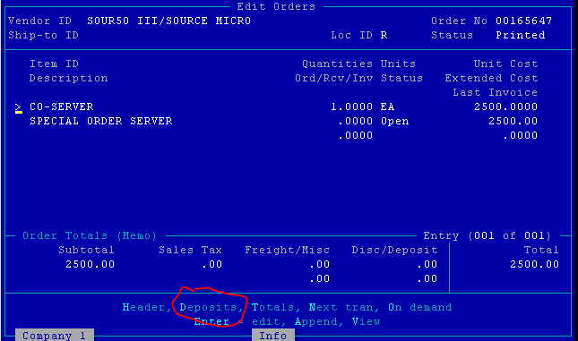
Enter the deposit amount, date, MOP, check number, and Yes or No if you want to print the check.
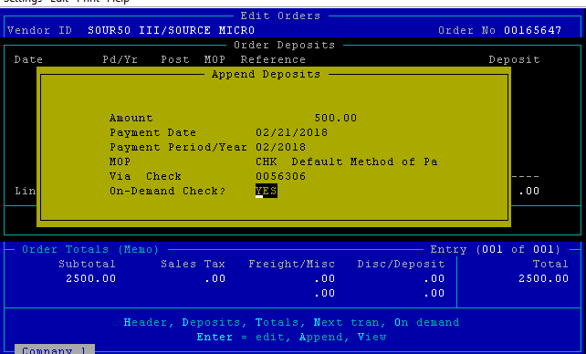
If YES to print an on-demand check, you will be prompted to page down, then select a printer to print the check.
If NO to print an on-demand check (the check was hand written or ACH/CC) you will be prompted to page down.

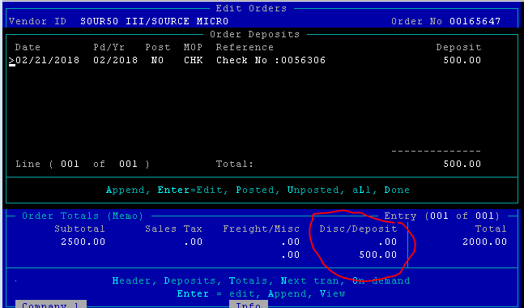

At this point you can delete the payment by hitting F3. The Disc/Deposit and Total fields return to their original amounts.
If the payment is correct, hit D for Done to accept the payment.
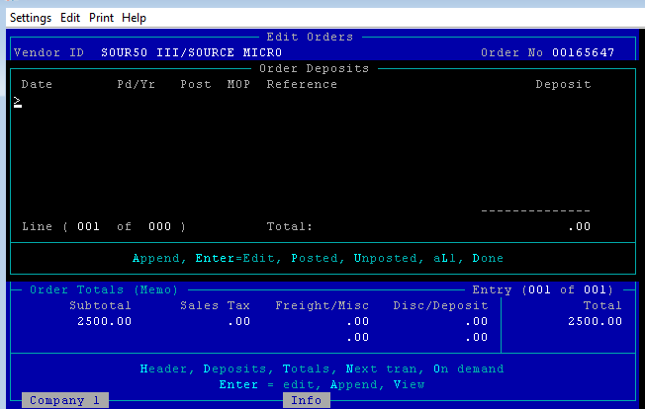

Entering a prepayment check
Receive and Invoice a PO, Select D for Deposits to enter a prepayment amount to print a check or just enter the check amount.
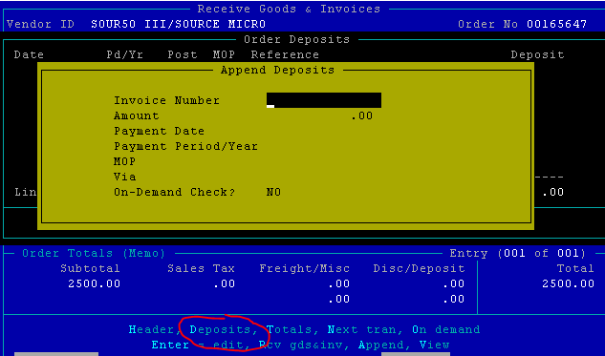

At the Invoice Number field, hit F2 to look up the invoice number and select from the list.
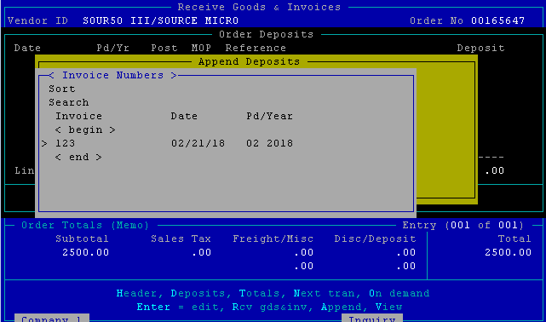

Enter the amount of the payment (partial or in full), date, MOP, and check number.
The amount paid can not exceed the invoice total.
Enter YES or NO if you want to print the check.
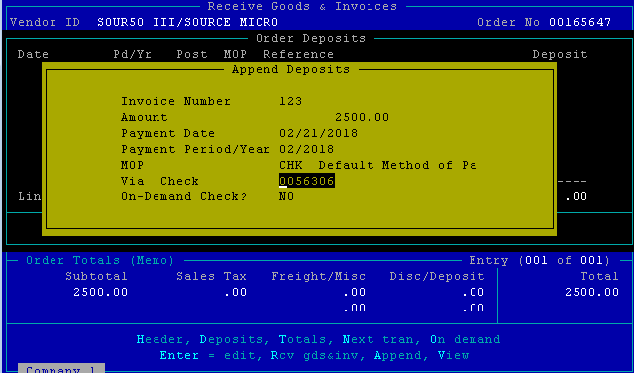

If the payment amount is correct hit D for Done to accept the payment.

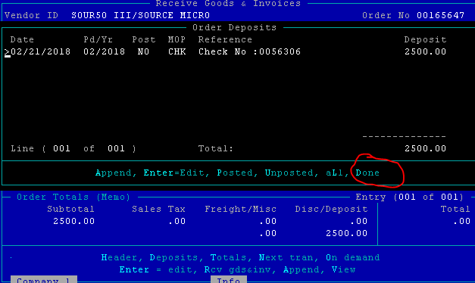

When you have completed your PO transactions, print the purchases journal, returns journal, receipts and invoices report, and post transactions. This will place invoiced PO’s in the Pay Invoices/Hold Release Invoice file.

