OSAS
PURCHASE ORDER
ENTERING A PREPAID PURCHASE ORDER

If a purchase needs to be prepaid before receiving and invoicing the purchase order the following must be done.

Make sure that you are able to print online checks.
Go to Resource Manager
Go to Company Set up
Go to Options and Interfaces
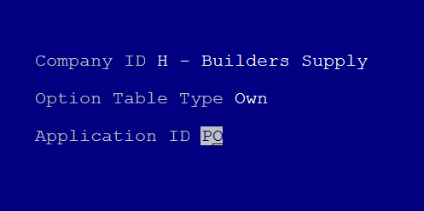
Enter PO for the Application ID and hit enter.
(company ID will be your company ID-this is an example)

Go to Option 11, Allow printing of online checks?
IF the value is YES, hit F7 to exit and proceed with Step 1.
If the value is NO, hit enter to change the value to YES.
W to write
Yes to write the change.

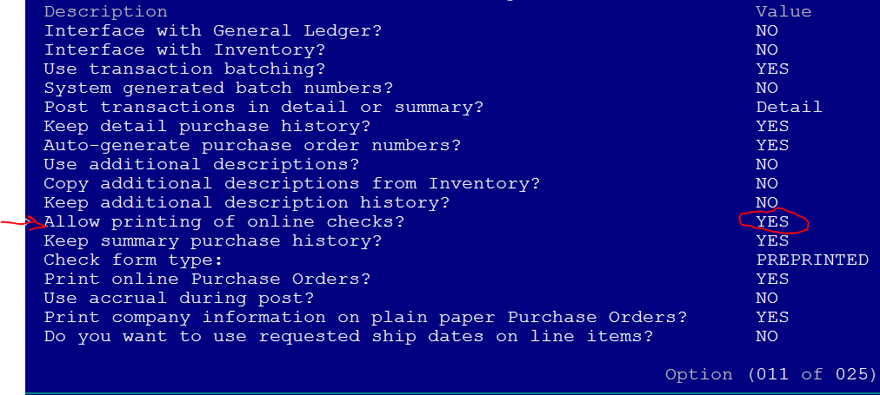

Step 1 This is to write the Deposit Check.
Go to Purchase Order
Go to Daily Work
Go to Enter Orders
Using #3, Goods Received and Invoiced, enter the purchase order to the vendor that is to be prepaid.
At Item ID do not enter an inventory number, hit enter to the description. The description should describe the prepayment. (To prepay Response Computer Group for service. See PO (you may have to edit this later) for original PO)
The GL account should be something other then inventory or purchases. Maybe miscellaneous expense.
Enter the quantity of 1 and the cost.
At T for totals and I for invoice enter the amount being paid (Prepayment), the check number, date, and YES to print online check. The balance due on this purchase order will be zero.
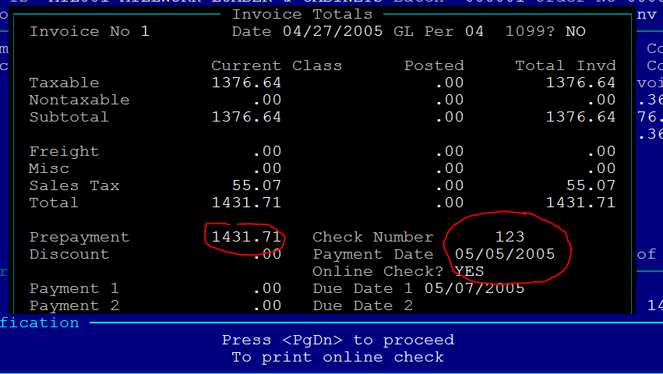

Step 2 This is to enter the PO so it can be received and invoice later.
Go to Purchase Order
Go to Daily Work
Go to Enter Orders
Using #1, New Order, enter a purchase order showing the inventory items that are to be ordered.
The last line item will be an offset to the prepayment. At the Item ID hit enter to the description field. At description enter “Prepayment paid on (date) with check (number)”
The GL account should be the same number used when entering the prepayment in step 1.
Enter the quantity of 1 as a positive number.
Enter the amount of the prepayment amount as a negative number.
Finish the purchase order as normal.
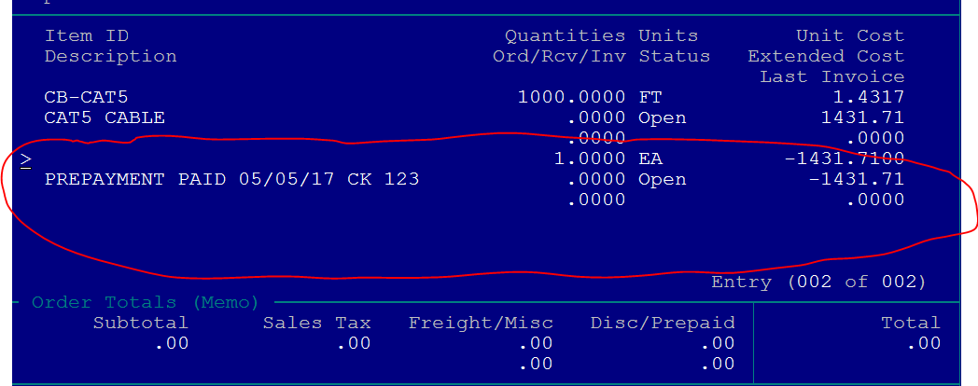

Now you have a purchase order to receive goods on. When receiving the PO make sure to receive the negative amount of the prepayment.
When the invoice is applied the total of this PO will be zero or the balance due less the prepayment.

