OSAS

AR/SO

MONTH END

**Make sure all Order/Invoices, Cash Receipts, and Credit Memos have been entered and posted.**

**Run Aged Trial Balance** (Open Invoices/Aged Trial Balance).

Scan ATB for things that may need to be corrected and correct as needed.

Balances of a few cents, credits not applied to invoices, etc.

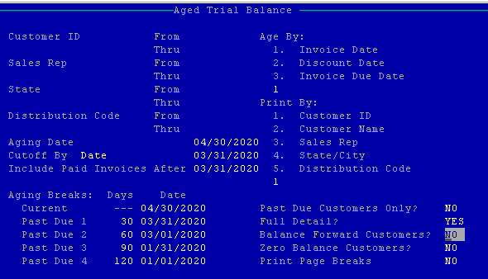

**Calculate Finance Charges** (Open Invoices/Calculate Finance Charges)- Optional

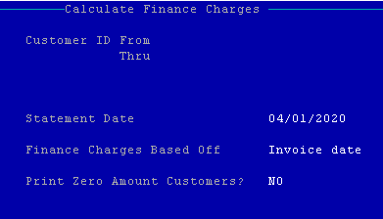

Calculated finance charges can be changed or zeroed by going to a Customers Credit and Balance Information screen in File Maintenance/Customers.

The calculated finance charge is displayed in New Finance Charges, change as/if needed.

The Finance Charge? Field is YES/NO for whether finance charges are calculated.

Finance Charges post when Month End is run.

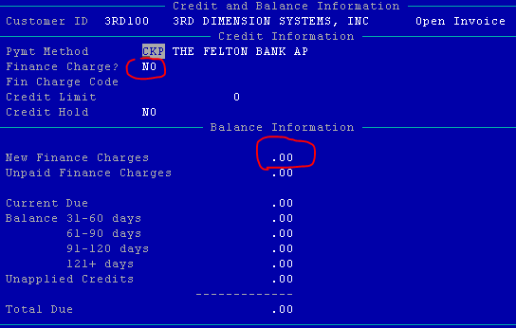

**Statements printed.**

Closing Date is the date that invoices need to be paid to avoid further finance charges.

Statement Date is the date that statements are printed.

Cutoff Date – Invoices with dates after the cutoff date will not be included in the aging report.

Include Paid Invoices After – Any paid invoices with dates on or after the date entered will be printed on the report.

Print YTD Finance Charge?-NO except for year end, then YES.

Print PO Number – Yes or No

Print Statements – make a selection.

Dunning Messages – Enter a General comment for all statements or a message for those customers with invoices 30/60/90 days old.

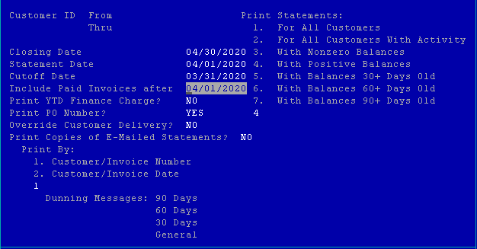

**Sales Tax Report** (Periodic Processing/Sales Tax Report)

This report can also be printed from Resource Manager/Sales Tax Reporting/Sales Tax Report.

**Clear Sales Tax** (Resource Manager/Sales Tax Reporting/Clear Sales Tax)

Sales tax amounts continue to accumulate until they are cleared, therefore for accurate totals, sales tax must be cleared at the end of each month.

**Commissions Report** (AR/Open Invoices/Commissions Report)

**Backup –** if your system was backed up overnight, that should be all your need.

**Month End** (Periodic Processing/Periodic Maintenance)

Make sure the Current Period/Fiscal Year shows the month that is ending.

If it does not, go to File Maintenance/Tables/ARPDx and update as needed.

The period/fiscal year showing is where finance charges will post.

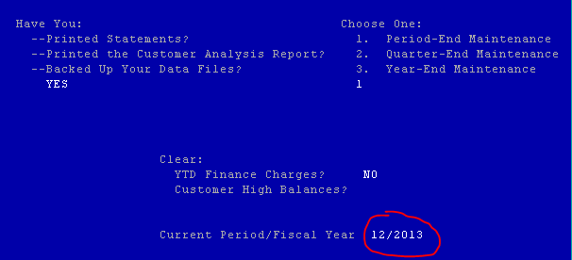

**Print Aged Trial Balance** (Open Invoices/Aged Trial Balance)

Make sure ATB balance matches GL AR ending balance for that period.

GL/Journal Transactions/GL Activity Report

Enter the Accounts Receivable GL account number in the Main Account from/thru fields.

Lines 1-4 under Headings can be updated by you.

Keep this report.

