OSAS

Split/Reapply Credits or Payments

Sales Order

Open Invoices

Aged Trial Balance

Check or answer YES to Full Detail.

The Unapplied column is all the way to the right.  Easy to see.

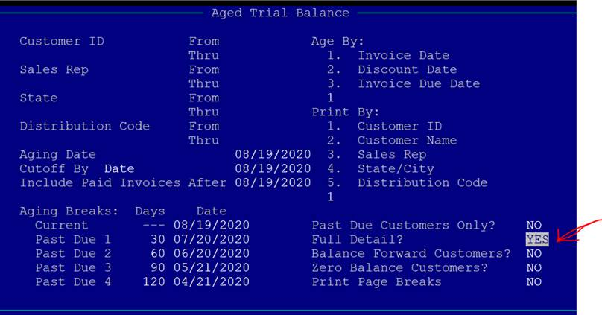

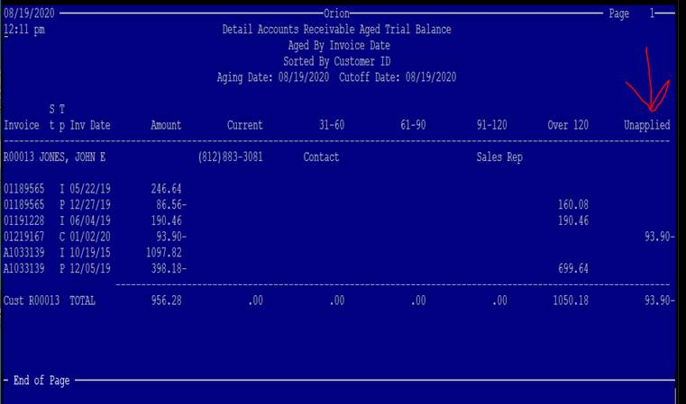

In Open Invoices/Hold Release Invoices, you can reapply the Unapplied to the invoice as needed.

Credits and Payments are the only Type that can be Reapplied.

Arrow to the Credit or Payment

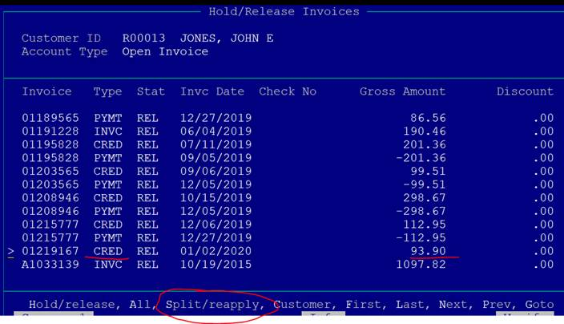

S to Split/Reapply

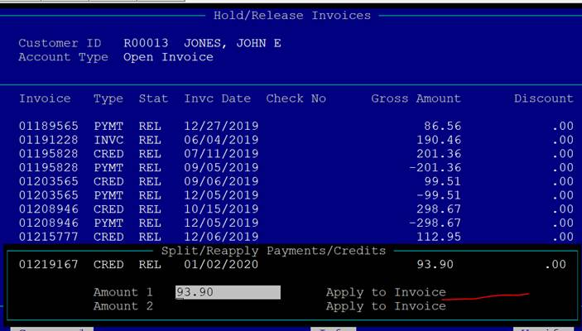

Enter the invoice number with all the preceding zeroes to apply the credit or payment to.

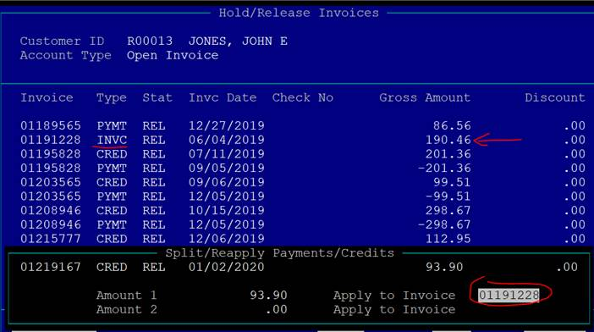

And it’s applied.

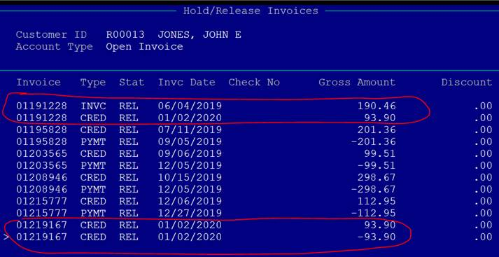

You can see in Cash Receipts that the Unapplied is gone and invoice 01191228 is reduced by the amount reapplied.

