OSAS
Sales Order
System Generated Order Numbers Turn On/Off

To turn off the system generated order numbers so a sales order number can be entered manually:
Go to Resource Manager
Go to Company Set Up
Go to Options and Interfaces
Option Table Type will show Share, hit enter.
Application ID-enter SO or AR
Use the arrow down key to arrow down to the seventh option which is System Generated Order Numbers.
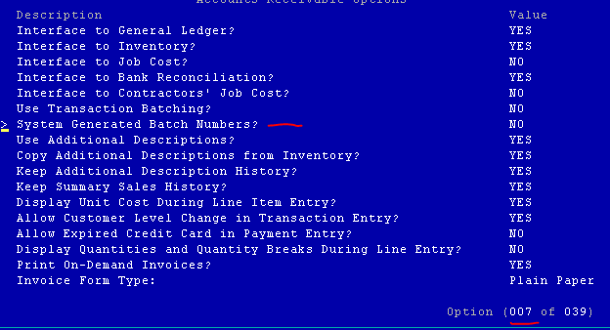
Hit enter to change the value from YES to NO.
Hit W to write the changes
Write Changes-enter Y for yes.
You will now be back at Application ID. Hit F7 to exit, then F7 to exit again.

You can now enter a sales order and manually enter the order number.

When you are ready to go back to having the system generate the order numbers do the following:
Go to Resource Manager
Go to Company Set Up
Go to Options and Interfaces
Option Table Type will show Share, hit enter.
Application ID – enter SO
Use the arrow down key to arrow down to the seventh option which is System Generated Order Numbers.
Hit enter to change the value from NO to YES.
Hit W to write the changes
Write Changes – enter Y for yes.
The system will now automatically give you a sales order number.

To change the starting sales order number:
Go to Sales Order
Go to File Maintenance
Go to Edit Sales Order Number
Enter the sales order number that you would like to appear the next time you enter sales orders.
Page down 2 times

You are now ready to enter sales orders and have the system generate the sales order number for you.

