OSAS
Account Payable or Accounts Receivable
Fix Open Invoices

This is a For Purchase modification.

Fix Open Invoices is just that, a fix to AP/PO or AR/SO ONLY. It does not correct GL, Inventory, Bank Reconciliation, etc. If you delete an invoice through Fix Open Invoices, there is no audit trail.

Fix Open Invoices is best used for correcting dates, customer or vendor ID’s, or check numbers. We suggest using caution when correcting amounts or deleting invoices through Fix Open Invoices as the corrections/deletions cannot be traced.

Fix Open Invoices can only be used in Text version, not GUI.

Go to AP/PO
Go to File Maintenance
Go to Fix Open Invoices
Vendor ID – Enter ID.
Invoice Number – Enter Invoice number or hit F2 and select from the list.
Seq. Number (usually 0)-Normally the sequence number is 000000. If you have used the same invoice number more than once, the sequence number will be 00000x (x = the x time the invoice number was used).
Once you hit enter, the invoice information will appear at the bottom of the screen.
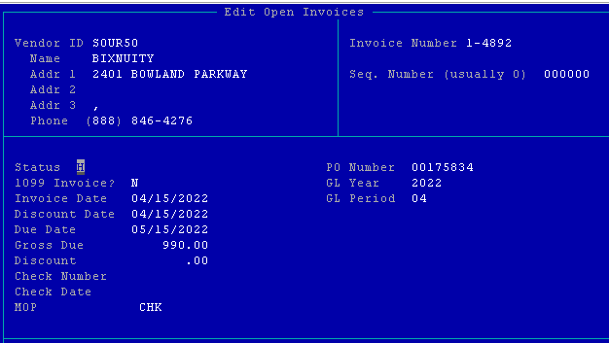

Hit enter to the date field(s) and change as needed then page down.
Or
Hit enter to the check number field, change as needed then page down.
Or
Hit enter to an amount field, change as needed then page down (this will not update GL).
Or
Up arrow to the Vendor ID, change to Vendor ID as needed then page down. This is useful if you enter an invoice to the wrong vendor and need to change it. AP history is not updated.

Go to AR/SO
Go to File Maintenance
Go to Fix Open Invoices
Customer ID – Enter ID.
Invoice Number – Enter Invoice number or hit F2 and select from the list.
Type Code – 1 if an invoice, 5 if a credit memo, 7 if a payment.
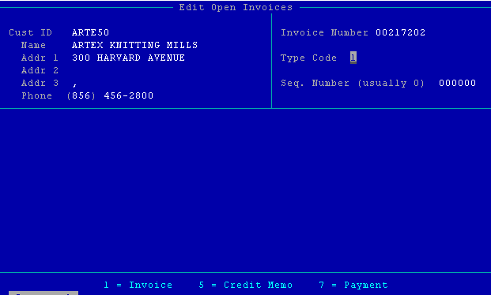

Seq. Number (usually 0)-Normally the sequence number is 000000. If you have used the same invoice number more than once, the sequence number will be 00000x (x = the x time the invoice number was used).

Once you hit enter, the invoice information will appear at the bottom of the screen.
AR/SO- Prompt will display at the bottom of the screen ‘Do you want to delete this invoice?’ – Always answer NO.

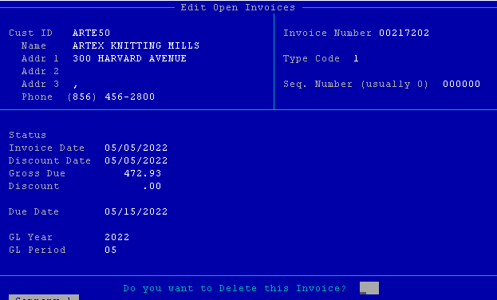

Hit enter to the date field(s) and change as needed then page down.
Or
Hit enter to the check number field, change as needed then page down.
Or
Hit enter to an amount field, change as needed then page down (this will not update GL and not recommended).
Or
Up arrow to the Customer ID, change to Customer ID as needed then page down. This is useful if you enter an invoice to the wrong customer and need to change it. AR history is not updated.

