Processing Sales Order RMAs
Returned Material Authorizations or RMA’s are a new enhancement added into the Sales Order application for OSAS v7.6x and allows the user to better process and record returned items. The feature is turned on by selecting a new option for the SO application. Regardless of the option you choose this document will guide you through the process of entering either a Return or an RMA.
Select your method of handling a return of goods, by answering the option “Use Return Processing?” with either a YES or No.
NOTE: Selecting “No” will allow for using the Miscellaneous Credits method of handling a return of product from a customer, in much the same way past versions of the software have.

Sales Order Options & Interfaces
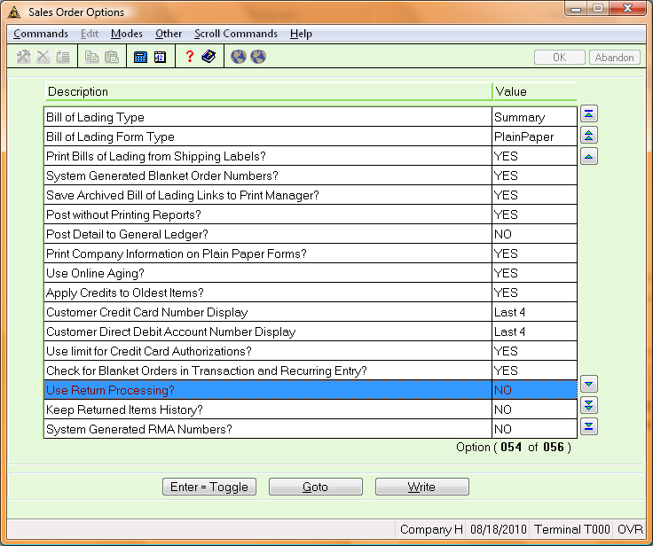
Option | Description
Use Return Processing | Select No if you wish to only process Miscellaneous Credits. If you wish to use the new RMA Functionality and additional options below select Yes.
Keep Return Items History? | Select Yes to keep history for Returned Items. If the option “Use Return Processing?” is set to no then this option will also be set to NO.
System Generated RMA Numbers? | Select YES to have the system Generate RMA numbers for you. If you select “NO”, the user will need to enter each RMA number to be used at the time of transaction entry.

“Use Return Processing?” is NO.

Process Description:
When the option “Use Return Processing?” is set to “NO”, then a Miscellaneous Credit is now a “Received RMA”. Process the transaction in the following manner:
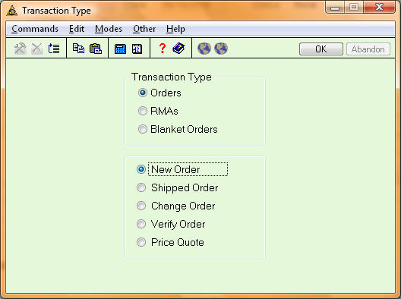
- Select the RMAs, the bottom choices will now change to the following.
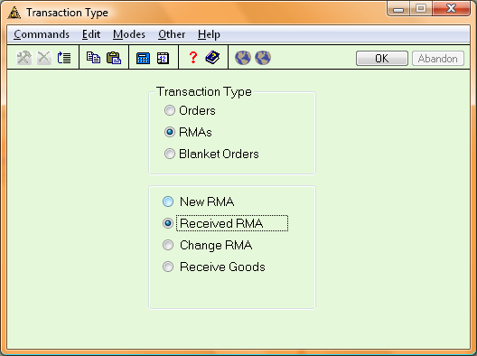
- After changing the Transaction Type from Orders to RMAs the lower portion of the screen will allow for RMA related transaction types. Click the ”Received RMA” choice and click the “OK” button or use the PGDN key to verify the selection.
The Sales Order header Screen appears.
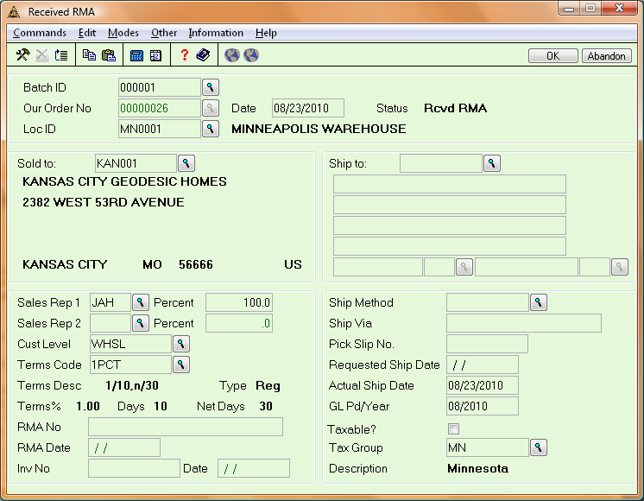
Two new fields appear at the bottom of the screen, they are “RMA No” and “RMA Date”. These fields are available for reference use when doing a Miscellaneous Credit (Return), they do not provide any future functional advantage for the user in this circumstance.
NOTE: When changing the status of a Received RMA to a Miscellaneous Credit the RMA No field will become Order No.
- Enter all of the necessary information per normal order entry on the header screen and use the PGDN key or Verify Command to write that information.
Your Line Item entry screen will appear.
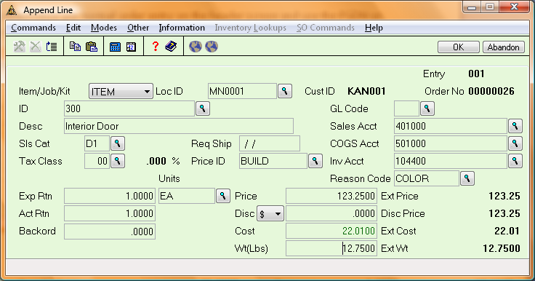
- Proceed to enter the necessary information for the line item you wish to return. In addition to the normal line item entry information you will see a “Reason Code” field. Although it is not required, entering a reason for the return will enhance the processing and available information posted to history in the future. Click the “OK” button or press PGDN to complete your line item entry.
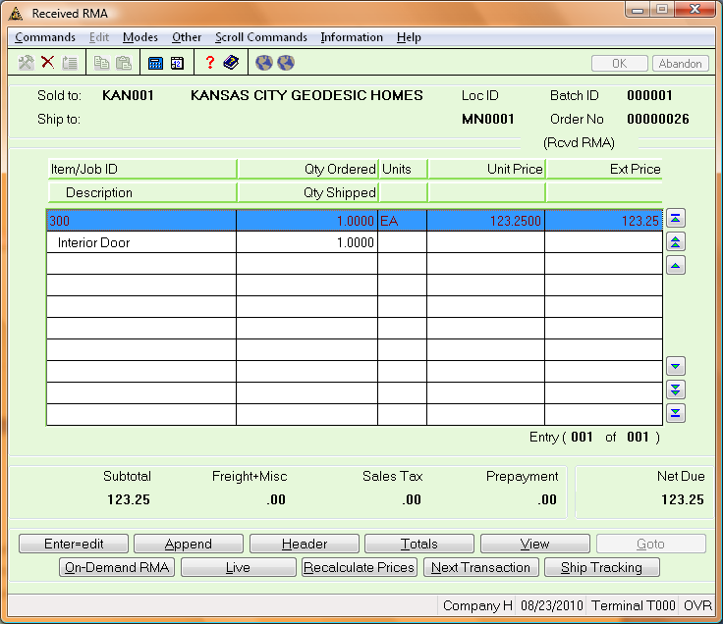
- To continue processing your return you will need to change your received RMA to a status of “Live” by clicking on the “Yes” button to “Change Status to Miscellaneous Credit”.
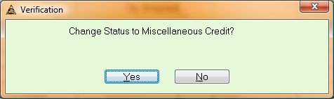
This process will change the status of your received RMA to that of a Miscellaneous Credit. You may now process your Miscellaneous Credit as you have in the past. Options include printing an On-Demand Invoice (Note: The On-Demand RMA button label has changed with the status of the order) if the option has been selected.
- Proceed to Print Invoices if needed and print the Miscellaneous Credits Journal before posting to complete the process.

“Use Return Processing?” is “Yes”

Process Description:
Choose additional option functionality by answering the following:
Option | Description
Keep Returned Items History? | Select YES to allow the users to view returned items in history.
System Generated RMA Numbers | When this option is set to YES then the system will generate the next form number based upon the FRMAxxx table. If the option is set to No then the user will enter each RMA number as they choose.
When the option “Use Return Processing?” option is set as “YES”, you need to enter return based upon the status of the return.
Transaction Type | Description
New RMA | When recording a returned item, select the New RMA transaction type and append item(s) returned. Further processing at this status will include changing quantities or line items and process with the Change RMA transaction type. Once posted, you will need to complete processing by Received Goods.
Received RMA | Use Received RMA transaction types to enter RMAs where you process both a RMA and the receipt of goods simultaneously.
Change RMA | Use the Change RMA to change quantities, append or delete line items from an unposted RMA of any status.
Receive Goods | Select the Received Goods transaction type if you wish to further process an existing New RMA.

New RMA Processing
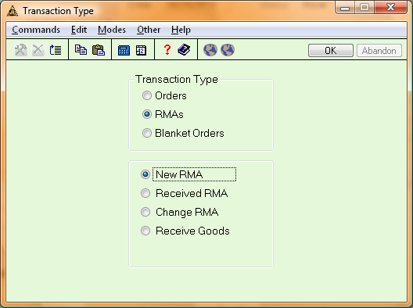

The Transaction Header Screen appears.
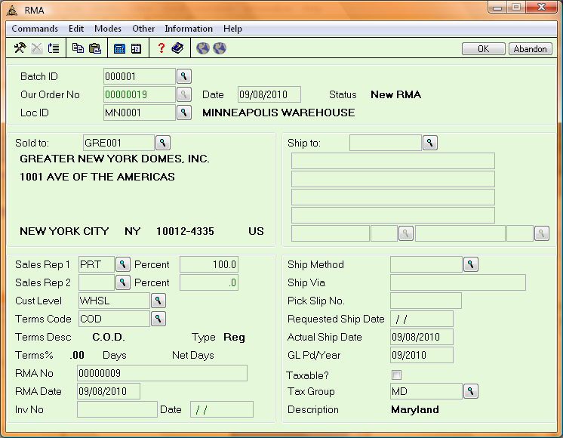
- Enter the “RMA No” if you would like a specific RMA number. If the option “Use System Generated RMA Numbers?” is “YES”, then the software will populate the field based upon the FRMAxxx table (must be created). Enter the remaining information on the screen and click “OK” or press PGDN to proceed to the line item screen.
Enter your Line Item information
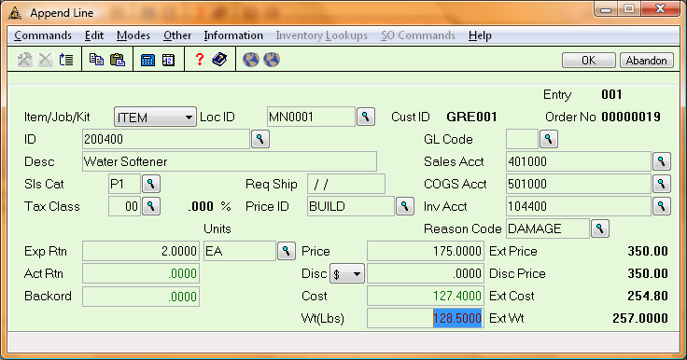
- Enter the desired information including the “Reason Code” for the return and the “Exp Rtn” (Expected Return quantity). The “Act Rtn” (Actual Return Quantity) is not available until you are at a “Received Goods” status. Click the “OK” button, or press PGDN to proceed.
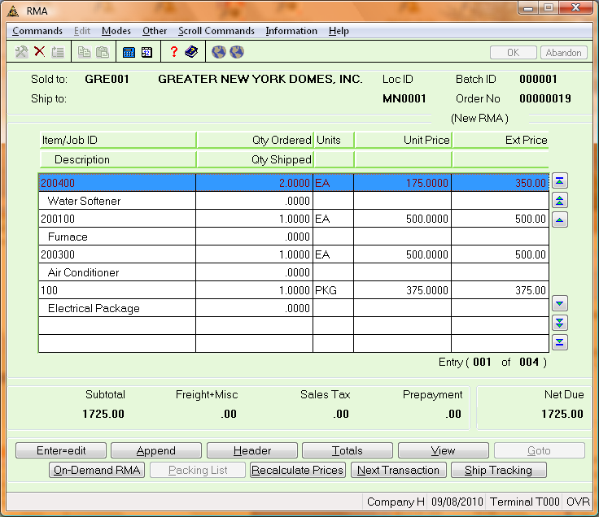
- With your line items entered for the New RMA you should proceed to either…
- Use the “Next Transaction” button to enter another RMA.
- Optionally, use the “On-Demand RMA” button to print and/or email an RMA out to the customer.
NOTE: You can also use the “Print Invoices” function to print your RMAs.
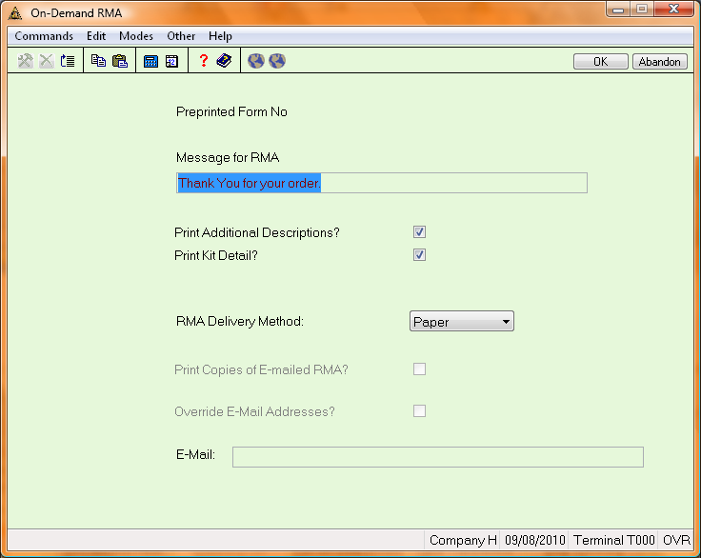
- When you have completed any additional printing or processing of the New RMA you can view your New RMA by running the Open Order Report and be sure to include New RMA’s in the selection picks.

Received Goods Processing
When the goods for an existing RMA have arrived, further processing of the existing RMA will take place as before by selecting the Transactions function from within the Sales Order application. Select RMA and then the Received Goods transaction type and receive the goods for an existing RMA.
The Transaction Header Screen appears.
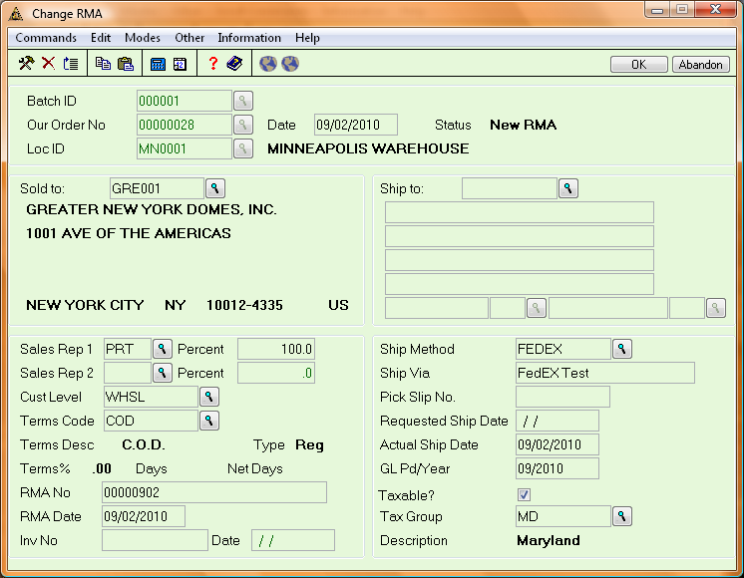
- Upon selecting the RMA (Order Number) you are prompted to “Return All? (Y/N)”. If you wish to return all items associated with New RMA then select “YES”, if you are only returning a portion of the RMA or wish to manually review and receive each line item then select “NO”.
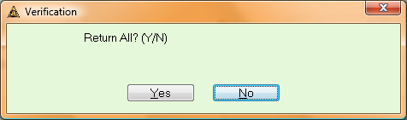
NOTE: If selecting YES to “Return All”. You can still use the Edit button to change the received quantity per line item.
The Line Item detail appears, if you answered NO to the “Return All?” question all Qty Shipped values will be set to zero.
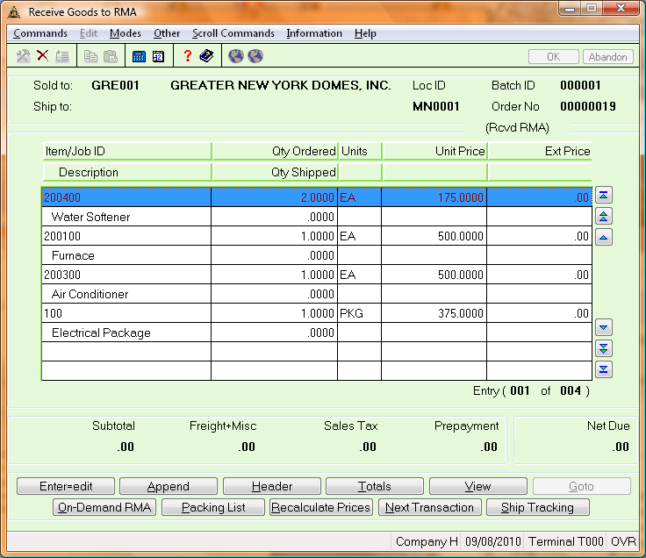
Select the individual line items and enter the “Act Rtn” quantities for that line item.
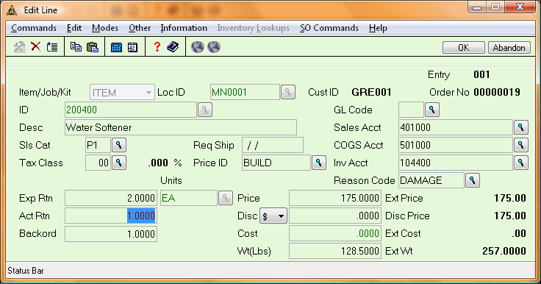
When you have completed entering the received goods amounts the can view the RMA entries.
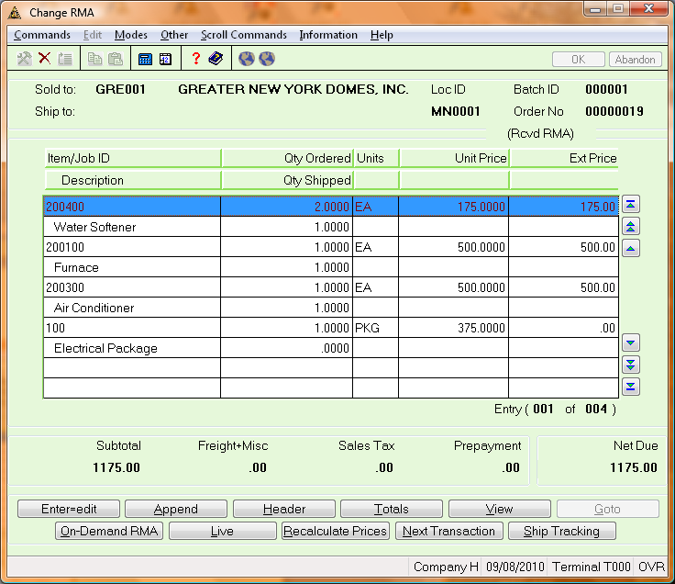
- Now that you have received goods for several line items, you can continue processing by using the Exit command (F7) or clicking the “Next Transaction” button.
- Next, select t he “Return Items” function on the Transactions menu. Only RMA line items that have a received quantity will appear.
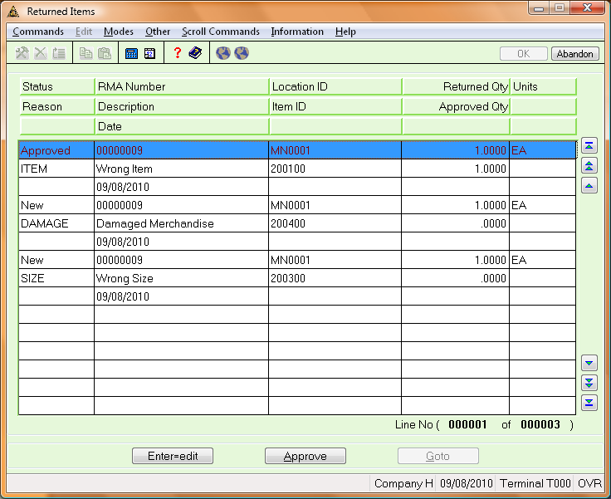
- In order to further process a RMA you will need to “Approve” any received goods that are returned to your inventory. Click the “Approve” button and a message appears confirming the item returns to stock.
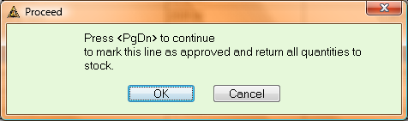
If the line item quantity cannot fully be approved press the “Enter=Edit” button to change …
- The GL Pd/Year.
- The Reason Code, select from the inquiry or add additional Reason Codes in the same function in Codes Maintenance.
- The Status of the line item to “New “or “Approved” .
- The “Approved Quantity” of the item. The quantity approved may be less than the returned quantity if a portion received cannot be returned to your inventory.
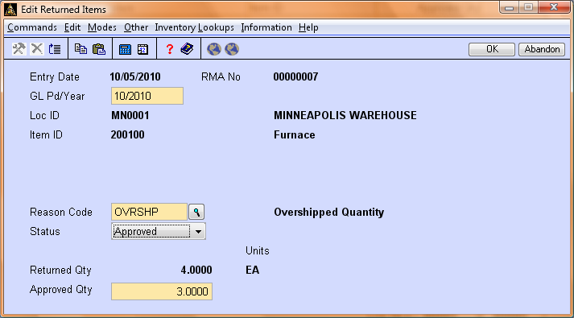
NOTE: Posted quantities cannot be changed.
- After approving quantities continue processing by running the associated reports and using the “Post Returned Items” function.
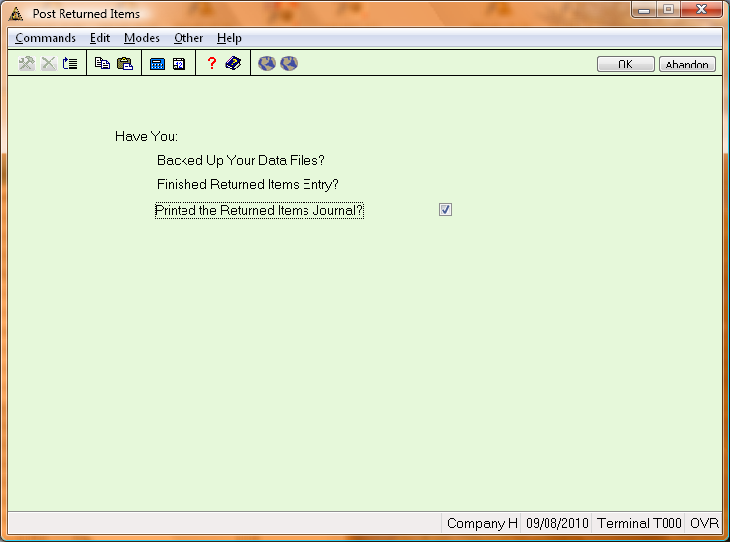
During the Post Return Items process the following GL transaction are created.
Inventory (Pending Rtn) |  |  | Inventory |  |  | Loss from Sale Return
 | CR |  | DB |  |  | DB

If you have approved the full quantity returned there will be NO entry for the “Loss from Sale Returns” as that entry will occur only for the cost of the difference of the Approved Quantity and the Returned Quantity.
When you return to the Return Items function you can now see your Approved Items have a status change of Posted.
You are now ready to finish the process by making a Miscellaneous Credit.. Go to the Transactions function.
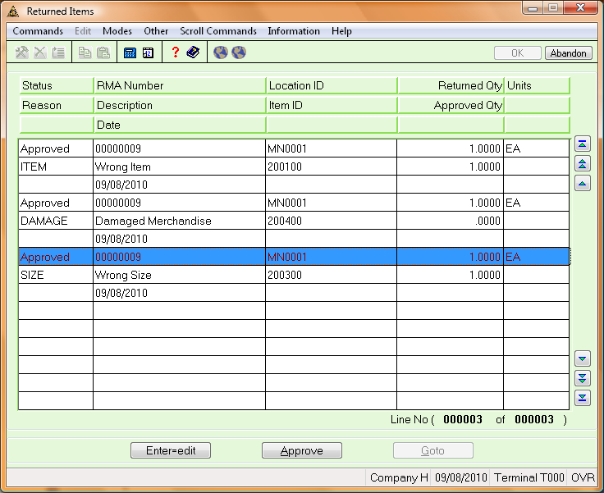

Inventory  (Pending Rtn) |  |  | Sales |  |  | Accounts Receivable |  |  | COGS
DB |  |  | DB |  |  |  | CR |  |  | CR

