OSAS
BANK RECONCILIATION
REMOVE CLEARED TRANSACTIONS

This should be run after you have completed the bank reconciliation and it balances with GL.

Go to Bank Reconciliation
Go to Reconciliation
Go to Change Cleared Transaction

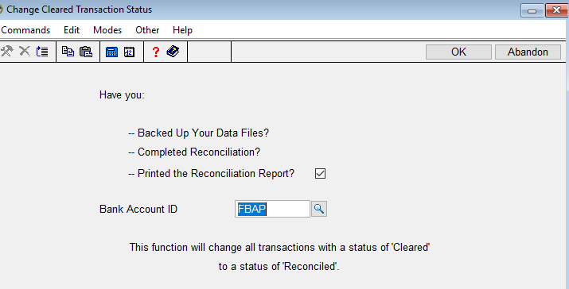
Have you backed up, completed the reconciliation, and printed the reconciliation report? YES
Bank Account ID – Enter the bank account ID to remove cleared transactions.
Page down/OK

Everything that has a YES as cleared will be moved to another file (Purge Reconciled Transaction file).
There is no need to ever run the Purge Reconciled Transaction function.

