OSAS
BANK RECONCILIATION
RECONCILIATION

Go to Bank Reconciliation
Go to Reconciliation
Go to Cleared Transactions

Use the Cleared Transactions function to tag bank transactions that have cleared your bank account, as they appear on your bank statement.
Include Unposted GL Journal Entries in Balance? – it doesn’t matter if you check or not.
Bank Account ID- Enter the ID of the bank account you want to clear transactions
for, or hit F2 to look up and select the ID from the list that appears.
Bank Account Balance-The balance will appear.
Statement Balance- Enter the balance from the bank statement for this bank account.
Statement Type-Select Date or Period – RCG uses Date.
Statement Date- Enter the date shown on the bank’s statement (ending date)
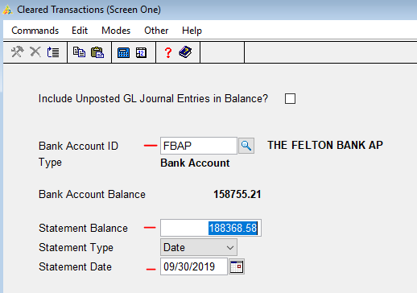
Click OK

Clear Type- Enter 1 if you want to clear deposits, 2 if you want to clear disbursements, 3 if you want to clear transfers, or 4 if you want to clear adjustments.
Tag Status- Enter 1 if you want to work with only tagged items, 2 if you want to work with only untagged items, or 3 to work with both tagged and untagged items. (tagged = cleared) – I like to use 3.
Transactions Date From/Thru- Hit enter to begin with the first transaction date or check number on file. You may want to put the month ending date in the Thru field. - I leaves the From/Thru fields blank.
Hit the Enter key to change tag field to Yes (cleared). See the bottom of the screen for prompts of other ways to clear or unclear. To untag (unclear) hit enter again and the tag field will change to No.
After all entries have been tagged hit H for header to choose a different Clear Type.
Go through all the Clear Type options until all entries needing to be cleared are tagged.

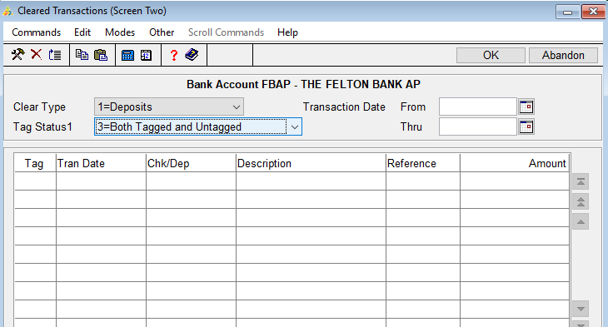

Go to Bank Reconciliation
Go to Reconciliation
Go to Reconciliation Report
Bank Acct ID- Enter the ID of the bank account you want to produce the reconciliation report for.
Print for- Select the way you would like to reconcile, Date or Period.
Transaction Date From/Thru- Leave the From date blank, enter the last day of the month in the Thru field.
Include Unposted GL Journal Entries in Balance? – it doesn’t matter if you check or not.
Print in Detail
Print either cleared, outstanding, or both. I use Outstanding
Print
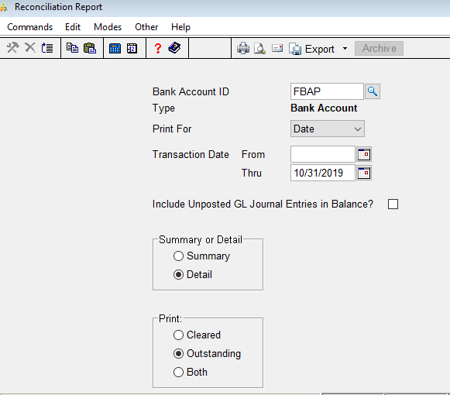

After you have the reconciliation report completed and everything is correct (Accumulated Balance on the Reconciliation Report equals the ending balance in GL for this account) Do not do this step if everything does not balance.
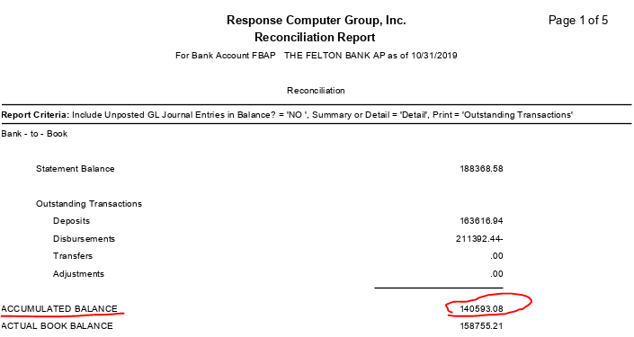

Go to Bank Reconciliation.
Go to Reconciliation
Go to Change Cleared Transactions Status
Have you… check the box.
Click OK
Bank Account ID- Enter the ID of the bank account you want to produce the reconciliation report for.
OK
