OSAS v8

Bank Reconciliation

The main items that need to be set up for Bank Reconciliation:

1-Bank Accounts (Resource Manager/Company Setup/Bank Accounts)

2-Entering your outstanding checks/deposits from your last reconciled bank statement.

Turn the Interface to GL switch off when entering and posting outstanding checks/deposits so they don’t hit GL twice.

Turning off GL switch for BR

Resource Manager/Company Setup/Options and Interfaces.

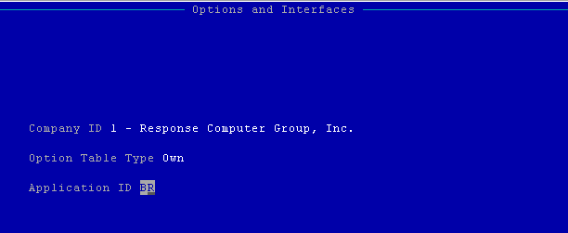

Change the Interface to GL value to NO. Make sure to click Write to write the change.

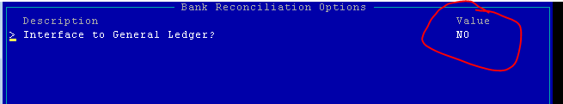

Enter outstanding checks/deposits through Bank Reconciliation/Transactions/Transactions

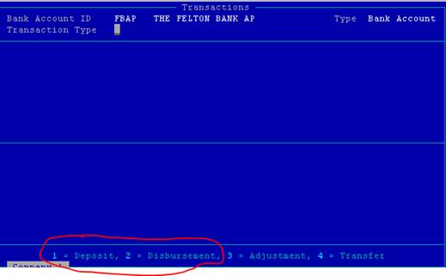

Since the GL switch is turned off, it doesn’t matter what GL numbers you use to enter the outstanding checks/deposits (an example is below)

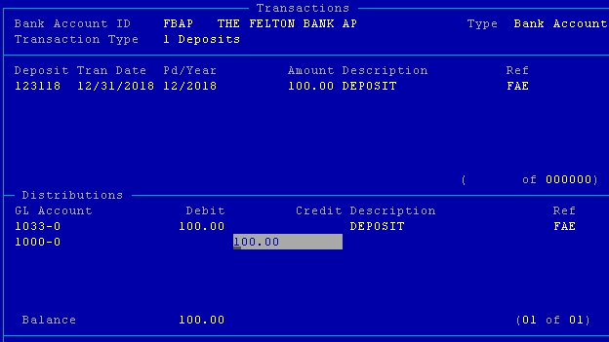

You would then run the BR Journal and Post Transactions to get the outstanding checks/deposits into Bank Rec.

After posting, turn the Interface to GL switch back to YES.

You should turn on the Interface to Bank Rec switch for AR and AP (or SO and PO) in Resource Manager/Company Setup/Options and Interfaces if it is not already on.

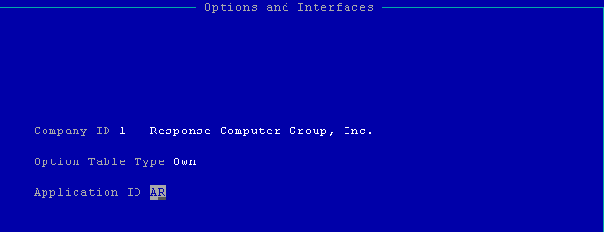

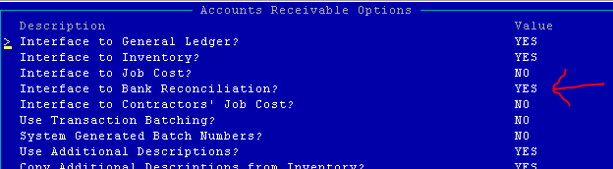

Make sure to Write the changes after changing the Value to YES. Do the same for SO, AP, and PO (if you have those applications.)

This will allow AR deposits and AP checks to post to Bank Rec.

Once these steps are completed, you wait until you receive your next bank statement and begin clearing checks/deposits.

Bank Rec/Reconciliation/Cleared Transactions

I always answer YES to include unposted GL J/E so that any unposted journal entries in GL are included in the calculated bank balance.

Enter the Bank account’s statement balance from the bank statement and the bank statements ending date.

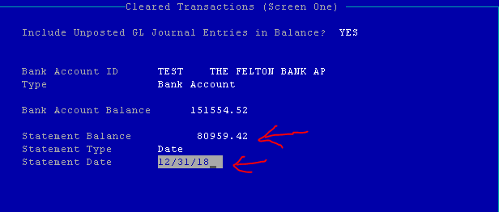

Clear Deposits/checks/adjustments/transfers as shown on your bank statement by hitting enter or checking the box (GUI).

Undo the clear by hitting enter or unchecking the box.

Hit H for Header to change the Clear Type to 1-Deposits, 3-Adjustments, 4 Transfers.

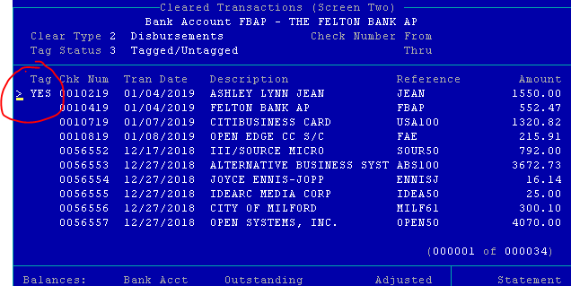

After clearing checks and deposits, enter any miscellaneous charges/deposits as needed. These items need to be entered in Bank Reconciliation rather than GL (journal entry) so they hit Bank Rec. Items entered in General Ledger DO NOT hit Bank Rec.

Run the Reconciliation Report.

You can print just the outstanding items or select Both to see the cleared and outstanding items.

The Accumulated Balance should match your Bank Account GL account balance for the end of the month.

A list of outstanding check/deposit/adj/trf also prints.

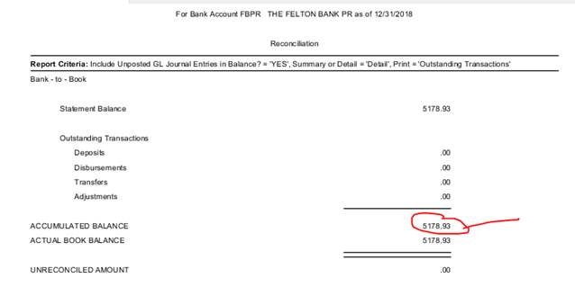

Lastly, when everything is correct, Run Change Cleared Transaction Status.  This takes out all cleared (those items with a YES or checked) from the Cleared Transaction file.

I never run Purge Reconciled Transactions.  Your files are big enough to hold all old transactions.