OSAS
GENERAL LEDGER
ENTERING GL ACCOUNT NUMBERS

General Ledger/File Maintenance/GL Accounts.
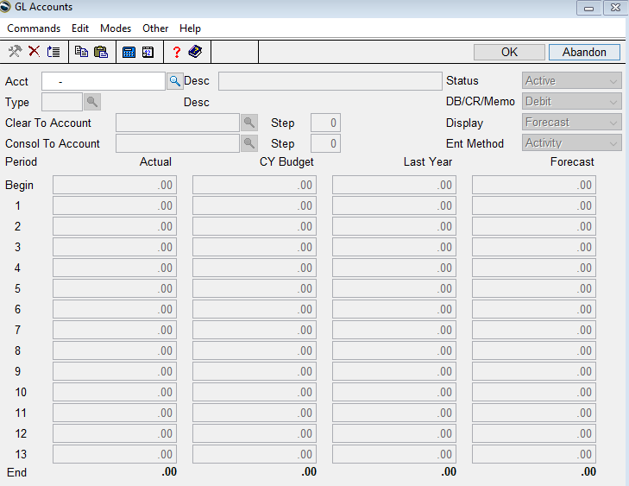
Account-Enter the new GL account number.

Copy from-It will be easier to copy from a GL number that already exists. Enter a GL account number that is around the number that you are entering or hit enter to skip this field. **Make sure to update the Type and Desc (description) if using Copy from**
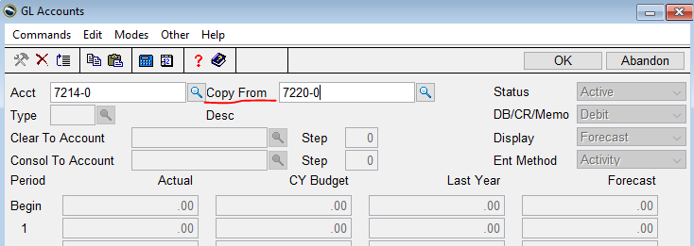
Status-Active or inactive. If setting up, probably Active.

Type-Hit F2 to select an account type from the list. This will determine if the account should be a debit or credit and whether it is a balance sheet or income statement account.

Description-Type in the description for the new account number.

DB, CR, Memo-Expenses will be debits and Income will be credits. Memo is used for titles, notes, or information. The default is determined by the account type selected.

Clear to Account-All expense and income accounts have a clear to account which is Retained Earnings. If you copied from an account this should already be filled out.

Step-If you used the clear to account field, enter step 1, otherwise page down.

Consol to Account-If this account number will be consolidated to an account that is on a different computer, enter the account number that it will be consolidated with; otherwise hit enter to skip the field.

Display-Options for Budget display in the right column are Forecast or NY Budget. This will change the last column heading. The default is F (Forecast); hit enter to accept this default if budget is not an issue at this time.

Entry Method-The amounts in the columns can be entered Period Activity or Period Balance. Enter your choice or hit enter to accept the default of A.

Click OK. The amounts in each period will be updated when Post to Master is performed. Page down to update the entered information and continue entering new GL account numbers.

