OSAS
GENERAL LEDGER
YEAR-END CLOSING CHECKLIST

VERSION 7.6 and higher

Before any work is posted for Period 1 of the new year you must create a new GL Year. But first please check to make sure that the Clear and Close function has been performed for the last GL year.

- Go to General Ledger.
- Hit F9 and switch to the last GL year. If the current GL year is 2017, switch to 2016.
- Go to File Maintenance.
- Go to GL Accounts.
- Enter an expense GL account such as the telephone account.
- Is there an amount in Period 13 of the actual year? Possibly a negative amount? (Remember you are in Last Year)
If YES: Go to Periodic Processing, Update Current Year. This will make sure all information from the last GL year has been updated to the current GL year before creating a new GL year.
If NO: Check to make sure CLEAR AND CLOSE has been done and just not posted. Go to Transactions, Edit Transactions. Are there any entries with period 13 showing? If YES, post to master, run a trial balance to make sure all revenue and expense accounts year to date totals are zero, then following the above YES instructions. If NO, go to Periodic Processing, Clear and Close by Step. After Clearing and Closing by step using period 13, Post to Master for period 13. Run a Trial Balance for period 13, using actual amounts, to make sure all revenue and expense accounts year to date totals are zero.

If all revenue and expense account YTD are NOT zero, a manual journal entry will have to be entered.
Go to GL, Journal Transactions, Transactions.
Enter the revenue or expense GL account number that is not zero. Enter the amount opposite of what the balance is showing (if showing in the debit column, enter as a credit)
Description is Clear and Close, reference is your initials, date is todays date, GL period must be 13, page down.
The offsetting entry is the Retained Earnings account number.
After all entries have been made, W to write the entries.
Post to master for period 13-13.
Run another trial balance for period 13 to make sure all revenue and expense accounts are zero.
Before updating current year you will need to correct the GL accounts that did not clear with the clear and close function.
Go to GL, File Maintenance, GL accounts. Enter the GL account number that did not clear automatically.
Make sure that the Clear to Account is the Retained Earnings accounts number.
Also make sure that the Step is 1.
Page down or ok.
Once that is done you can update current year. The changes that were just made will move over to the current GL year so next year all revenue and expense accounts should clear and close.

Periodic Processing/Update Current Year. – Everyone using OSAS will need to be at a menu to run Update Current Year.
Have you printed all reports…. Answer YES
Enter your Retained Earnings Account number or hit F2 and select from the list.
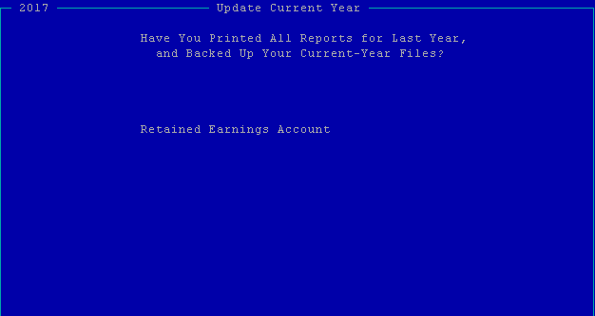
If you get a message – There are unposted entries do you want to continue, answer YES. If you don’t get the message, you are good to continue.

Hit F9 and switch back to the current GL year.

Now that you are sure that last years GL has been cleared and closed to retained earnings, and you have updated the current year you can proceed with creating a new GL year.

First make sure that update current year worked. In the current GL year, go to File Maintenance, GL accounts. Enter a revenue or expense account and make sure that the Last Year column has a negative figure in period 13.
If YES, precede below.
If NO, go back to the last GL year, run Update Current Year again. If a message at the bottom of the screen states that there are unposted entries – do you want to proceed, Yes must be entered to update.

- Go to General Ledger.
- Go to Periodic Processing.
- Go to Create Last-Year Data. Use the Create Last-Year Data function to create last year Master and Journal files so you can still do work in last year while continuing your work in the current year. THIS MUST BE DONE BEFORE ANY WORK IS POSTED FOR PERIOD 1 OF THE NEW YEAR.

REMEMBER
- After your have Created Last-Year Data all postings to the current year (with a 2018 date) for AR/SO, AP/PO, PR, IN, FA, and BR, will go to the new year. If you want the posting to go to 2017 you must make sure the transaction(s) has a 2017 date.
- Use the F9 key to switch between current year and last year files when working in GL and PR.
- Update Current Year can be performed whenever you have entered and posted transactions in last year files and would like to update the beginning balances in the current year files. Go to General Ledger (last years), Periodic Processing, Update Current Year.

The General Ledger month end procedure for year-end is the same as a normal month end.
- Enter and verify all transactions for the last accounting period (usually period 12) for each company. When they are correct, post them to the Master file and print all relevant financial statements. **Remember to hit F9 and switch to the Last Year.

A month or two into the new year your accountant will provide you with closing entries. Enter closing journal entries in period 12 and post them to the master file. **Remember to hit F9 and switch to the Last Year.
Print the year-end financial statements for each company, which will show the closing entries just entered.

MAKE SURE YOU BACKUP AT THIS POINT.

Now that all of last year’s work is complete you must clear all revenue and expense accounts to the Retained Earnings account.

- Go to General Ledger.
- Hit F9 and switch to the Last GL Year.
- Go to Periodic Processing.
- Go to Clear and Close by Step. This will clear all revenue and expense accounts to a capital account (usually Retained Earnings). Select the step (usually 1) and the period (13).
- Print the GL Activity Report for period 13. Check to insure that all closing entries are included and that the ending balances are zero (revenue and expense accounts only). If any revenue or expense accounts have an ending balance, go to Transactions and enter a manual closing entry in period 13. Then go to File Maintenance, GL Accounts, and update the clear to account.
- Post to Master for period 13.
- Print a Trial Balance and make sure all the revenue and expense accounts now have a year to date balance of zero. Do not continue until all revenue and expense accounts are zero.
- Closing is completed. We advise to keep all GL years open. DO NOT CLOSE. This enables you to go back to previous GL years and run financials statements. Your system is capable of keeping as many GL years as needed.

