**OSAS**

**Version 8**

**Tips and Tricks/New Features**

**Help**

In GUI mode, help is just a click away.  Text mode is F1 at any field.

Running AR statements and don’t know what to do at a certain field, click the ?

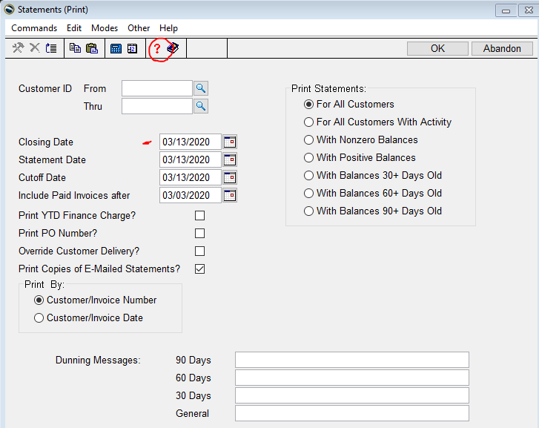

Help box displays

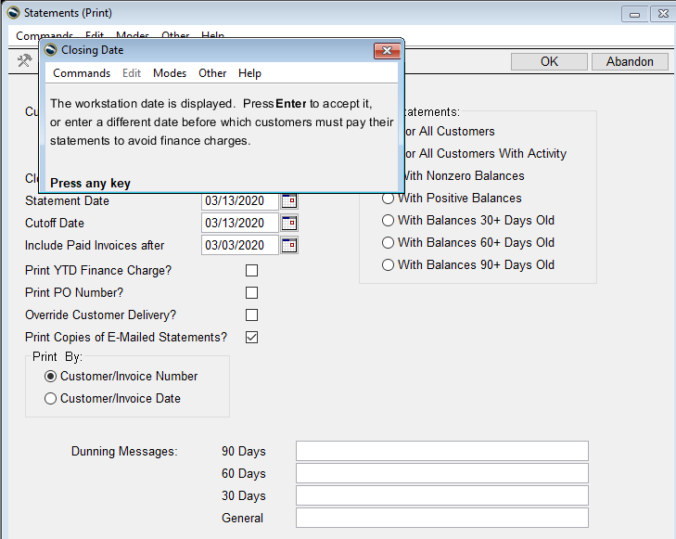

Another example

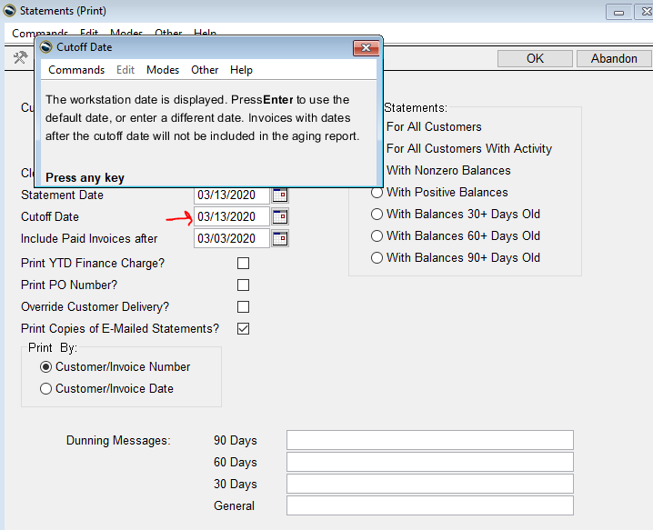

Text Mode

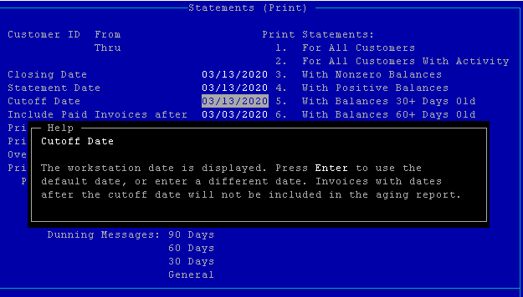

**General Ledger**

GL/Information Inquiry/Accounts Inquiry – Use this view to see everything about a specific GL account – the Actual balance, balance with unposted entries included, budgets, and account set up.

Enter GL account number.  See Actual totals by period for this year/Budget this year/Last Year Amounts /Forecast Budget

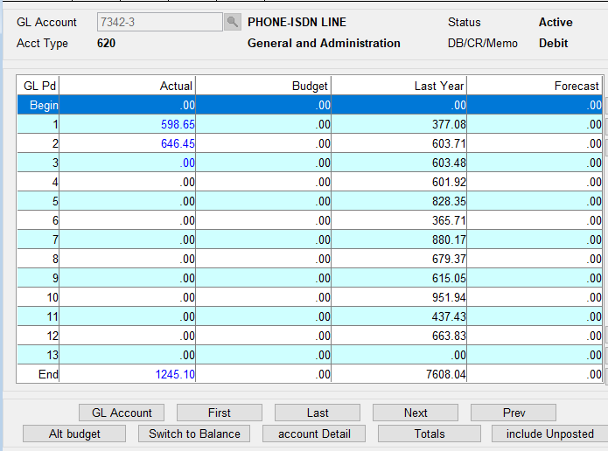

Click Switch to Balance, the account grand total balance is shown.    (this is showing where the Switch to Balance button is located)

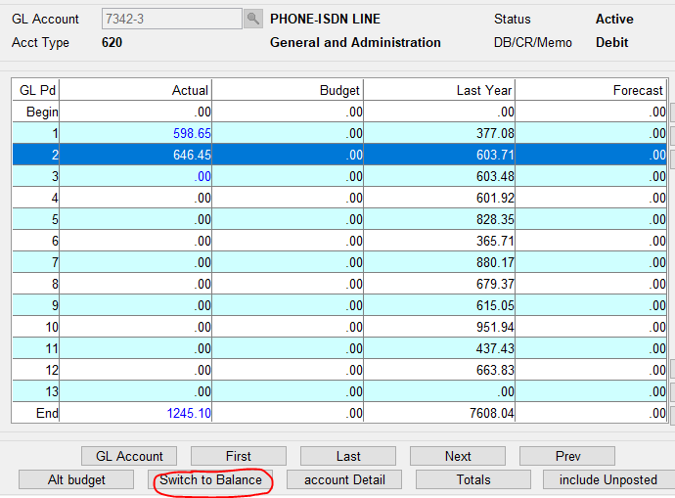

This is the account balance by period for entries that have been posted to master.

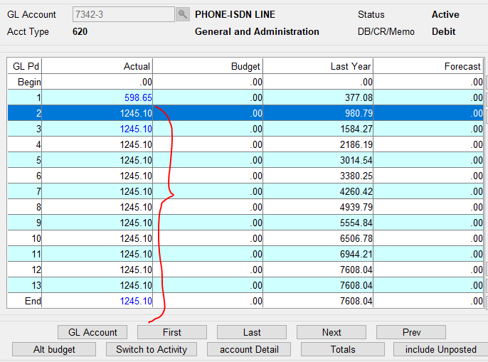

Want to see the account balance real time (with entries not posted to master yet), Click Include Unposted.  (Below is just showing where the Include Unposted button is located)

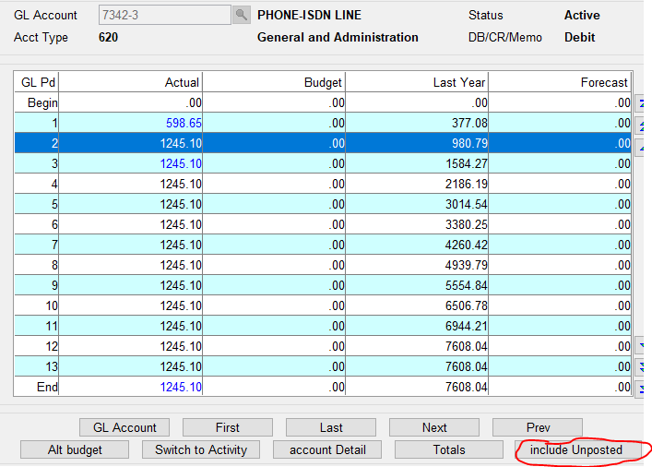

Now you have the actual balance for that GL account.  No longer must run the GL Activity Report to check a balance.

This also helps to see if entries from other modules were posted to prior or future periods.

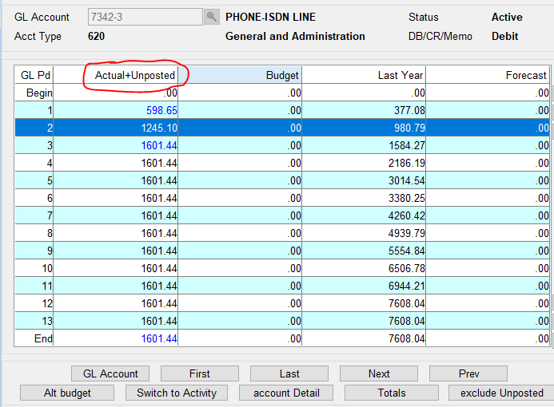

This is an example of an account with unposted (to master) entries.  Click Include Unposted…. (This is how the account looks without Include Unposted)

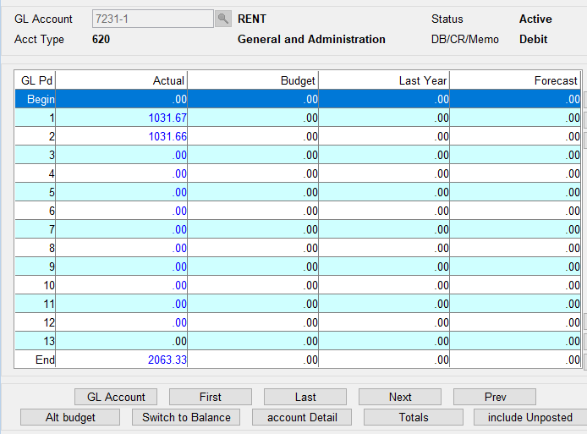

…and see that each period has entries.

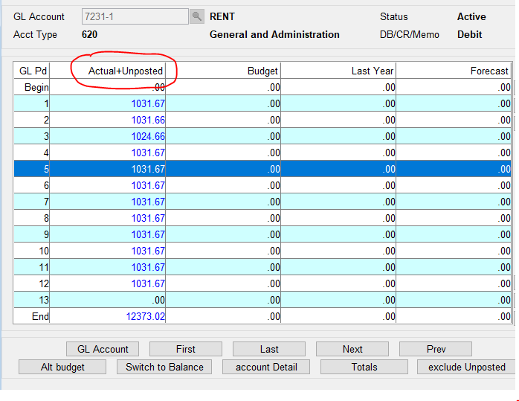

Click Switch to Activity and see each period including unposted.  Switch to Balance/Activity toggles as it is clicked.

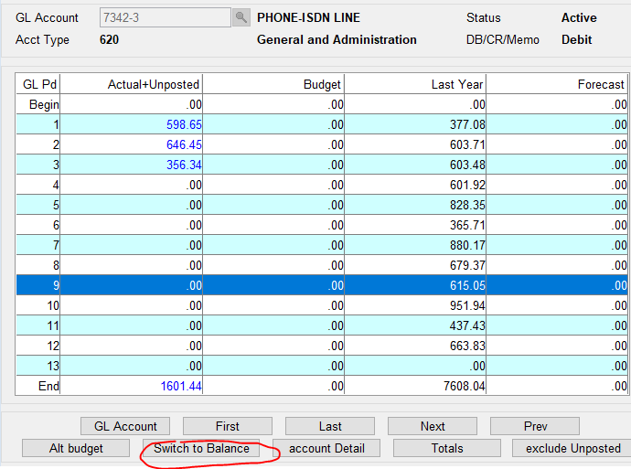

Click Account Detail to see how the account was set up, Status/Account Type/Debit, Credit, or Memo account/Clear to Account and Step for Revenue and Expense accounts.

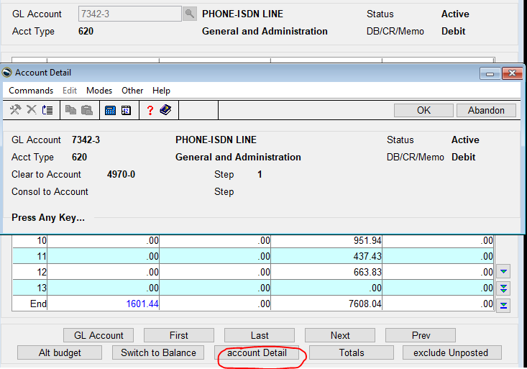

Click Totals to see the GL account total of entries posted to master only.

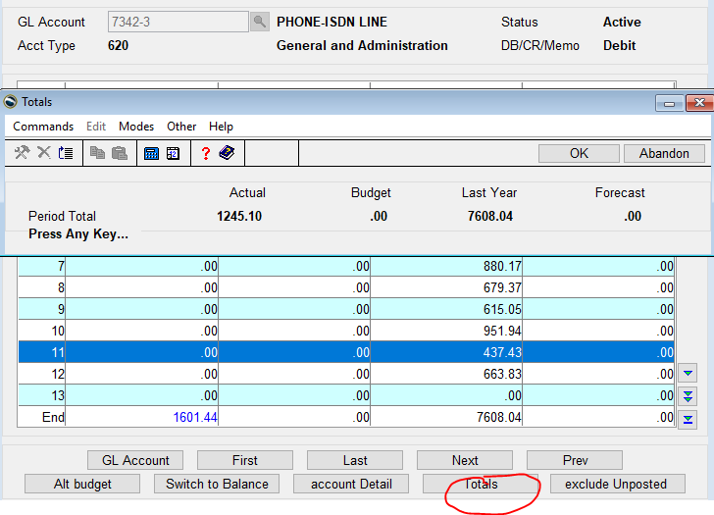

Click Alt Budget to change Forecast to NY (Next Year) Budget amounts.

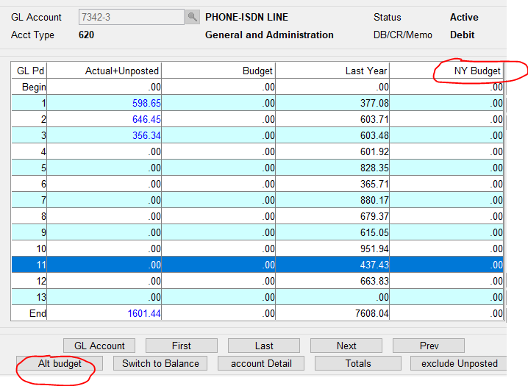

**Accounts Receivable**

AR/Information Inquiry/Detail History

Use Filter button to see only what you need.

Customer wants to know what invoices were applied to a certain check, filter on Payments and see only check numbers, click Start Date and enter a starting date to filter even more.

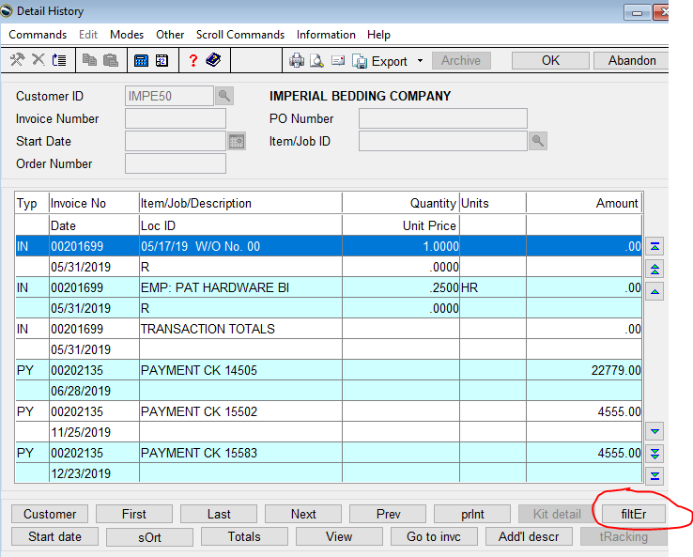

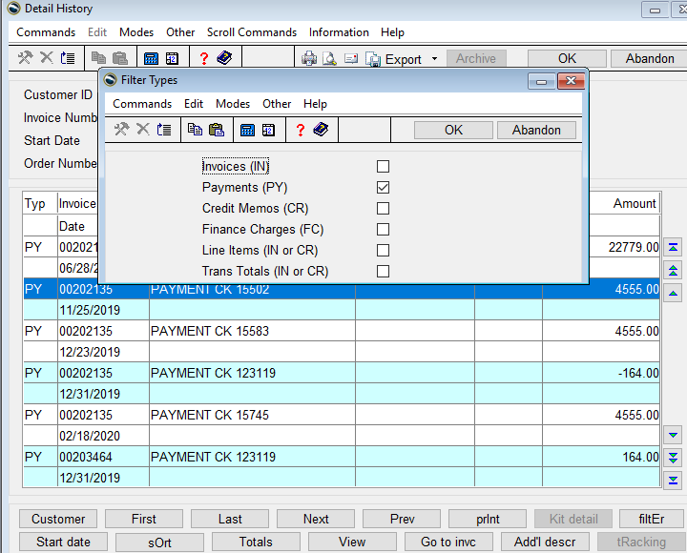

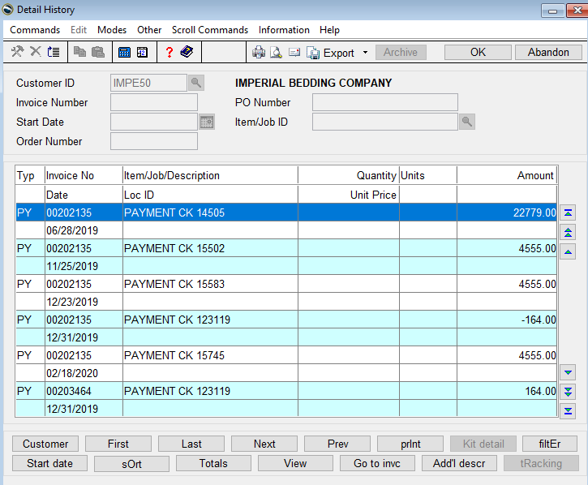

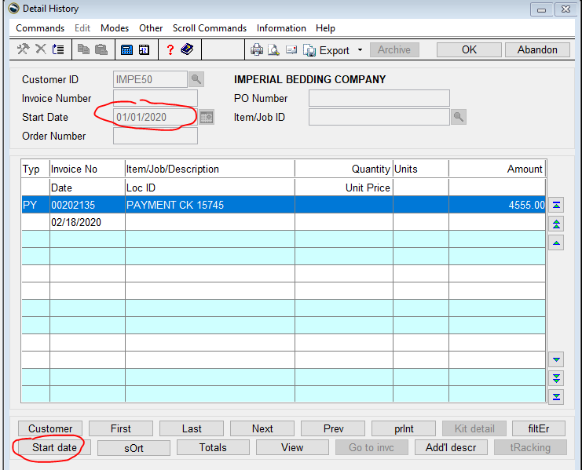

**Accounts Payable**

Print checks through Hold/Release Invoices

AP/Pay Invoices/Hold Release Invoices

Prepay an invoice or invoices for a vendor, new field call Print On Demand Check appears.  Click or press O to Print Check.

Vendor with invoice to prepay.  No Print On Demand Check prompt appears.

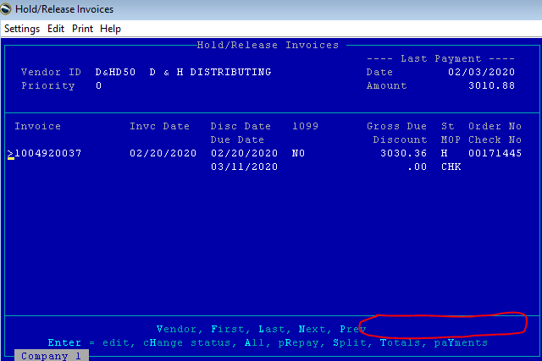

Prepay invoice, Print On Demand Check prompt appears.

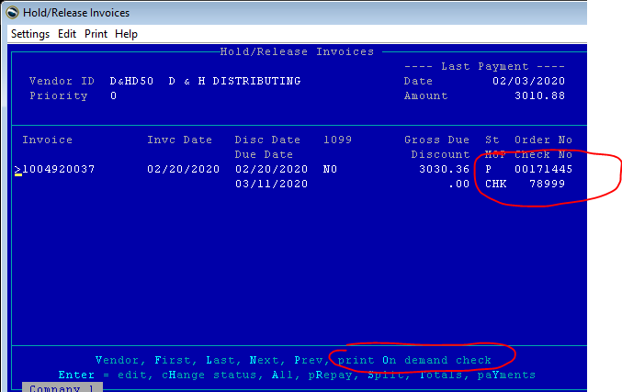

Can prepay multiple invoices for one vendor….

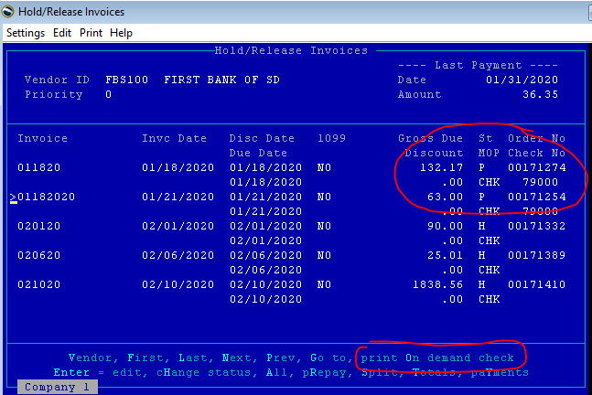

…. Print On Demand Check, prints all invoices prepaid for that vendor.

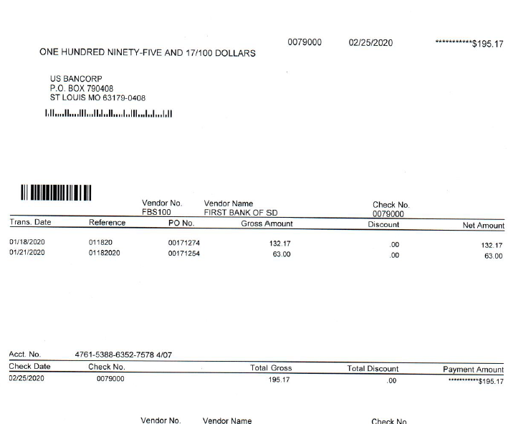

Click Change Status or H (Text) and prepaid check is removed.  Don’t have to void check because it has not been posted, only printed.

The last function in Hold/Release invoices for an invoice, whether it’s a check printed multiple times using different check numbers, or a change in status is what is posted when Post Payments is performed.

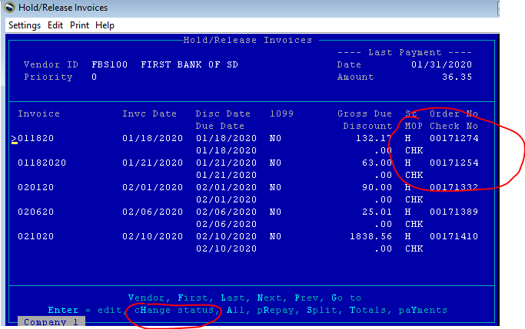

To process ONLY prepayments through to GL, Prepare Payments (AP/Pay Invoices/Prepare Payments) using an invoice and discount date of 01/01/1901.  A message that the date may be invalid will appear, click OK to proceed.

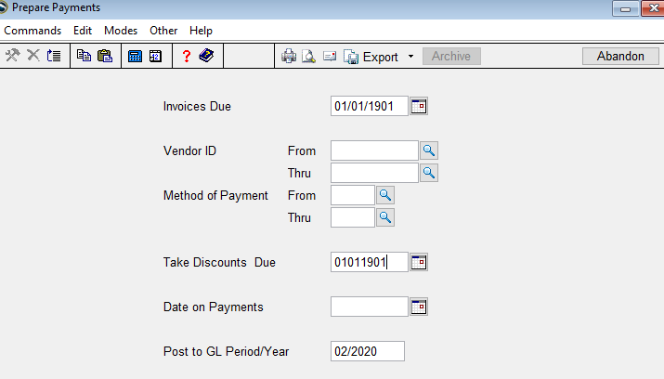

In GUI, ALT + D = workstation date which is normally the current date.  (or D in text)

ALT + + sign or – sign will change the date forward or backward in any date field.

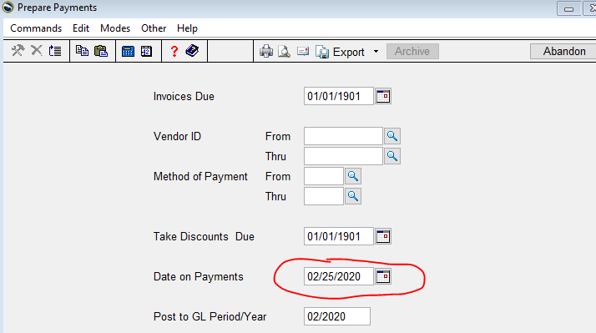

Below is the Prepare Payments report showing only Prepaid Checks prepared.  This works even if all invoices are posted as Released because nothing is due before 01/01/1901, unless an invoice date was entered incorrectly.

Print the Payment Register and Post Payments to process prepayments through to GL.

