OSAS
PAYROLL –DIRECT DEPOSIT
PRINTING CHECKS/VOUCHERS

Entering payroll for Direct Deposit employees is the same as regular payroll, Daily Work/Payroll Transactions/Time Ticket Journal/Misc Deductions Journal/Post Transactions.

If employees would like their direct deposit voucher emailed make sure Voucher Delivery in File Maint/Employees/General Information is set to Email Vouchers.
And make sure an email address for Type Voucher has been set up in File Maint/Employees/Email Addresses.

- Go to Payday Work.
- Go to Calculate Checks.
- If the message, Checks already on file. Do you want to start over? appears, you have either not posted the last run of payroll checks, (Enter NO and run the check register to see what prints. If the last payroll run prints, go to Post checks.) or you have already calculated checks and made changes and want to start over. (Enter Yes and Calculated checks again.)
- Group Code-Enter the group code set up for your employees. (Possibly 0, the number)
- Period End-Enter the date the pay period ends.
- Date on Checks-Enter the date that should appear on the checks.
- GL Period-will default from the date. Change if not correct.
- Pd Code-Enter the number of the payroll for the month. (1, 2, or 3) Remember this affects schedule deductions.
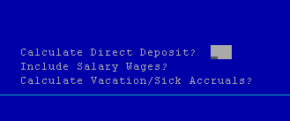
Above are the extra fields to be answered when using Direct Deposit.
Calculate Direct Deposit – YES
Include Salary Wages – This field is also in regular Payroll. Answer YES even if you are using Direct Deposit if you have salaried employees.
Calculate Vacation/Sick Accruals – This field is also in regular Payroll. If you have the system calculate vacation/sick accruals answer YES or NO.
- Page down.
- P to Print
- Select printer.
- Go to Edit Register.
- Print Employer tax and deduction information-Optional; so enter Y and hit enter.
- Print Register in-Enter 2 for detail or 1 for summary.
- Print by-Enter 2 for Employee and hit enter, or pick from the list.
- P to Print
- Select printer.
- Check the edit register to make sure taxes have calculated for each employee and the amount of each check is correct.
- If any changes need to be made do them NOW. To add or subtract hours go to Daily Work making sure you post transactions and calculate checks again (see step 3-9). To change deductions or tax withholdings go to Manual Checks and select Change a Calculated Check. Do not calculate checks again after changing a calculated check. Run Edit Register to make sure everything is correct.
- Go to Print Checks.
Print checks for employees not using Direct Deposit.
- Put the payroll checks in the printer.
- First check number-this number may or may not be correct. You may enter a higher check number then appears, but if a lower check number must be entered go to File Maintenance, Payroll Information, Employer Bank Information. Enter the next check number and page down. Then go back to Print checks.
- Check printing order-Enter E for employee or select another option.
- Print remaining leave-Enter N for none or Y for the remaining leave to show on the check stub.
- P for Print
- Select printer.
- After checks have printed take checks out of printer and put regular paper back in.
- Print Direct Deposit Vouchers
Print vouchers for employees using Direct Deposit.
Vouchers not being emailed to employees will print first then emailed vouchers will be transmitted. You have an option to print emailed vouchers.
Payroll Reports and Posting
Create Direct Deposit File
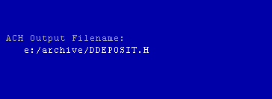
Your ACH Output Filename will appear. This will also print on the report.
Page down
P to print
- Go to Check Register –Printing of the employer tax and deduction information is optional; select report to print in 2 detail or 1 summary.
- Paycheck Received Report-This report list all employees receiving checks with a line beside their name for s signature. This is an optional report.
- Go to Withholding Report. This report has the 941 information. Look at the bottom of the report under grand totals. FWH is the Federal withholding amount, OAS and MED are the FICA amounts for the employee.
- Print Earnings As-Enter 1 for Gross earnings and hit enter.
- P to Print
- Select printer.
- Employer’s Tax Report- Select your option Y or N. This report shows the employer’s portion of the FICA, SUI and FUTA liability. This is an optional report.
- Employer’s Liability Report- Select your option Y or N. This report shows the employer’s portion of the Social Security, Medicare, SUI and FUTA liability. This is an optional report.
- Pay Period Deduction Report-This is a good report for printing 401K or SIMPLE employee contributions and employer’s match. This is also good for giving AP wage attachment check information. Select option 1-3. This is an optional report.
- Go to Post Checks.
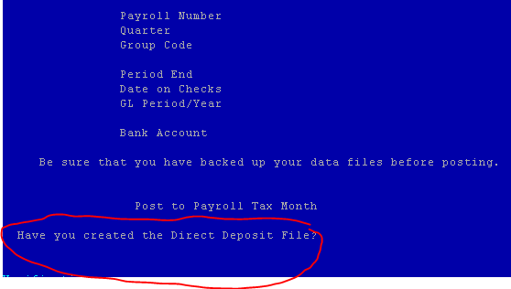

- Post to payroll tax month-The default will be the month you are in. If this is correct hit enter or enter the tax month the payroll should be posted to.
Have you created the Direct Deposit File? This is your last time to create the direct deposit file before having a mess on your hands! Answer is YES but make sure you really have.
- P to Print
- Select printer.
- Go to Post Expense to G/L. RCG customers will normally have this right under Post Checks. Otherwise it is found in Periodic Processing. This can be done just once at month end or weekly.
- Enter Y to have you backed up.
- Post to GL Period-Hit enter to accept the default or enter another GL Period.
- Post to GL in-Enter 2 for detail or 1 for summary.
- P to Print
- Select printer.

Your direct deposit payroll is now complete.
You will now need to transmit the file to your bank as per your banks procedures.

