Open Systems

OSAS

Direct Deposit Setup

V8.0

See document “DD osas 8 emailing vouchers.rtf” for instructions on setup in Resource Manager/Options and Interfaces before beginning.

After RM direct deposit set up has been completed,

Go to Direct Deposit/File Maintenance/Direct Deposit

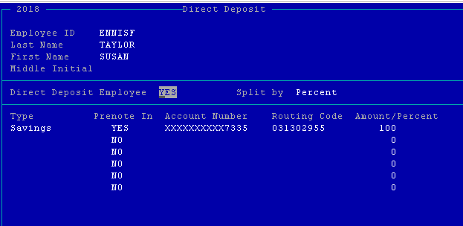

If the employee received direct deposit answer YES. Direct deposit will not happen until Prenote =YES.

Split by Percent or Amount (dollar amount). A total of 6 splits are allowed. This means 6 different accounts can be funded through direct deposit.

Type: Checking/Savings/Paycheck/or leave blank for none.

Prenote: until the bank has received and verified the bank account information on this line the default will be NO. Create Prenotification File in Periodic Processing must be run before Prenote will change to YES.

Account Number: Enter the account number for the type indicated.

Routing Code: Enter the routing number for the account number entered.

Amount/Percent: enter the percent or amount of the employee pay that goes to the account entered. If the split type is by amount and any net pay remains after having been distributed to the employee’s accounts, the system automatically applies the remaining pay to the last authorized account. You may use 9999999.99 on the last split type to direct the remaining amount to that split type.

Set up the Employee’s master file:

Voucher Delivery: Email, Paper, or No voucher

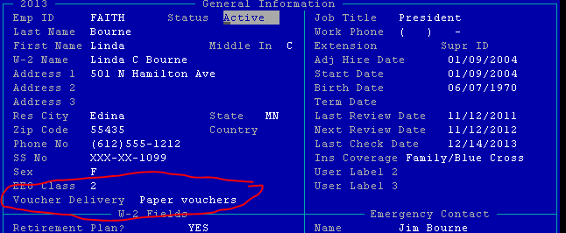

If the voucher will be emailed, set up the email address for the voucher.

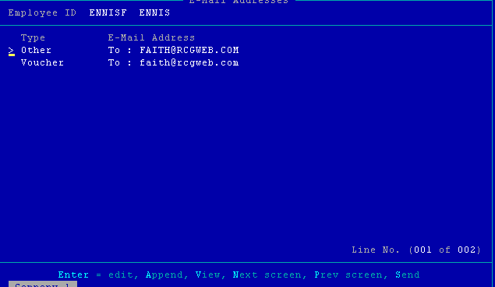

Once everything has been setup, a Prenotification File will need to be created and sent to your bank so accounts/routing can be verified.

Go to Periodic Processing

Go to Create Prenotification File

Resend All Prenotifications? Answer YES if you want to resend the prenotification information for ALL employees. Answer NO to only send employee information that has changed. Normally the first time the Prenotification File is run the answer is YES.

Mark All Prenotifications in this run Approved: YES will set the Prenote In flag in the direct deposit file maintenance screen to YES. If NO, you will have to update the employee’s direct deposit status manually.

Bank Account: enter the bank account ID for the prenotification file or hit F2 and select from the list.

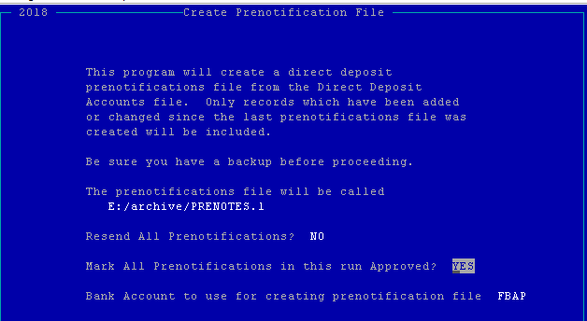

Once all employees have been approved through prenotification you are ready to being using direct deposit.