Open Systems

Payroll

Updating W-4 Employee Information

Payroll

File Maintenance

Employees

Select Tax Information

Click OK at Tax Group

Hit enter at FED

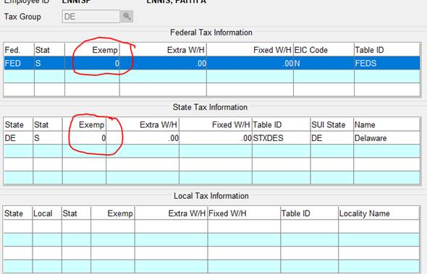

The box below will appear.

Enter 0 in Exemp

OK

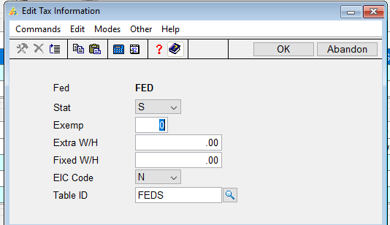

Click Switch to State to update the State exemptions.

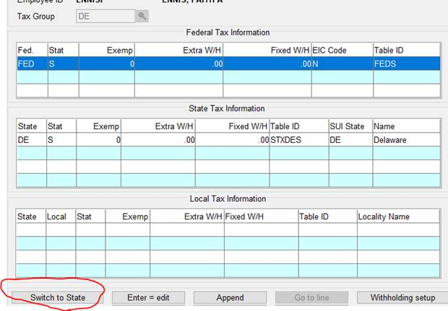

At the State Tax Information, hit enter.

The box below will appear.

Enter 0 for the exemptions.

OK

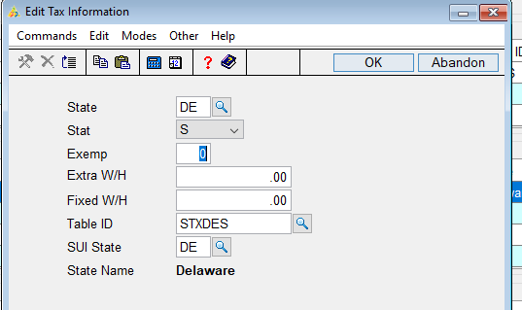

Click Next Page, done.