Open Systems

Payroll

Vacation/Sick Time Entry and Usage

Vacation and sick time can be entered on the front end or accrued weekly/monthly/etc.

**Entering vacation/sick time on the front end.**

Go to Payroll

Go to File Maintenance

Go to Leave Adjustments

Enter Employee ID

**Leave Type**: - Enter V for vacation or S for Sick or click on your selection (GUI)

**Description**: Enter a description of the adjustment (ie 2015 hrs) or leave blank.

**Date**: The workstation date will default, change as needed.

**Earning Code**: Enter the earning code that corresponds with the Leave Type (VAC or SIC)

**Adjustment**: Enter a positive or negative number to increase or decrease the hours for vacation or sick. This is for initial balances or corrections. Use payroll transactions to adjust vac/sic hours used.

Remaining vacation and sick hours show at the bottom of the screen. Your adjustment will increase or decrease those hours.

Page down or click ok

Vac/Sic hours will show in the employee master file under salary information. The hours can only be accessed/adjusted in File Maintenance/Leave Adjustments.

When entering payroll transactions, use earning code VAC or SIC for vacation or sick time paid. The total hours remaining will be updated when checks are posted (Payday Work/Post Checks)

**Entering vacation/sick time to be accrued.**

The tables that set accruals needs to be set up first.

Go to Payroll

Go to File Maintenance

Go to Tables

**Table ID**: MAXVSxxx

This table stores the maximum number of vacation and sick hours an employee can accrue.

When you post vacation and sick accruals, the system checks the sick and vacation hours remaining in the employee’s master file (displayed in Salary Information) and limits the accrued hours posted to the employee’s master file for the paycheck based on hours entered in this table.

**Table ID**: SICccxx VACxx

This table is used if you set the option Automatic Accrual of Vac/Sick Time to YES (RM/Company Setup/Options and Interfaces).

The cc in the table ID name represent the sick/vacation accrual code you enter in the Sick Accrual Code/Vacation Accrual Code fields on the Salary Information screen in the Employee master file. You don’t have to use the cc if all employees accrue the same.

The xxx represent the company ID.

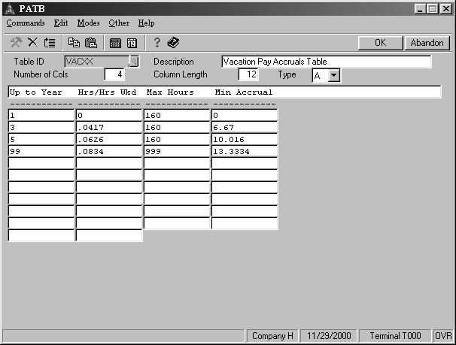

**Up to Year** – number of years the employee has worked for the company.

**Hrs/Hrs Wkd** – number of hours that will be accrued per hour worked for that company.

**Max Hours** – maximum number of hours worked per pay period that can be used to calculate the sic/vac hours accrued.

**Min Accrual –** minimum number of sic/vac hours an employee will accrue per pay period.

When you calculate checks, the system checks the employee’s start date and uses the appropriate row of the VACxx or SICxx table based on the number of years the employee worked for the company.

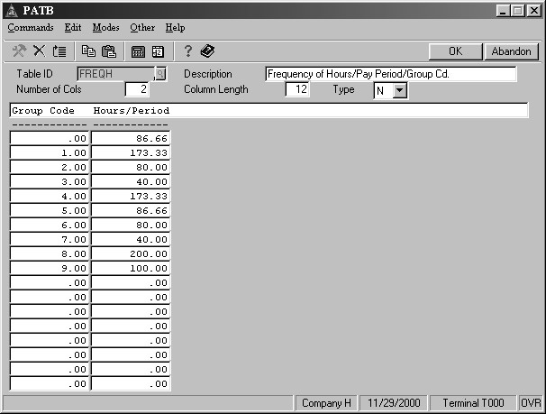

**Table ID**: FREQxxx

For salaried employees, the employee’s group code is checked and the row for the employee’s group code in the FREQxx table is read for the number of hours worked in the pay period. For hourly employees, the total hours entered for time tickets is used by the system.

The value for the number of hours worked is multiplied by the Hrs/Hrs Wkd (SICxx or VACxx table) to calculate accrued sic/vac hours. The system uses the greater of the two values, calculate sic/vac hours or the minimum hours, for the sic/vac accrual amount for the pay period.

Set up Sic/Vac Accrual Code in the Employee’s master file.

Go to Payroll

Go to File Maintenance

Go to Employees

Salary Information

Enter the xx code used in the SICxx and VACxx table for each employee.

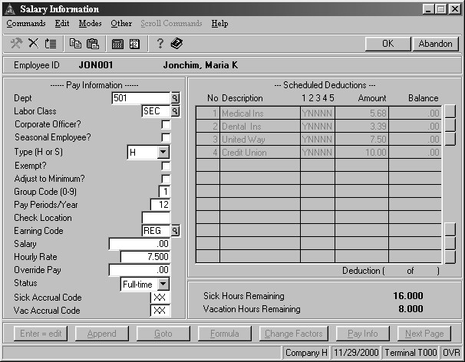

Everything has now been set up whether you are using front load vac/sic hours or accrued vac/sic hours.

When calculating checks, you will be prompted to calculate vacation/sick accurals. Answer YES or click if this pay period vac/sic should be accrued.

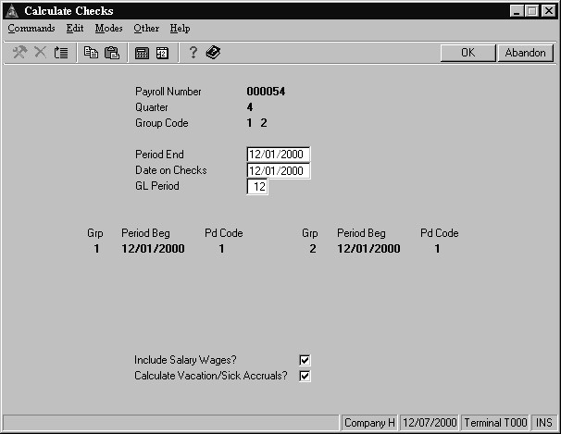

Print the Sick Leave and Vacation Report to verify the accrual amounts, then use the Accrual Adjustments (Payday Work) function to adjust the sick/vacation time accrued in this pay period if needed.

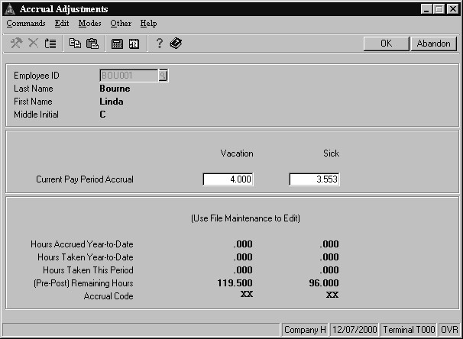

If the vacation and sick accrual amounts for an employee needs adjusting, enter the employee ID. The amount of vacation and sick time accrued for the employee in this check run are displayed in the Current Pay Period Accrual section. (Even if you have multiple checks for an employee, there is just one accrual record per employee per pay period that combines all check accruals.)

Use these fields to enter the vacation and/or sick time adjustments. Enter a negative amount to reduce the accrual amount, a positive number to increase the accrual amount, PgDn to save the adjustments. Print the Vacation and Sick Leave Report to verify that the adjustments entered have corrected the accrual amounts for this paycheck run.