OSAS

Bank Accounts

Go to Resource Manager

Go to Company Setup

Go to Bank Accounts

Bank Account ID – Enter a Bank Account ID for this Bank. If you are setting up a bank account that is similar to one already set up, use the Copy From field which will appear after you enter the bank account ID. Otherwise hit enter to Type.

Type – Bank Account. Do not use Credit Card

GL Account Number – Enter the GL account number associated with this bank or hit F2 and select from the list.

Status – Active should default.

Account Description – Enter the bank name.

Address/City/State/ – Enter (optional)

Phone/Fax/Bank Contact – Enter (optional)

Email address/website – Enter (optional)

Page down or OK

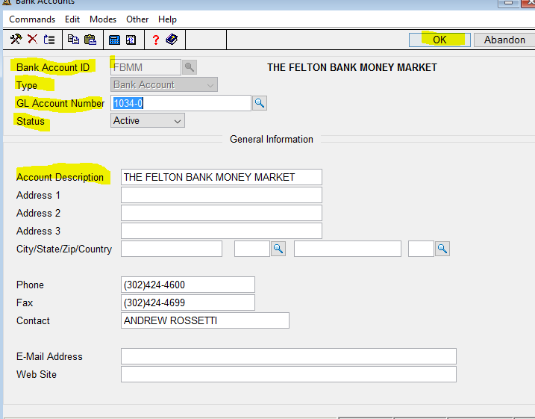

Account Number – Enter the bank account number

Routing Code – Enter the bank routing number

Account and routing numbers are the only required fields on this screen.

The Next Check Number can be entered through AP/Print Checks the first time you print checks.

Page down or OK

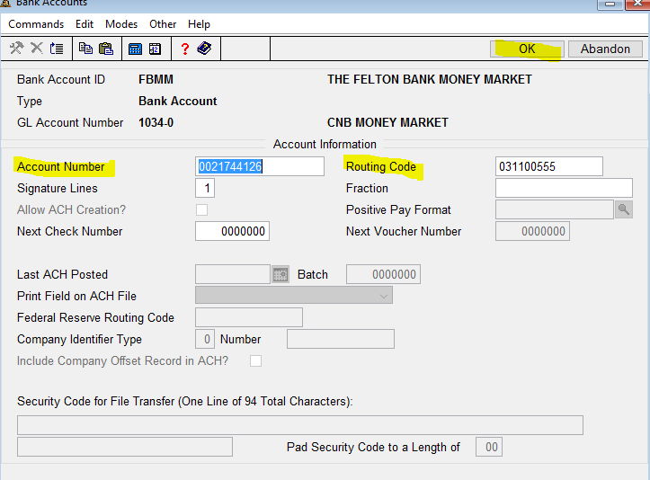

Page down – the last statement balance and other fields are used with Bank Reconciliation and can be setup the first time Bank Rec is used.

