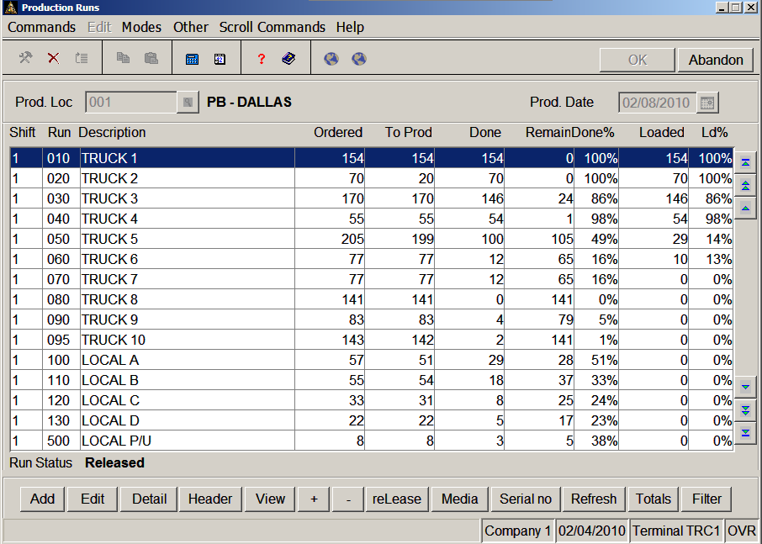

The Production Runs screen gives a birds-eye view of the production for a given day. This screen is updated as pieces are ordered, produced and loaded. Details for each run are available at the push of a button, including the status of individual pieces.

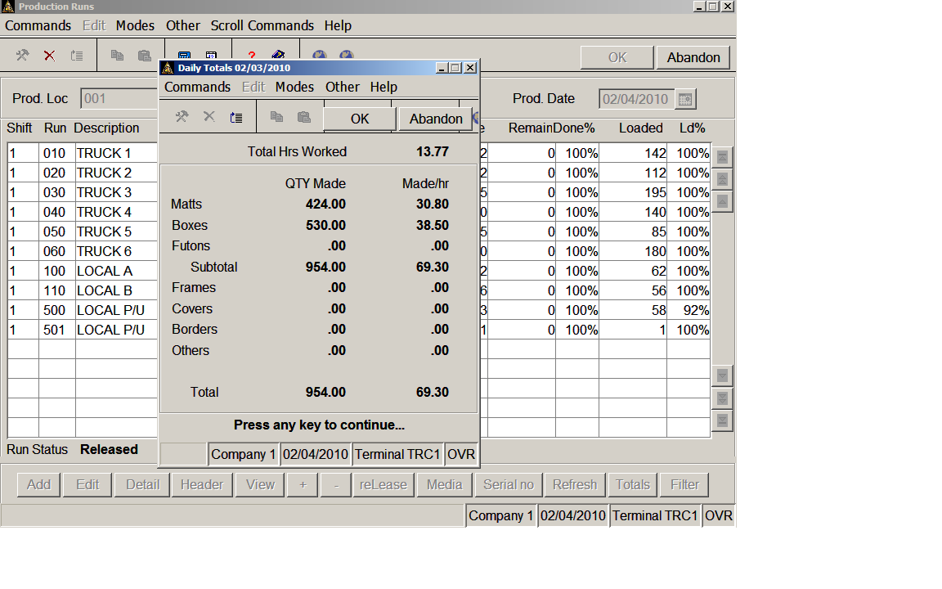

The Daily Totals screen gives statistics for the day broken down by Product type. Hours are counted from first scan through last scan of the day. Management can also see a version of this screen that includes dollar figures.

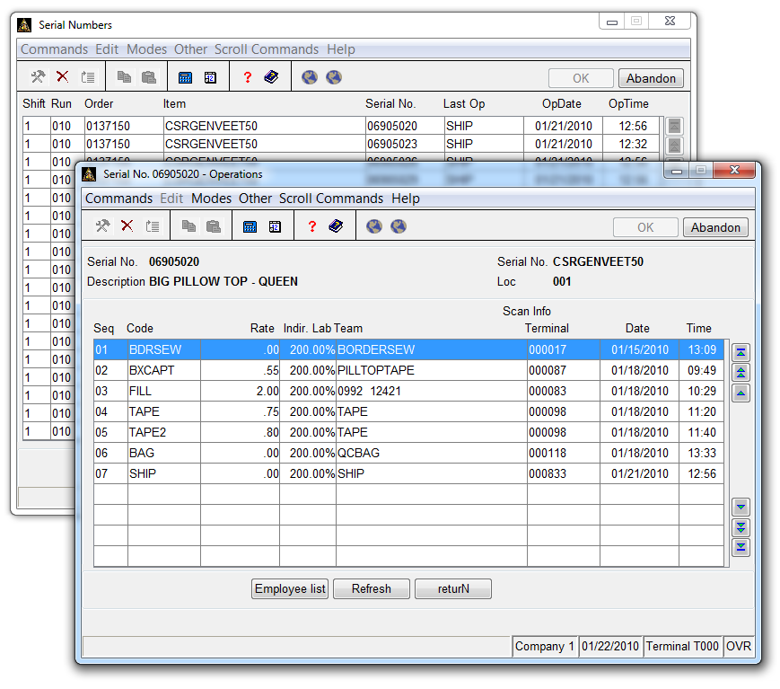

All of the production inquiry screens provide drill down to serial number detail. Drill down to see all the serial numbers on an order, for example, to determine what may be holding up completion. Each serial number shows the last operation scanned, so a given piece can be tracked through each stage of production. Date and time for All operations for each serial number may be viewed, as well as a list of employees who performed the operation. If subassembly production is required, the status of subassemblies can also be viewed from this screen.

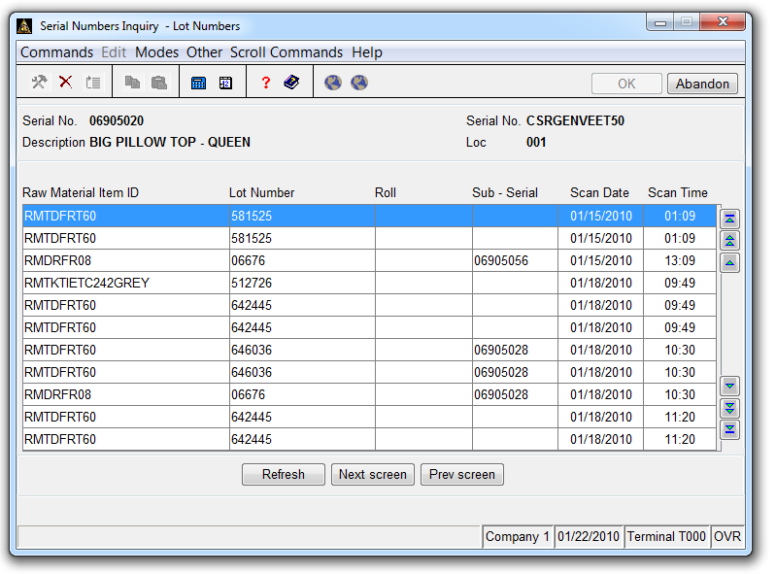

If lotted items are used, lot numbers can be required to be entered at a given operation and from that point attached to each serial number with date/time of use for easy reference. Lot numbers for subassemblies are also copied up to the finished good record.

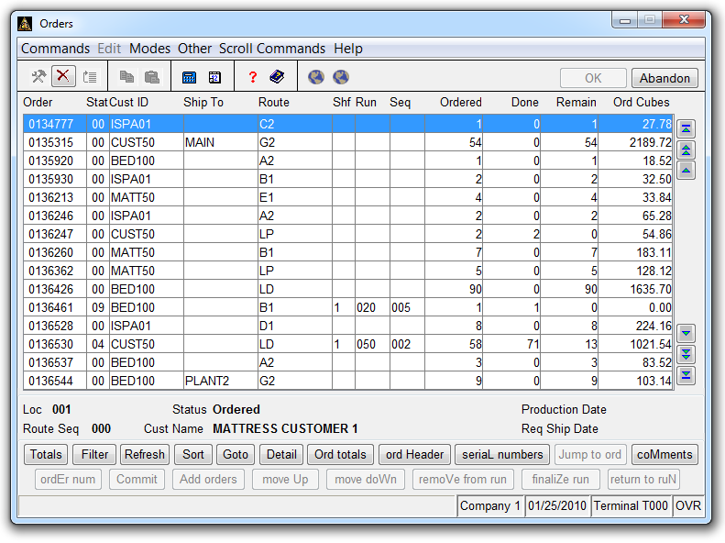

The Production Orders view gives a quick glance of all orders. The filter screens allows each user to filter their screen output and sorts according to their immediate needs. Customer Service personnel can use this screen to provide up-to-the-second information. Scheduling personnel can use this screen to quickly choose and prioritize orders for production.

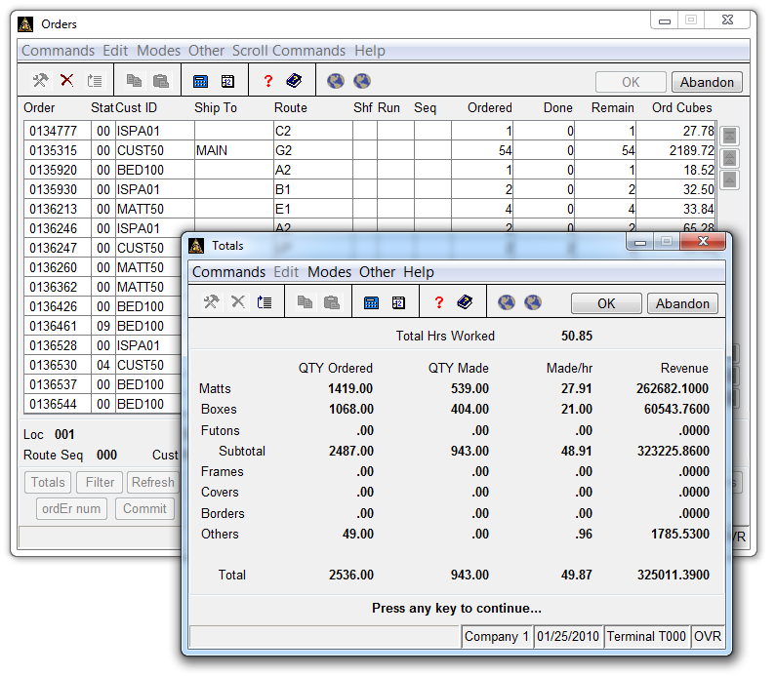

This Totals view shows quantity and dollar totals for all of the orders selected by the current filter.

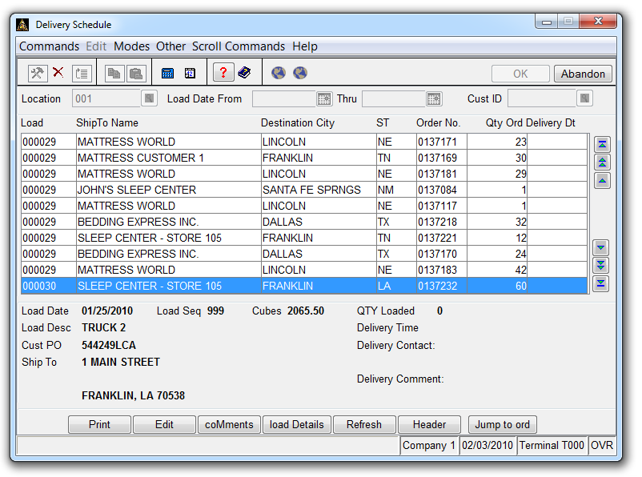

The Delivery Schedule View shows orders as they are grouped onto loads. All the information pertaining to delivery appointments can be entered here and printed on a schedule that can be used to direct the truck driver.

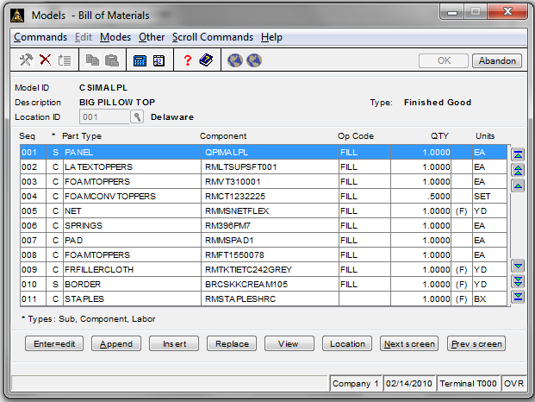

The Build-a-Bed module provides a virtual bill of materials which matches one model to any number of sizes. Here is the virtual BOM for all the sizes of the Big Pillow Top model CSIMALPL. The components of the BOM are defined as either size or factor dependent, and will be replaced by the correct item number replacement and quantity in the SKU’s for each bed size that will automatically be created.

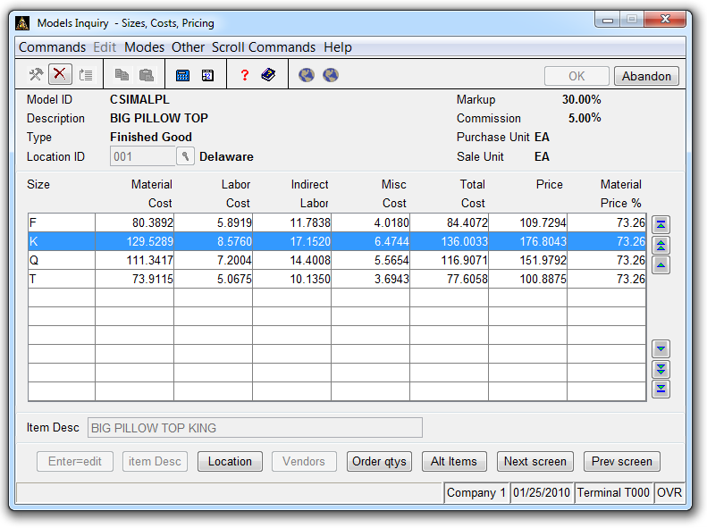

Here are the sizes for the Big Pillow Top. Adding a size is as simple as appending it and re-posting the model to the production inventory. Cost estimates here are derived by drilling down into the bill of materials and totaling the cost of the materials and labor according to the replacements for each size. Experimentation can be done with the model until acceptable cost figures result. Changes to the model doesn’t effect real production data until the model is completed and posted.

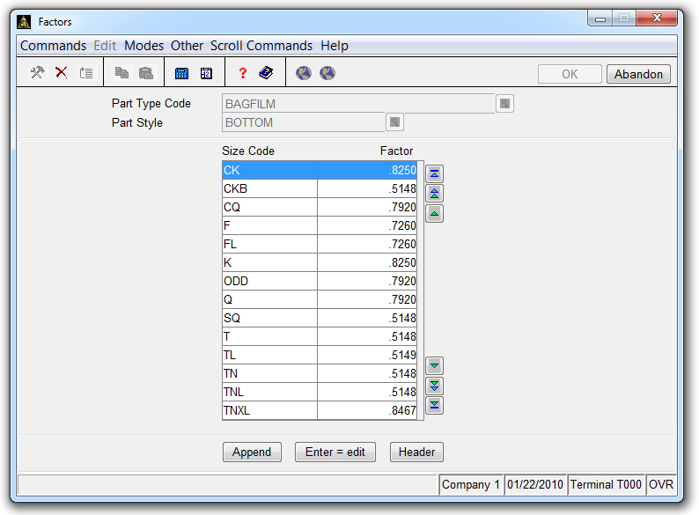

Factor-Dependent Components are calculated by a pre-defined factor for each size.

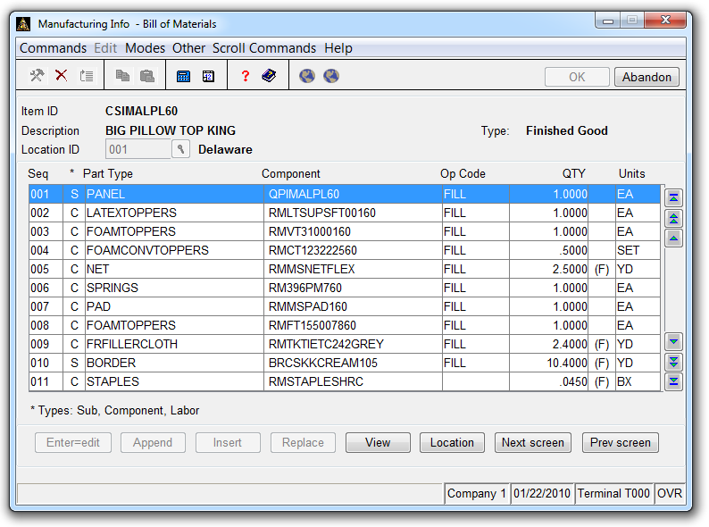

This is the resulting Bill of Materials for the King Size of the Big Pillow Top. Notice that the Item ID is the Model ID+ a suffix. “60” is the suffix that is defined for size King in this example. Suffixes are flexible and user-defined. Also the resulting item descriptions can be generated according to user preference. The same suffix is used to replace the size-dependent model components with their “real” component id’s. Notice that QPIMALPL became QPIMALPL60 here. The information for each item is available for information inquiry before posting the model, so that all the information can be checked and verified during the design stage. Changes won’t affect production until the model is posted.

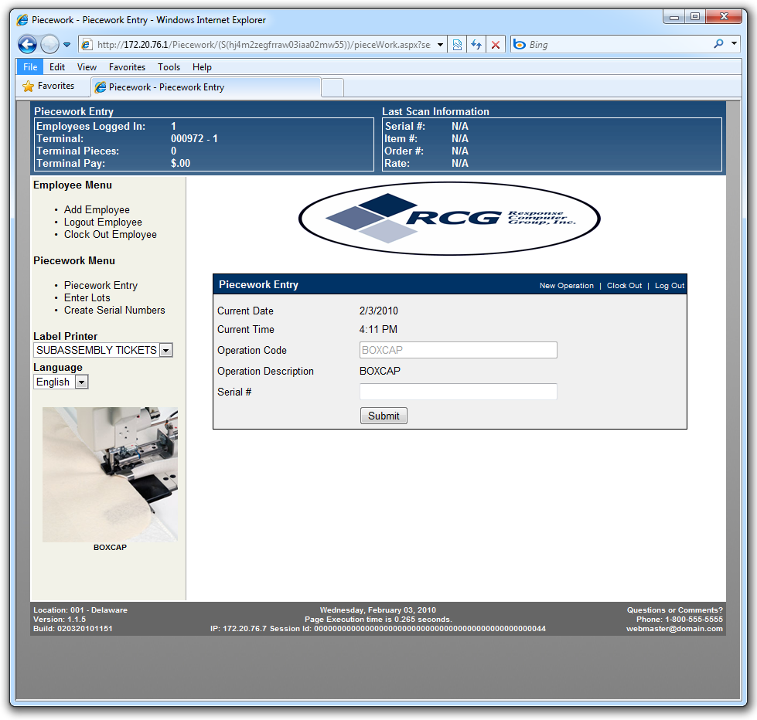

Operations on the manufacturing floor are performed using this web interface. Employees login and out and hours are tracked as well as piecework scans. Pictures can be added to help illustrate the operation. Multi-lingual prompts are available. At the top of the screen the employees can see their piecework totals for the day. Multiple employees can work on the same operation as a team, and the piecework pay is automatically split between them.

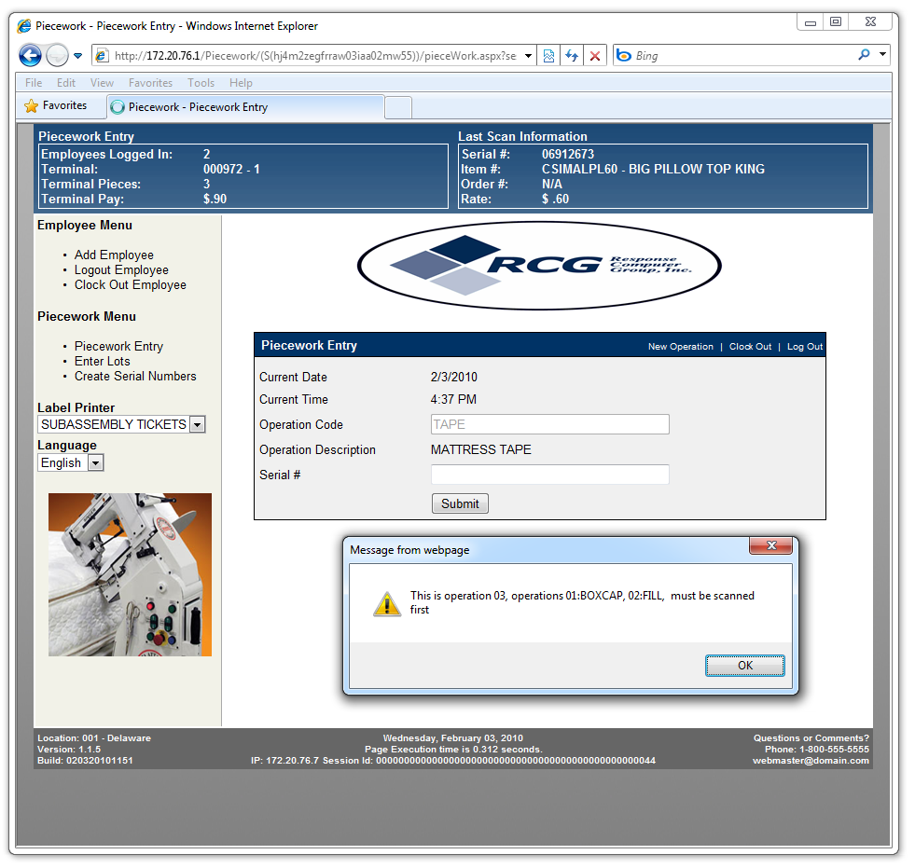

Each serial number has defined operations which must be performed in order. User-friendly prompts help the piecework employees to follow the defined procedures.

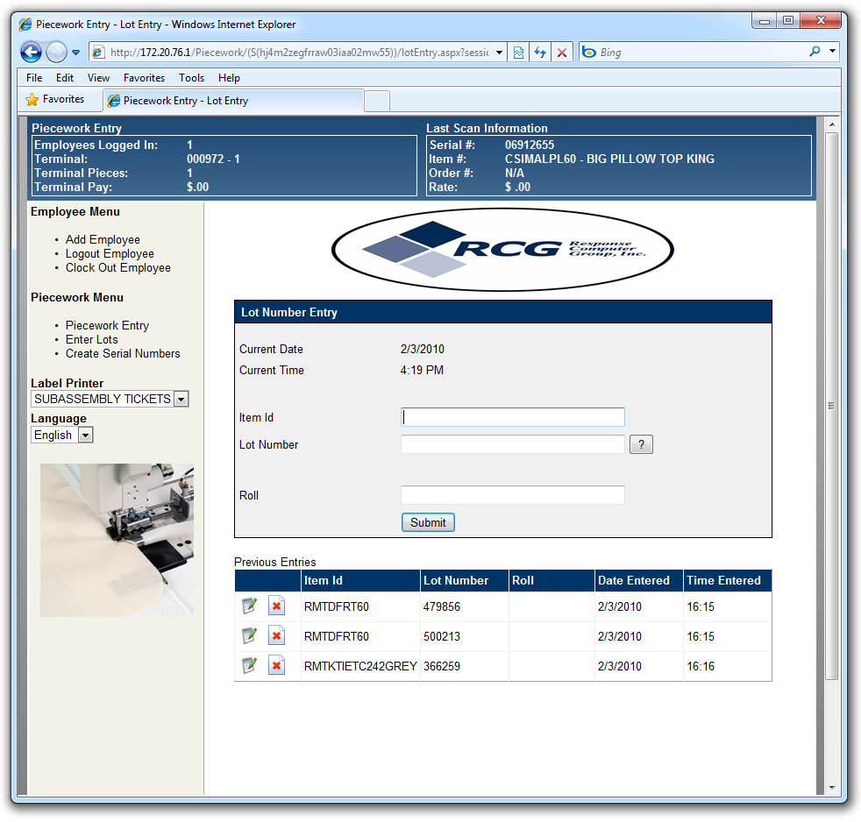

Validation prompts can be added to each operation to require scanning of lot numbers, subassemblies, or special components. No operation is allowed to complete until all required fields are entered.